**2018-2087**

United States Court of Appeals
  
for the Federal Circuit

PLASTIC OMNIUM ADVANCED INNOVATION AND RESEARCH,

*Plaintiff-Appellant*,

v.

DONGHEE AMERICA, INC. and DONGHEE ALABAMA, LLC

*Defendants-Appellees*.

*Appeal from the U.S. District Court for the District of Delaware
  
in Case No.: 16-0187-LPS, Judge Leonard P. Stark.*

**CONFIDENTIAL OPENING BRIEF FOR APPELLANT
  
PLASTIC OMNIUM ADVANCED INNOVATION AND RESEARCH**

Robert C. Mattson

*Principal Attorney*Alexander J. Hadjis
  
Christopher Ricciuti
  
Sasha S. Rao

OBLON, MCCLELLAND,

MAIER & NEUSTADT, LLP 1940 Duke Street Alexandria, VA 22314 [rmattson@oblon.com](mailto:rmattson@oblon.com) (703) 413-3000

*Counsel for Appellant*

COUNSEL PRESS, LLC (202) 783-7288

**CERTIFICATE OF INTEREST**Counsel for Appellant certifies the following:

**1. The full name of party represented by me:**

Plastic Omnium Advanced Innovation and Research

1. **The name of the real party in interest (please only include any real party in interest NOT identified in Question 3) represented by me is:**

Plastic Omnium Advanced Innovation and Research

1. **Parent corporations and publicly held companies that own 10% or more of stock in the party:**

Plastic Omnium Advanced Innovation and Research’s parent is Plastic Omnium Auto Inergy SAS. Plastic Omnium Auto Inergy SAS’s parent is Compagnie Plastic Omnium SA, and Compagnie Plastic Omnium SA’s parent is Burelle SA. No publically held corporation owns 10% or more of Plastic Omnium Advanced Innovation and Research’s stock.

1. **The names of all law firms and the partners or associates that appeared for the party or amicus now represented by me in the trial court or agency or are expected to appear in this court (and who have not or will not enter an appearance in this case) are:**

Oblon, McClelland, Maier & Neustadt, LLP: Eric Schweibenz; Frank J. West; Vincent K. Shier; Michael West; and Katherine D. Cappaert (no longer with firm).

Barnes & Thornburg: Chad Stover and Regina Murphy

1. **The title and number of any case known to counsel to be pending in this or any other court or agency that will directly affect or be directly affected by this court’s decision in the pending appeals. See Fed. Cir. R. 47.4(a)(5) and 47.5(b):**

IPR2017-01605, IPR2017-01633, IPR2017-01647, IPR2017-01654,

IPR2017-01890, and IPR2017-01945, pending before the United States Patent and Trademark Office, Patent Trial and Appeal Board

i

Dated: August 31, 2018 /s/ Robert C. Mattson

Robert C. Mattson

*Counsel for Appellant, Plastic Omnium Advanced Innovation and Research*

ii

**TABLE OF CONTENTS**

CERTIFICATE OF INTEREST i

TABLE OF CONTENTS iii

TABLE OF AUTHORITIES v

STATEMENT OF RELATED CASES vii

JURISDICTIONAL STATEMENT 1

INTRODUCTION 2

STATEMENT OF THE ISSUES 5

STATEMENT OF THE CASE 6

I. Plastic Omnium and Its Patented Technology 6

1. Plastic Omnium’s Parison Patents 14
2. Plastic Omnium’s Preassembled Structure Patent 16

II. Donghee’s Accused Process 19

III. Proceedings Before the District Court 26

SUMMARY OF THE ARGUMENT 29

STANDARD OF REVIEW 31

ARGUMENT 32

I. Summary Judgment of Non-Infringement Due to the Parison Terms

Was Based on an Erroneous Claim Construction 32

1. The Patents are Directed to a Process Involving the Splitting of

a Parison 32

1. The Patents Do Not Have the Cutting-Location Requirement

Imposed by the District Court Through Summary Judgment 35

iii

1. The Summary Judgment Grant Was Based on the Improper

Addition of the Cutting-Location Requirement 38

1. Summary Judgment of No Infringement Under the Doctrine of

Equivalents Was Erroneous 41

II. Summary Judgment of Non-Infringement Due to “Preassembled

Structure” Was Based on an Erroneous Claim Construction 42

1. A Preassembled Structure Is a Structure that Is Made Prior to

the Fuel Tank and Is Not Necessarily Made from Multiple Parts 43

1. There Is No Requirement that a Preassembled Structure Be

Formed Prior to Its Attachment to an Accessory or Duct 47

CONCLUSION 48

ADDENDUM Appx1

CERTIFICATE OF SERVICE

CERTIFICATE OF COMPLIANCE MOTIONS OR BRIEFS CONTAINING MATERIAL SUBJECT TO A PROTECTIVE ORDER

CERTIFICATE OF COMPLIANCE

iv

**TABLE OF AUTHORITIES**

***Page(s)***

**Cases**

*Am. Piledriving Equip., Inc. v. Geoquip, Inc.*,

637 F.3d 1324 (Fed. Cir. 2011) 38

*Anderson v. Liberty Lobby, Inc.*,

477 U.S. 242 (1986) 31

*Chimie v. PPG Indus., Inc.*,

402 F.3d 1371 (Fed. Cir. 2005) 31

*Daniels v. School Dist. of Phila.*,

776 F.3d 181 (3d Cir. 2015) 31

*Digital-Vending Servs. Int’l, LLC v. Univ. of Phoenix, Inc.,*

672 F.3d 1270 (Fed. Cir. 2012) 44

*DSW, Inc. v. Shoe Pavilion, Inc.*,

537 F.3d 1342 (Fed. Cir. 2008) 44

*Phillips v. AWH Corp.*,

415 F.3d 1303 (Fed. Cir. 2005) 44, 47

*Profectus Tech. LLC v. Huawei Techs. Co.,*

823 F.3d 1375 (Fed. Cir. 2016) 31

*Rhine v. Casio, Inc.*,

183 F.3d 1342 (Fed. Cir. 1999) 43

*Smith & Nephew, Inc. v. Ethicon, Inc.,*

276 F.3d 1304 (Fed. Cir. 2001) 40

*Teva Pharms. USA, Inc. v. Sandoz, Inc*.,

135 S. Ct. 831 (2015) 31

*Vita-Mix Corp. v. Basic Holding, Inc.*,

581 F.3d 1317 (Fed. Cir. 2009) 37

v

*Vivid Techs., Inc. v. Am. Sci. & Eng’g, Inc.,*

200 F.3d 795 (Fed. Cir. 1999) 40

**Statutes**

28 U.S.C. § 1295(a)(1) 1

28 U.S.C. § 1331 1

28 U.S.C. § 1338 1

vi

**STATEMENT OF RELATED CASES**

No other appeals have previously been taken from the proceedings below.

This appeal concerns Plastic Omnium’s U.S. Patent Nos. 6,814,921; 6,866,812; 7,166,253; and 9,399,327. Each patent is subject to an *inter partes* review proceeding filed by appellees: IPR2017-01625 against the ’253 patent; IPR2017-01633 against the ’812 patent; IPR2017-01647 against the ’921 patent; and IPR2017-01890 against the ’327 patent. Final written decisions are due in these proceedings between December 2018 and February 2019.

vii

**JURISDICTIONAL STATEMENT**

The district court had jurisdiction under 28 U.S.C. §§ 1331 and 1338, and entered final judgment on June 11, 2018. (Appx1-3.) A notice of appeal was timely filed on June 15, 2018. Jurisdiction of this appeal is based upon 28 U.S.C. § 1295(a)(1).

1

**INTRODUCTION**

Plastic Omnium Corporation is a world-leading tier-one supplier to the

automotive industry. It designs and manufactures everything from car bumpers to fuel systems. The appellant, Plastic Omnium Advanced Innovation and Research, has its principal place of business in Brussels, Belgium, along with many design and manufacturing facilities around the world, including at least nine in the United States.

Plastic Omnium is responsible for inventing, in 1999, fundamental manufacturing technology that enables plastic fuel tanks that meet and exceed strict emissions requirements to be employed in automobiles. Along with that technology, Plastic Omnium invented devices that are used to install and attach functional components, such as valves, to an automobile’s plastic fuel tank. Both Plastic Omnium’s fuel tank manufacturing technology and its fastener technology are at the center of this appeal.

Automotive fuel tanks were historically made out of metal. By the 1980s, Plastic Omnium and other early adopters started making fuel tanks out of plastic. One of the primary problems preventing these tanks from meeting increasing emissions requirements stemmed from how the outer shell of the tank was formed and how functional valves and other accessories were installed within the tank.

2

Plastic Omnium realized that the mass-production of emission-friendly plastic fuel tanks for automobiles could be achieved through a manufacturing process that involved splitting a “parison” — the plastic tube that is produced by the same equipment the plastic fuel tank industry had been using since the early 1980s — to create two sheets of plastic that are then molded to form the top and bottom of a tank. Although at the time it was theoretically possible to use two independently-manufactured plastic sheets to manufacture a plastic fuel tank, such a two-sheet process could not be scaled or industrialized to make tanks for automobiles. Plastic Omnium’s parison-splitting process was key to solving the emissions problem on a mass-production scale.

In conjunction with the development of its parison-splitting manufacturing technology, Plastic Omnium also invented fastener technology to install components in a plastic fuel tank in a manner that is also designed to reduce emissions. Its fastener technology utilizes a preassembled structure as an interface to both anchor itself to one of the sheets, *i.e.*, the wall of a tank, and to hold a component.

Donghee’s accused process, which is nearly identical to Plastic Omnium’s, relies on the exact same manufacturing technique and fastener technology invented by Plastic Omnium. Donghee employs equipment to form a parison, that parison is split into two sheets, and those two sheets are used to make the outer shell of the

3

Donghee fuel tank. Likewise, accessories mounted to the tank’s interior walls are attached using a preassembled structure that serves as an interfacing component that both anchors itself to the tank’s wall and holds the accessory.

Donghee moved for summary judgment of non-infringement. The district court concluded, based on the erroneous rationale that Plastic Omnium’s patents do not cover a process that involves splitting a parison within the equipment used to form the sheets that are eventually molded to form the walls of a fuel tank, that Donghee does not infringe the Plastic Omnium fuel tank manufacturing patents. The court also erroneously concluded that Plastic Omnium’s fastener technology patent requires a two-piece fastener as opposed to one that is formed as a single component.

There is, however, no splitting location requirement in Plastic Omnium’s asserted plastic fuel tank manufacturing patents — the only requirement, which is undisputedly met by Donghee’s process, is simply that a parison be split to permit sheets to be formed that serve as the shell of the fuel tank. Neither the patents’ claims, nor their written descriptions, specify where the claimed parison must be split.

Similarly, the court’s two-piece fastener requirement is not grounded in Plastic Omnium’s asserted fastener patent. The fastener patent contains claim

4

language and a written description that expressly addresses and encompasses a single-piece preassembled structure.

STATEMENT OF THE ISSUES

1. Whether, in concluding that there is no infringement as a matter of

law, the district court erred in its interpretation of the ’921, ’812, and ’327 patents’ “extruded parison” terms by adding to that phrase a requirement that an extruded parison must be split at a certain point in the manufacturing process when the claims and the written description of the patents do not specify a point at which the extruded parison must be split?

1. Whether, when applying its erroneously limited interpretation of the “extruded parison” terms, the district court erred in concluding that there is no infringement as a matter of law under the doctrine of equivalents when the accused manufacturing process generates an extruded parison and splits the extruded parison to carry out the same purpose and achieve the same result as the “extruded parison” element.
2. Whether, in concluding that there is no infringement as a matter of law, the district court erred in its interpretation of the ’253 patent’s “preassembled structure” term by requiring the claimed component to be: (i) comprised of multiple pieces and (ii) entirely assembled before being attached to a fuel tank,

5

when the ’253 patent’s claim language and written description both expressly encompass a single-piece component as the “preassembled structure?”

**STATEMENT OF THE CASE**

This appeal arises out of Plastic Omnium’s assertion of a number of its

plastic fuel tank twin-sheet blow-molding patents against Donghee. On May 22, 2018, the district court entered summary judgment of no infringement against the patents at issue in this appeal — U.S. Patent Nos. 6,814,921 (the ’921 patent); 6,866,812 (the ’812 patent); 7,166,253 (the ’253 patent); and 9,399,327 (the ’327 patent). A final judgment issued on June 11, 2018. Plastic Omnium appeals from that judgment.

**I. Plastic Omnium and Its Patented Technology**

Plastic Omnium, initially through its corporate predecessor, Solvay, has

manufactured plastic fuel tanks since the early 1980s. In fact, Solvay was one of the first adopters of plastic fuel-tank technology in the world, leading the shift from metal fuel tanks to the plastic tanks found in most cars today.

Metal fuel tanks were the historical norm. Yet, they suffer from many shortcomings. They are heavy, subject to corrosion, and not easily molded to conform to the odd/complex cavity shapes required by the design of many automobiles. By remedying these deficiencies, plastic fuel tanks were the evolutionary next step from metal.

6

Initially, plastic fuel tanks were made by blow molding a tubular “parison” — a plastic body with a closed, typically circular, cross section that is formed with a component called an “extrusion head,” “coextrusion head,” or “coextrusion die.” A parison and coextrusion die are depicted below in the photo of actual machinery

on the left and the graphic on the right.
  
[(](https://www.plasticomnium.com/en/automotive-equipment/auto-inergy-division/our-expertises/manufacturing.html)https://www.plasticomnium.com/en/automotive-equipment/auto-inergy-division/our-expertises/manufacturing.html)

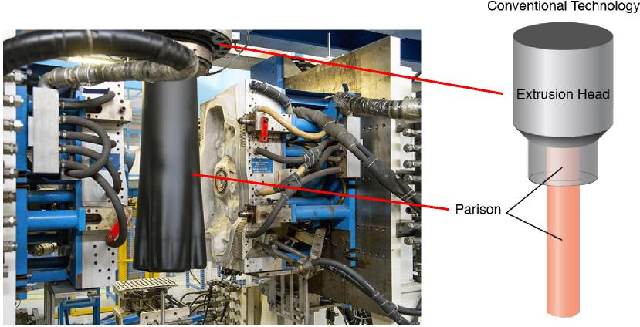

(Appx244, Figure 6.)

Once the parison is formed and reaches its desired length, the blow molding process is carried out by first applying two mold halves that close around the parison. Then, compressed air is blown into the parison to expand the parison’s walls into the shape of the mold to form the walls of the vessel that is being

7

created. A bottle that has been created by blow molding a parison is shown below.

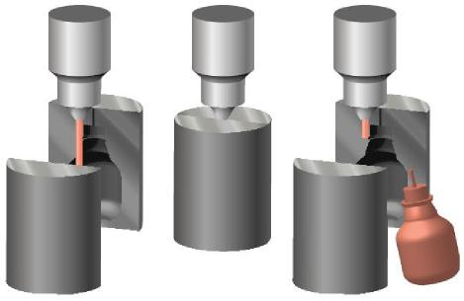

(Appx239, Figure 1.)

For some time, automotive fuel tank technology has involved the installation of components inside the fuel tank. This maximizes the tank’s fuel capacity while minimizing the overall space the tank occupies within the vehicle. It also permits a number of necessary functions — such as ventilating fuel vapor, preventing fuel leakage if the vehicle/tank rolls over, and reducing slosh noise — to be performed by certain accessories, such as valves and baffles.

When using conventional plastic blow molding techniques to manufacture fuel tanks, however, the ability to place these accessories inside the tank is problematic. This challenge, nicknamed the “ship-in-a-bottle” problem, exists because the accessories must be placed within the relatively small opening in the bottom of a fully extruded parison, depicted above, without interfering with the parison before blow molding. (’812 Patent (Appx77), 1:24-33.)

8

Thus, accessories were often installed by cutting holes in the tank’s exterior wall and passing the accessory through the opening. A plastic fuel tank that was manufactured by cutting holes in its exterior wall so accessories can be installed is shown below. For example, valves, which are purple-colored, are seen from the exterior of the tank and are mounted through the tank’s wall.

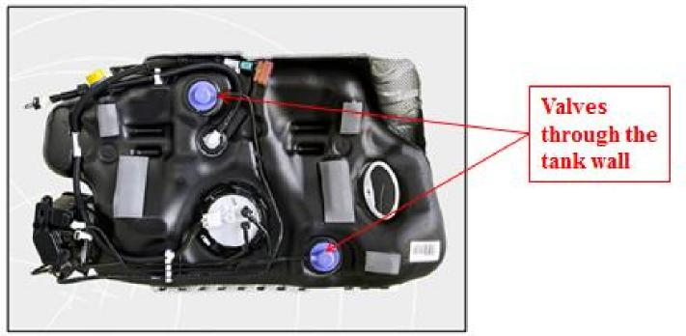

(Appx240-241, Figure 3.)

But, when accessories are mounted through the fuel tank’s wall, an undesirable interface (or leakage/permeation point) between the interior of the fuel tank and the outside atmosphere is created at that mounting location. This occurs because plastic fuel tanks are typically manufactured out of high-density polyethylene (HDPE) with a hydrocarbon barrier layer sandwiched between the layers of HDPE making up the tank. (Appx240, ¶34.)

When a hole is cut in the tank’s wall to attach an accessory, this barrier layer is broken, providing a permeation pathway for the stored hydrocarbons to escape

9

out into the atmosphere. (*Id.*) While this may be sufficient for certain applications, a plastic fuel tank with interfaces created by components attached through the exterior of the tank may not meet certain emissions standards for environmental regulations. (’812 Patent (Appx77), 1:6-23.)

One way to address the ship-in-a-bottle problem is to manufacture a plastic fuel tank by using two independently manufactured plastic sheets to create two separate side-walls that are then molded and permanently fastened together after the components have been attached to the inside of the side-walls. Such a two-sheet process could not, however, be scaled or industrialized to make tanks for automobiles.

Plastic Omnium developed a new technology that solved the ship-in-a-bottle problem and that could be employed on a mass-production basis to create an emission-friendly plastic fuel tank. Plastic Omnium realized that two sheets of plastic that are then molded to form the top and bottom of a plastic fuel tank could be formed by first creating, or extruding, a parison and then splitting the parison to form the sheets. Plastic Omnium’s parison-splitting process was key to solving the emissions problem on a mass-production scale.

Splitting a parison to create two sheets provides consistency in the material and thickness of the twin shells of the tank. (’921 Patent (Appx71), 1:47-52; ’812 Patent (Appx77), 1:42-53.) Moreover, splitting a parison to create two sheets

10

permits the manufacture of a twin-sheet blow molded plastic fuel tank by retrofitting conventional blow molding equipment.

Both Plastic Omnium’s and the conventional processes begin with a coextrusion die to form a parison. Plastic Omnium’s technology adds a splitting device positioned after the coextrusion die to split the parison after it has been created. Not only does this advantageously allow conventional extrusion equipment to be retrofitted to practice Plastic Omnium’s inventions, it avoids the prior “drawback of having to position two extrusion heads and/or extruders capable of simultaneously producing two flat sheets, the thickness uniformity and the production uniformity of which are [required to be] constant from one sheet to another and at any point on each of the sheets.” (’812 Patent (Appx77), 1:42-46.)

More specifically, Plastic Omnium’s patented process begins by forming a tubular parison and then splitting it to form a sheet or multiple sheets. This parison-splitting process is depicted in ’921 and ’812 patents’ Figure 1. In these figures, the tubular parison is formed using a coextrusion head (component 2). As the parison exits the coextrusion head, a blade (component 3) located at the exit of the coextrusion head splits the parison.

In the ’921 patent’s Figure 1 (reproduced on the left, below) only one blade (3) is depicted to form a single sheet (’921 Patent (Appx73), 5:24-27), whereas the ’812 patent’s Figure 1 (reproduced on the right, below) depicts two blades (3)

11

placed at 180o opposite one another to form two sheets (’812 Patent (Appx79), 5:27-32).

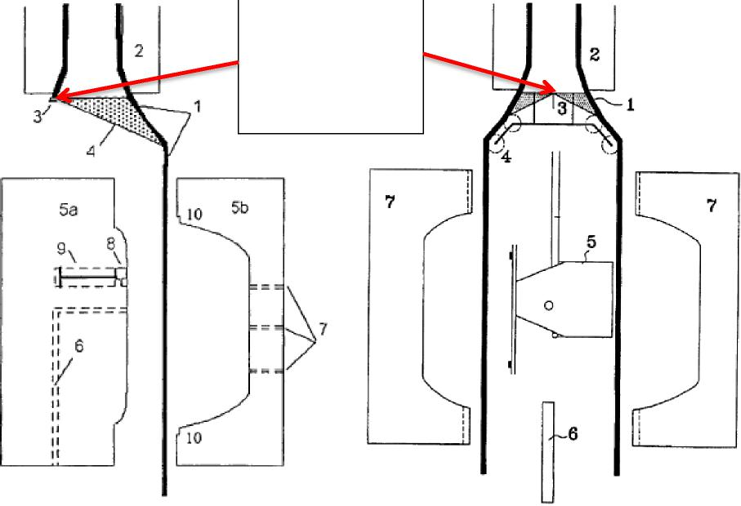

Splitting of the parison 1 at the exit of the coextrusion head

’921 Patent Fig**.** 1 and ’812 Patent Fig**. 1 (Appx243)**

The use of a parison to form of a single sheet or multiple sheets accomplishes the purposes of Plastic Omnium’s patents — the inside walls of the tank are openly exposed to permit large components to be directly installed onto the inner walls of the tank (*i.e.*, eliminating the ship-in-a-bottle problem), the parison results in consistent and uniformly thick tank walls, and the use of a parison allows the process to be carried out through retrofitting modifications to the conventional

12

blow molding tank manufacture process. (’921 Patent (Appx71), 1:47-52; ’812 Patent (Appx77), 1:23-53.)

During the patented blow-molding process (and prior to the sheet or sheets being sealed together), accessories, such as valves and baffles, are attached to the fuel-tank’s interior walls without piercing the wall. This reduces emissions and makes for a more structurally secure tank. (Appx241, ¶35.)

One way to physically attach an accessory to the fuel-tank wall before the split parison is molded into the shape of a fuel tank is to guide one of the sheets that is created by splitting the parison in front of a mold and a central core or punch (elements 5a and 5b in the ’921 patent’s Figure 1, and depicted below in step (a)). The mold closes on the core and then air is injected into the mold to provide an initial shaping of the fuel-tank walls (steps (b) and (c)). While the molten plastic is still pliable, accessories are installed on the tank’s interior wall (step (d)).

Next, the mold is opened, the core is removed, and the two fuel-tank half shells are joined together to finish shaping the fuel tank and seal the half shells together to form a completed fuel tank (step (e)). (Appx244-245, ¶38.) This process, which is described in the ’921 patent (Appx73, 5:28-42), is illustrated in steps (a)-(e), below.

13

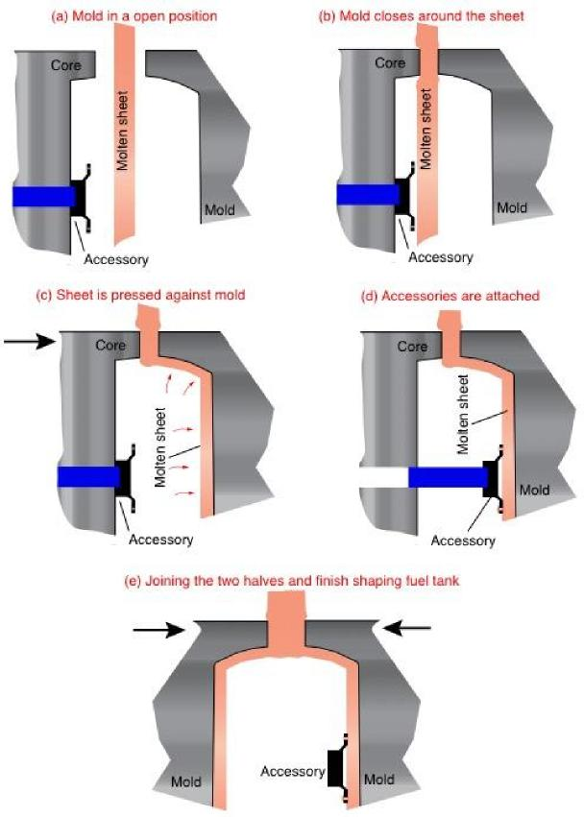

(Appx244-245, ¶38.)

**A. Plastic Omnium’s Parison Patents**

Plastic Omnium’s parison patents are directed to a process that includes

creating and splitting a parison to form sheets from which the walls of a plastic fuel tank are formed. By way of example, the ’921 patent’s claim 1 recites (emphasis added):

14

A process for manufacturing plastic hollow bodies from two shells formed by molding, which are joined together, at least one shell being produced by compression-molding a portion of a plastic sheet between a mold and a punch and by the remaining portion of the sheet being blow-molded in the region not compression-molded, characterized in that it is applied to the manufacture of a fuel tank and in the sheet is obtained in the same manufacturing line as the shell which will be produced from this sheet, by the *cutting and opening an extruded parison of closed cross section*.

(Appx73.)

Dependent claim 4 requires:

at least one accessory of the fuel tank is inserted into the shell and

fixed onto it.

The “parison terms” portion of this appeal pertains to the “extruded parison of

closed cross section” limitation of the ’921 patent, along with the following limitations of the ’812 and ’327 patents: “extruding a parison” (’812 patent claim 32) and “split or at least two-part parison” (’327 patent claims 1 and 9).

Specifically, despite that neither the asserted patents’ claims nor their written descriptions specify where the claimed parison must be split, the district court concluded that the claims do not cover splitting a parison inside of the extrusion equipment — the equipment from which the two plastic sheets that ultimately form the walls of a fuel tank pass out of and into the open atmosphere. The court

15

concluded incorrectly that the patents require the extruded parison to be cut or split outside of the extrusion equipment.

The patents, however, merely claim and describe the process of splitting a parison to form the walls of a fuel tank. The claims, as exemplified by claim 1 of the ’921 patent, reproduced above, simply call out a plastic tank manufacturing process that involves “cutting and opening an extruded parison” — no more and no less. The claims do not specify where the parison must be cut, only that it, naturally, be cut at some point after the parison has been formed. The written description is no different.

For example, the specification of the ’921 patent states that the “tubular extrudate [*i.e.*, the parison] (1) leaving the circular die, which is mounted on the extrusion head (2), is cut along a generatrix using steel blade (3) placed at the exit of the circular die.” (’921 Patent (Appx73), 5:24-27; *see also* ’812 Patent (Appx79), 5:23-30 (“The tubular multilayer extrudate (1) of circular cross section [*i.e.*, the parison] ... leaves the extrusion head (2) and is separated into two sheets (1), using two steel blades (3) placed at 1800 to each other, at the exit of the circular die mounted on the extrusion head (2).”)

**B. Plastic Omnium’s Preassembled Structure Patent**

Plastic Omnium’s ’253 patent is directed to a specific technique and device

for attaching functional accessories to the inner wall of a twin-sheet tank while it is

16

being manufactured. In particular, a pre-made component, which is claimed and explained as a “preassembled structure,” is designed to act as an interface between the inner wall of a tank and an accessory that is attached to the inside of the tank. The preassembled structure is designed to be fastened to the tank’s wall and to also hold the accessory. Thus, the preassembled structure affixes the accessory to the tank’s inner wall.

This permits the accessory to be attached to the inner wall when a direct connection between the accessory and the tank’s wall is either not possible or is not desired. For example, material compatibility problems may prevent a direct connection between an accessory and a fuel tank’s wall. Or, a standard, pre-designed interfacing attachment component can be created to attach to the inner wall of a tank during its manufacture so a wide variety of accessories can be manufactured by others and attached to the tank via the interfacing component (sometimes even after the completion of the tank’s walls and the attachment of the interface component). (’253 Patent (Appx85), 4:13-22, 4:33-49.)

The ’253 patent’s claim 1 recites (emphasis added):

A process for manufacturing a hollow body using a mould, comprising the steps of:

incorporating at least one of an accessory or a duct within the hollow body;

17

after said step of incorporating, closing said mould in a way which eliminates any interface between said at least one of said accessory or said duct and an external atmosphere outside of the hollow body;

wherein said at least one of said accessory or said duct is *supported by a preassembled structure which comprises at least one device* configured to anchor said preassembled structure to an internal wall of the hollow body.

(Appx86.)

The district court construed “preassembled structure” as “a set of multiple parts previously joined into a single arrangement that is capable of attachment to at least one accessory.” (Appx952.) This interpretation conflicts with the ’253 patent’s claims and its specification. The ’253 patent’s claims require the preassembled structure to comprise “at least one device,” which means one device or more and, because this language modifies the claimed preassembled structure, the preassembled structure must be interpreted to encompass a single-component device. It cannot be limited to a two-or-more-component device.

Similarly, the specification does not dictate a multi-piece component. It only requires that the preassembled structure be produced in a separate process from the blow-molded fuel tank — that is, it is inserted into the fuel tank during the tank’s manufacture, rather than being made from the molten plastic tank wall. (’253 Patent (Appx85), 4:14-22 (emphasis added).)

18

II. **Donghee’s Accused Process**

Donghee manufactures, sells, and distributes automotive fuel tanks in the

United States to Hyundai Motor manufacturing Alabama LLC (Hyundai). Appellees’ manufacture and sale of its LFa tank is accused of infringing the patents on appeal. (Appx114-117.) Appellees manufacture the LFa tank at their facility in Auburn, Alabama using a blow-molding machine and a process called the Next Generation Fuel System II (NGFS II) process. (*Id.*) Donghee’s Alabama operations began in 2013. (Appx114.)

The relevant aspects of the NGFS II process as it pertains to the parison issue before this Court are undisputed. First, a circular “coextrusion die” or “coextrusion head” is used to create a plastic parison. (Appx247, ¶41.) The parison exits the coextrusion head and enters a separate “flat die tool” so that it can be cut into sheets: “for the accused product, it is undisputed that ‘[t]he extruded plastic parison is [] cut in a separate “flat die” tool after it leaves Donghee’s coextrusion die.’” (Appx20; *see also* Appx248-250, ¶¶42-43.)

More specifically, and as shown in the images, below, from appellees’ Alabama manufacturing facility, a circular coextrusion head (gray, circular drum in the top image) is directly connected to a piece of equipment called a “flat die tool” (green, rectangular component in the bottom image). (Appx263, Figure 24; Appx248-250, ¶¶42-43.) The coextrusion head extrudes a parison, which is then

19

***Confidential Images in Brackets. Associated Text is Non-Confidential.***

directly fed into the flat die tool. The flat die tool cuts the parison into two sheets of plastic. (*Id.*)

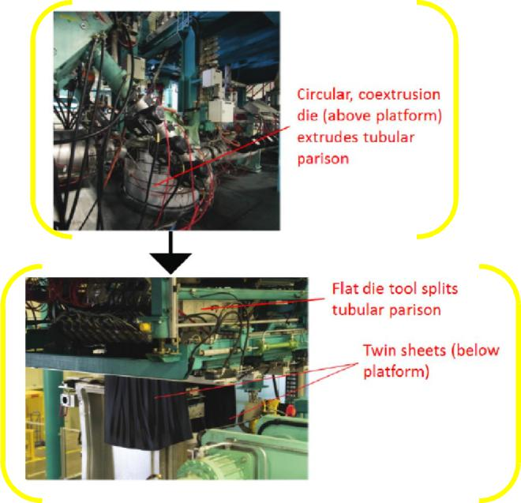

An illustration of this equipment, as it would appear in a single image and if it were unobscured by the support beams and platforms in the factory floor, is shown below.

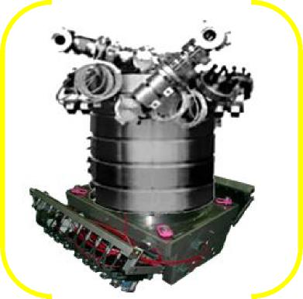

20

(Appx711; Appx736; Appx2326.)

As explained by appellees’ technical documentation, its “6-layer parison coextrusion die tool” (Appx711) — the gray circular drum in the image above — continuously extrudes a parison that is subsequently cut into “two level parison plates,” or sheets, by the “attached flat die tool.” (Appx710.) The extrusion head is called a “6-layer parison coextrusion die tool” because it forms six layers of plastic and combines them into an annular, closed cross-section shape of plastic, *i.e.*, a parison, by passing the plastic through a ring-shaped flow channel at the exit point of the extrusion head. (Appx261-265, ¶¶59-64.)

Appellees’ flat die tool, which is attached to the output of the circular coextrusion die tool during operation, is shown and explained in further detail, below. The first set of graphics, placed side-by-side, consist of (a) an actual image of the flat die tool (on the left side) and (b) blue and yellow images (on the right side) that illustrate a more functional depiction of the flat die tool. The graphic below the first set is taken from a specification of the tool.

21

***Confidential Images in Brackets. Associated Text is Non-Confidential.***

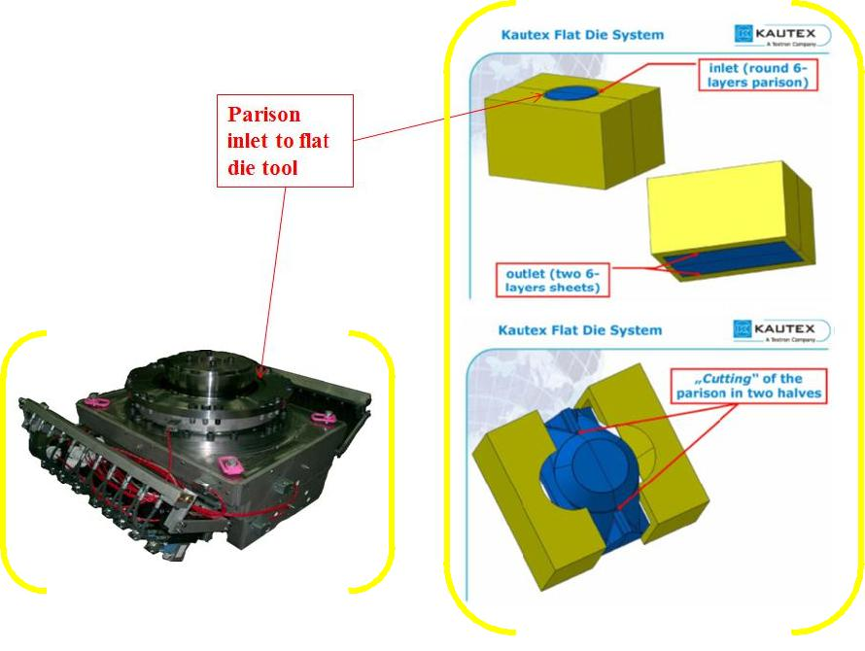

(Appx736-738; Appx2326.)

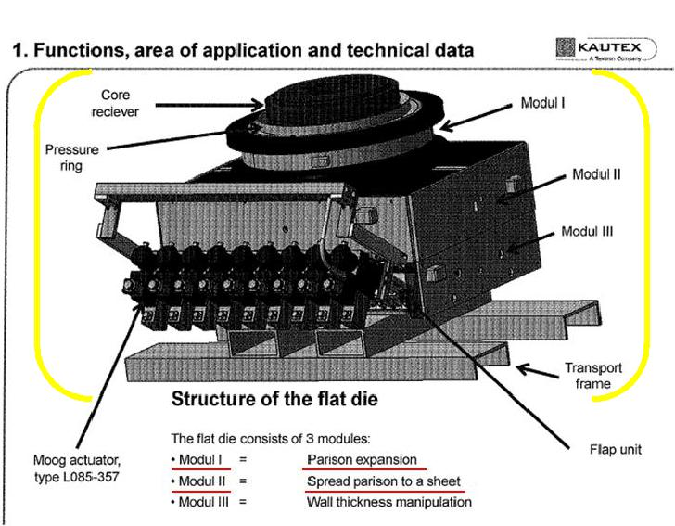

(Appx748, emphasis added.)

22

During operation, the parison generated by the drum-shaped extrusion die is fed into the flat die tool, initially widened or expanded by the flat die tool, and then split in two by the flat die tool. The manner in which this occurs can be seen through the illustration of the blue component in the functional graphics and the text describing the flat die tool in the functional graphics and the specification.

The illustration below has been generated to graphically, and more clearly, depict the flow of plastic through appellees’ coextrusion die (drum-shaped component) and flat die tool (box-shaped component). The coextrusion die forms a tubular parison (shown in pink) that is then fed into the flat die tool and then split into two sheets that are used to form the top and bottom halves of the LFa fuel tank. Again, as explained by the district court below, it is undisputed that appellees’ “extruded plastic parison is [] cut in a separate ‘flat die’ tool after it leaves Donghee’s coextrusion die.” (Appx20.)

23

***Confidential Images in Brackets. Associated Text is Non-Confidential.***

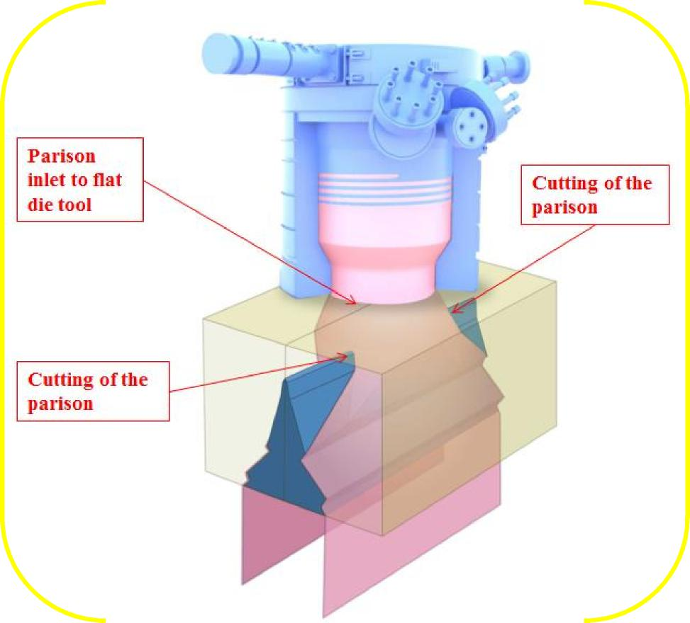

(Appx710-711; Appx736-738; Appx748.)

Once the two sheets from appellees’ coextrusion die tool reach the proper length, the NGFS II manufacturing process continues. The sheets are placed between two mold halves and a sealing frame to initially shape the sheets of plastic into top and bottom tank halves. (Appx250-251, ¶44.) The sealing frame is then removed from between the mold halves and replaced with a joining tool, which

attaches accessories, such as a Roll Over Valve (ROV), Fill Limiting Venting

24

Valve (FLVV), support pillars, and a baffle to the tank’s interior walls. (Appx251-252, ¶45.) After the accessories are attached, the joining tool is removed and the mold cavities are brought together to finish forming the tank halves and to seal the halves together. (Appx253, ¶46.)

The top half of a completed LFa fuel tank is shown below. It has two support pillars, ROV, and FLVV attached to its inner wall. The ROV and FLVV are each fixed to a mounting bracket that is attached to the tank’s wall with a self-formed plastic rivet. The outer tabs of each of the mounting brackets, which are black, can be seen in the LFa tank image below. The rivet is formed during the tank’s manufacture when a portion of the plastic wall of the tank is forced into and through an appropriately shaped orifice in the ROV/FLVV’s mounting bracket so that the ROV and FLVV are rigidly and permanently affixed to the tank’s wall. (’327 Patent (Appx107), 3:35-55; Appx245-246, Figures 7 and 8; Appx251-256, ¶¶45-50.)

25

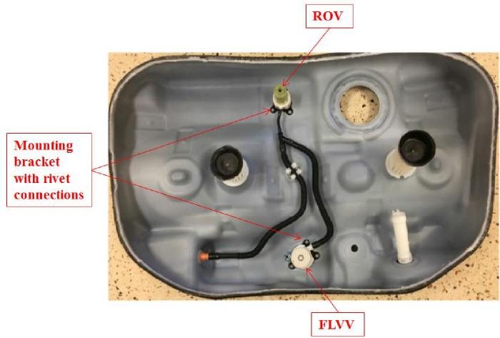

(Appx256, Figure 19.)

The mounting bracket that is used to support the ROV and FLVV, as discussed and illustrated above, is a pre-designed and pre-manufactured interfacing attachment component — a “preassembled structure” in the’253 patent’s claim language and as described above — that acts as an interface between the inner wall and the accessory to hold and anchor the accessory to the tank’s wall. The FLVV’s preassembled structure, for example, is the black mounting bracket with orifices through which rivets are formed to create an attachment to a tank wall and that acts as an attachment interface to allow the preassembled structure and FLVV to be secured to the tank’s wall.

III. Proceedings Before the District Court

On May 22, 2018, the district court granted appellees’ motion for summary judgment of no infringement of five patents asserted by Plastic Omnium, including

26

the patents involved in this appeal: the ’921, ’812, ’253, and ’327 patents. The appeal stemming from these four patents can be grouped into two issues.

First, as to the ’921, ’812, and ’327 patents, the court improperly concluded that appellees’ NGFS II manufacturing process does not infringe (either literally or under the doctrine of equivalents) the following limitations of each patent (collectively referred to as the “parison claims” or “parison terms”):

* “extruded parison of closed cross section” (’921 patent claim 1);
* “extruding a parison” (’812 patent claim 32); and
* “split or at least two-part parison” (’327 patent claims 1 and 9).

(Appx19-20.) Second, as to the ’253 patent, the district court improperly concluded that there is no infringement of claims 11 and 14 because the LFa fuel tank’s ROV and FLVV are not supported by a “preassembled structure.” (Appx23-24.)

In both scenarios, the district court’s non-infringement conclusions were predicated upon erroneous claim construction conclusions. Further, for the doctrine of equivalents, the district court ignored a material issue of fact in addition to applying an erroneous claim construction.

With respect to the parison terms, the court, through its *Markman* order, construed each limitation to mean “a tubular preform with a closed cross-section that has been forced through a die, and is cut as it exits the die or at some time thereafter.” (Appx946.) The court, however, failed to follow its own construction

in summary judgment.

27

Instead, the district court applied a construction that requires a tubular preform (which the court agreed both exists and is split in the Donghee process (Appx20)) to be split *outside of the manufacturing machinery* as opposed to either inside of or outside of the equipment. Here, the court concluded:

[s]ince, for the accused product, it is undisputed that “[t]he extruded plastic parison is [] cut in a separate ‘flat die’ tool after it leaves Donghee’s coextrusion die” (citations omitted), there is no genuine issue of fact that Donghee’s accused product does not literally infringe the Parison Claims.

(Appx20.)

As to the doctrine of equivalents, the court concluded that “a reasonable jury could not find cutting the parison while it is extruding within extrusion equipment is insubstantially different than cutting the extruded parison outside the extrusion equipment.” (Appx21.)

With respect to the ’253 patent, the district court construed the “preassembled structure” term to mean “a set of multiple parts previously joined into a single arrangement that is capable of attachment to at least one accessory.” (Appx952.) Not only does the court’s construction improperly require the claimed “preassembled structure” to be two or more pieces, but the construction also requires a temporal limitation requiring the two or more pieces to be assembled before an accessory is attached to the structure. (Appx23-24.)

28

Neither limitation is a requirement of the ’253 patent. The claim language of the patent itself indicates that a “preassembled structure” is a single-component article (“preassembled structure which comprises at least one device . . .”) (’253 Patent (Appx86), claim 1.) Similarly, there is no discussion in the patent’s written description of the preassembled structure being a multi-piece component. Nor is there any discussion of an advantage or the purpose of it being a multi-piece component — an explanation that would be present if the patent were describing a multi-piece component.

**SUMMARY OF THE ARGUMENT**

Donghee’s accused LFa fuel tank manufacturing process uses Plastic

Omnium’s parison splitting and preassembled structure technology. Donghee uses a coextrusion die tool to form a parison, that parison is split into two sheets, and those two sheets are used to make the top and bottom halves of Donghee’s LFa fuel tank. Likewise, accessories mounted to the LFa tank’s interior walls are attached using a preassembled structure that holds the accessory and acts as an interfacing component to anchor the preassembled structure/accessory to the tank’s wall.

As to Plastic Omnium’s parison patents, the district court concluded there is no infringement as a matter of law because the claims do not cover a parison that is split “inside any of the extrusion head/die equipment” (Appx20) and appellees’

29

“extruded plastic parison is [] cut in a separate ‘flat die’ tool after it leaves Donghee’s coextrusion die.” (*Id.*) In other words, the district court concluded that the parison terms are limited to a process that creates and splits a parison outside of the extrusion equipment in the open atmosphere.

The court’s conclusion is erroneous. The Plastic Omnium parison patents simply require a parison, once formed, to be split, irrespective of whether that splitting occurs inside or outside of the equipment. Because there is no cutting-location requirement by the patents and because it is undisputed that the accused Donghee process involves the splitting of a parison, the district court’s summary judgment determination must be reversed.

As to Plastic Omnium’s fastener technology and the claimed “preassembled structure,” the district court concluded during *Markman* that this term is limited to “a set of multiple parts previously joined into a single arrangement that is capable of attachment to at least one accessory.” (Appx952.) The court interpreted this construction during summary judgment to not only require a multi-part structure, but also a temporal attachment sequence in which the claimed preassembled structure is fully assembled prior to attachment to any accessory. (Appx24.) Plastic Omnium’s ’253 patent, however, contains neither requirement and, in fact, expressly addresses and encompasses a single-piece preassembled structure. The

30

district court’s conclusions to the contrary and underlying claim construction must be reversed.

STANDARD OF REVIEW

This Court reviews the district court’s ultimate construction of a claim, as

well as intrinsic evidence, de novo. *Teva Pharms. USA, Inc. v. Sandoz, Inc*., 135 S. Ct. 831, 841 (2015). Any subsidiary fact findings about extrinsic evidence, however, must be reviewed for clear error on appeal. *Id.*

The grant of summary judgment is reviewed in accordance with the law of the regional circuit, which is also reviewed *de novo* in the Third Circuit*. Profectus Tech. LLC v. Huawei Techs. Co.,* 823 F.3d 1375, 1379 (Fed. Cir. 2016) (a district court’s grant of summary judgment is reviewed in accordance with the law of the regional circuit); *Chimie v. PPG Indus., Inc.*, 402 F.3d 1371, 1376 (Fed. Cir. 2005) (the Third Circuit reviews a grant of summary judgment *de novo*).

Summary judgment is appropriate where there is no genuine issue as to any material fact and the moving party is entitled to judgment as a matter of law. Summary judgment may only be granted when no “reasonable jury could return a verdict for the nonmoving party.” *Anderson v. Liberty Lobby, Inc.*, 477 U.S. 242, 248 (1986). In determining whether there is a genuine issue of material fact, the evidence must be viewed in a light most favorable to the party opposing the motion. *Daniels v. School Dist. of Phila.*, 776 F.3d 181, 192 (3d Cir. 2015).

31

**ARGUMENT**

**I. Summary Judgment of Non-Infringement Due to the Parison**

**Terms Was Based on an Erroneous Claim Construction**

Plastic Omnium’s patented fuel tank manufacturing process, and its technology, begins by forming a tubular parison and then splitting it to form a sheet or multiple sheets that will then be molded to form the top and bottom halves of the fuel tank. This provides consistency in the material and thickness of the twin shells of the tank, and it permits the manufacture of a twin-sheet blow molded plastic fuel tank by retrofitting conventional blow molding equipment.

Other than requiring the parison to be formed before it is cut, the claims and written description of Plastic Omnium’s patents do not require that cut to occur at any particular point in the manufacturing process. The district court’s conclusion that the appealed patents exclude splitting “inside any of the extrusion head/die equipment,” (Appx20), was, therefore, erroneous and must be reversed.

**A. The Patents are Directed to a Process Involving the Splitting of a Parison**

Plastic Omnium developed a new technology where a single coextrusion head is used to form a parison from which to make two sheets of plastic that are then molded to form the top and bottom of the fuel tank. The claims of the patents, as exemplified by claim 1 of the ’921 patent, are simply directed to the creation and subsequent cutting of a parison:

32

A process for manufacturing plastic hollow bodies from two shells formed by molding, which are joined together, at least one shell being produced by compression-molding a portion of a plastic sheet between a mold and a punch and by the remaining portion of the sheet being blow-molded in the region not compression-molded, characterized in that it is applied to the manufacture of a fuel tank and in the sheet is obtained in the same manufacturing line as the shell which will be produced from this sheet, by the *cutting and opening an extruded parison of closed cross section*.

(Appx73, emphasis added.) The claims do not limit the point in the manufacturing

process at which parison is cut.

Also as shown below, Figure 1 of both the ’921 and ’812 patents illustrate a coextrusion head (component 2) that creates a parison within the head, and blades (component 3) that cut the parison as it passes out of the coextrusion head. (’921 Patent (Appx73), 5:24-27 (“tubular extrudate (1) [*i.e.*, the parison] leaving the circular die, which is mounted on the extrusion head (2), is cut along a generatrix using steel blade (3) placed at the exit of the circular die.”); ’812 Patent (Appx79), 5:23-30 (“The tubular multilayer extrudate (1) of circular cross section [i.e., the parison], ..., leaves the extrusion head (2) and is separated into two sheets (1), using two steel blades (3) placed at 1800 to each other, at the exit of the circular die mounted on the extrusion head (2).”)

33

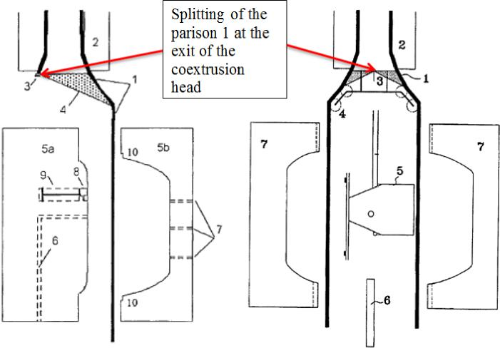

In both patents, the specification’s description of the production and splitting of a parison does not contain any cutting-location requirement and is silent on where the parison exists. And while the above figures depict post-processing equipment (rollers/ramps (4)) for opening and manipulating the parison after it is cut (’921 Patent (Appx73), 5:28-30; ’812 Patent (Appx79), 5:31-32), this in no way limits the depicted upstream cutting process to occurring outside of the extrusion equipment.

Rather, by forming two sheets of plastic from a single parison that is cut longitudinally, Plastic Omnium’s technology avoids the prior-art drawbacks of (1) “having to position two extrusion heads and/or extruders capable of simultaneously producing two flat sheets,” and (2) attempting to maintain uniform composition and thickness between the two sheets when two extruders are used. (’812 Patent

34

(Appx77), 1:34-47.) Overcoming these issues, as done by Plastic Omnium’s inventions, had nothing to do with cutting a parison only after it exists outside of the extrusion equipment. It was thus erroneous for the district court to read this requirement into the parison claims.

**B. The Patents Do Not Have the Cutting-Location Requirement Imposed by the District Court Through Summary Judgment**

In its summary judgment order (excerpt below), the district court deviated from its *Markman* claim construction by adding a cutting-location limitation to the “parison” claims of the ’921, ’812, and ’327 patents:

Because the splitting does not occur ‘at any stage earlier than right as the previously tubular structure *leaves the die/extrusion head*’ the claim construction makes clear that whether the extrusion equipment consists of a single combined extrusion head with a die or a more complex extrusion head with a separate attached die, the **splitting of the molten plastic must not occur inside any of the extrusion head/die equipment**. Since, for the accused product, it is undisputed that ‘[t]he extruded plastic parison is [] cut in a separate ‘flat die’ tool after it leaves Donghee’s coextrusion die’ ... there is no genuine issue of fact that Donghee's accused product does not literally infringe the Parison Claims.

(Appx20, italics in original, bold emphasis added.)

There is no requirement in the ’921, ’812, or ’327 patent that the claimed

parison be cut or split outside of the extrusion equipment. First, and most

importantly, the parison claims do not mention anything about where the parison

35

must exist before it is split, nor do they mention where the parison is split. The claims simply require a parison and they require that parison to be split.

For example, the ’921 patent’s claim 1 (Appx73) states that the fuel tank is manufactured “by the cutting and opening an extruded parison of closed cross section,” but there is nothing limiting the extruded parison to being cut and opened outside of the extrusion equipment, as concluded by the district court. Similarly, the ’812 patent’s claim 32 (Appx80) recites a process that includes the steps of “extruding a parison” and “cutting through said parison so as to form two portions separated by a cut,” but again, there is nothing limiting the extruded parison to being cut outside of the extrusion equipment. This same is true of the ’327 patent’s “split or at least two-part parison” limitation in claims 1 and 9. (Appx109.)

The written description is also devoid of a requirement that the parison must be cut outside of the extrusion equipment. For example, the ’812 patent states that the “term ‘extruded parison’ is understood to mean the product obtained by passing, through a die, a composition of at least one thermoplastic melt homogenized in an extruder whose head is terminated by the die. According to the invention, the parison has a closed cross section.” (’812 Patent (Appx77), 2:35-40.) Similarly, although it is not directly involved in this appeal, the Plastic Omnium ’490 patent that was asserted in the district court litigation defines a “parison” as “a preform, generally extruded, which is intended to form the wall of the tank after

36

being molded to the required shape and dimensions.” (’490 Patent (Appx95), 4:64­66.)

In fact, the district court’s original claim construction captured Plastic Omnium’s patented process in that it did not limit a parison to something that can exist and must be cut at a certain point, *i.e.*, outside of the extrusion equipment, as opposed to merely being cut after it has been formed (whether in the open atmosphere or in manufacturing equipment used to perform additional processing steps). Specifically, the court’s construction reads “a tubular preform with a closed cross-section that has been forced through a die, and is cut or split as it exits the die or at some time thereafter.” (Appx946.)

The parison must simply exit the die that shaped it before being split, regardless of whether the parison is still inside (or outside of) the “extrusion head/die equipment.” (Appx20.) By applying an incorrect claim construction during summary judgment — one that was also inconsistent with its earlier *Markman* order — the district court made a reversible error. *Vita-Mix Corp. v. Basic Holding, Inc.*, 581 F.3d 1317, 1323-24 (Fed. Cir. 2009).

“It is well settled that the role of a district court in construing claims is not to redefine claim recitations or to read limitations into the claims to obviate factual questions of infringement and validity but rather to give meaning to the limitations actually contained in the claims, informed by the written description, the

37

prosecution history if in evidence, and any relevant extrinsic evidence.” *Am. Piledriving Equip., Inc. v. Geoquip, Inc.*, 637 F.3d 1324, 1331 (Fed. Cir. 2011). But, that is exactly what the district court has done here. To obviate any underlying factual questions regarding appellees’ infringement of the parison terms — even after recognizing that “it is undisputed that ‘[t]he *extruded plastic parison is [] cut* in a separate ‘flat die’ tool after it leaves Donghee’s coextrusion die” (Appx20, emphasis added) — the district court grafted onto the claims a separate requirement that “splitting of the molten plastic must not occur inside any of the extrusion head/die equipment.” (*Id.*)

There is, however, nothing that excludes from the scope of the patents splitting a parison “inside any of the extrusion head/die equipment.” (Appx20.) The ’921, ’812, and ’327 patent’s claims apply to a parison regardless of where it has been created and split. In other words, the claims are not limited to only a tube of plastic that exits the extrusion equipment, but cover a plastic tube that is created inside the extrusion equipment and is subsequently split inside the extrusion equipment as well. The district court’s cutting-location requirement finds no support in the record and must be reversed.

**C. The Summary Judgment Grant Was Based on the Improper Addition of the Cutting-Location Requirement**

As explained above, an improper claim construction was applied by the

district court at the summary judgment phase of the case when it considered

38

***Confidential Images in Brackets. Associated Text is Non-Confidential.***

infringement of the appellees’ manufacturing process. Because the ’921, ’812, and ’327 patent’s claims cannot be limited to a process that must split a parison outside of the extrusion equipment, the district court’s grant of summary judgment must be reversed. Moreover, the facts of record establish infringement.

As explained in the Statement of the Case, above, appellees’ LFa manufacturing process creates a tube of plastic — *i.e.*, the parison — with an extrusion head. This tube of plastic exits the extrusion head and is fed into the flat die tool to then be split, as shown below.

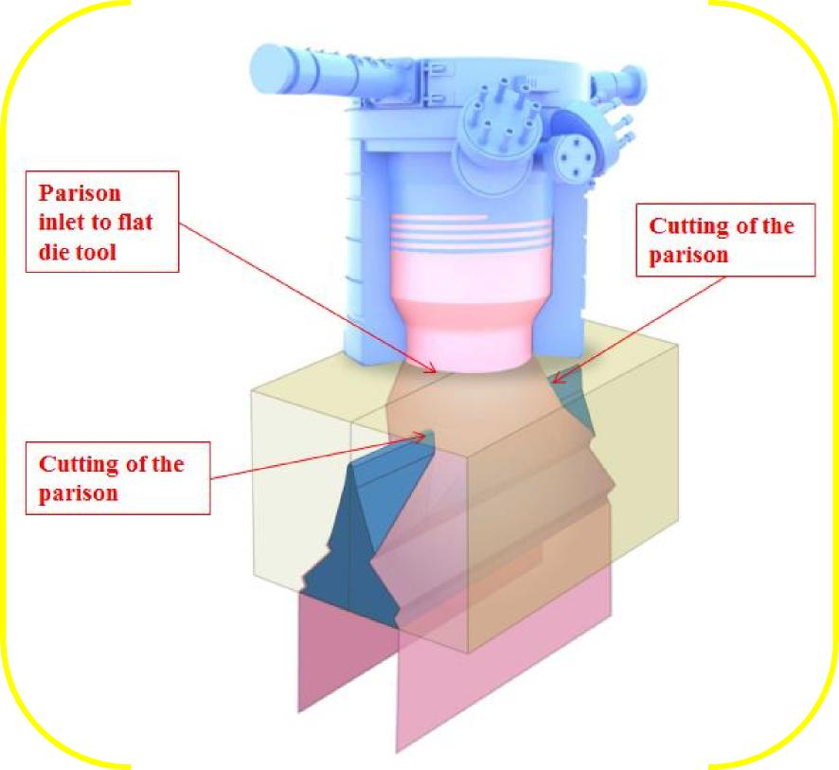

39

(Appx710-711; Appx736-738; Appx748.) The district court recognized that “it is undisputed that ‘[t]he extruded plastic parison is [] cut in a separate “flat die” tool after it leaves Donghee’s coextrusion die.’” (Appx20.) Thus, without the erroneous cutting-location requirement improperly grafted onto the parison terms, the court’s conclusion is flawed because a plastic tube is created by Donghee’s coextrusion die and that tube of plastic is split.

After the extruded parison made by appellees’ coextrusion die is split, the flat die tool performs post-splitting processing steps by opening the split-parison sheets and manipulating their thickness to exert a final profile on the sheets before molding. (Appx740-742.) But these post-splitting steps performed by the flat die tool do not erase the fact that an extruded parison is created and split up-stream of this part of the flat die tool. *See, e.g., Smith & Nephew, Inc. v. Ethicon, Inc.,* 276 F.3d 1304, 1311 (Fed. Cir. 2001) (stating that “[i]nfringement arises when all of the steps of a claimed method are performed, whether or not the infringer also performs additional steps.”); *Vivid Techs., Inc. v. Am. Sci. & Eng’g, Inc.,* 200 F.3d 795, 811 (Fed. Cir. 1999) (same).

These post-splitting processing steps are not only irrelevant to infringement, but the ’812 and ’921 patents also contemplate post-processing steps. For example, Figure 1 of both patents depicts the use of wheels, rollers, and ramps to open and manipulate the split-parison sheets. (’812 Patent (Appx79), 5:32-33; ’921 Patent

40

(Appx73), 5:28-30.) Appellees’ post-processing steps cannot insulate them from infringement.

**D. Summary Judgment of No Infringement Under the Doctrine of**

**Equivalents Was Erroneous**

The district court’s grant of summary judgment of no infringement under the doctrine of equivalents was also erroneous. Specifically, the court concluded that there could be no infringement under the doctrine of equivalents because a “reasonable jury could not find cutting the parison while it is extruding within extrusion equipment is insubstantially different than cutting the extruded parison outside the extrusion equipment.” (Appx21.)

First, the court’s rationale improperly reads into the parison claims the non­existent cutting-location requirement. Thus, for all of the same reasons discussed above, the court’s doctrine of equivalents conclusion must be reversed.

Second, even assuming for the sake of argument that an extruded parison in the context of the patents must be split outside of the extrusion equipment, there remains an underlying issue of fact. That is, whether splitting a tube of plastic within the extrusion equipment, but below the exit of the circular coextrusion die, is nonetheless an equivalent (and, thus, infringing) process.

Indeed, whether an extruded parison is split inside machinery or outside in the atmosphere, all of the steps are the same. As explained by Plastic Omnium’s expert, “to create two separate sheets from a conventional coextrusion die [which

41

is used in Plastic Omnium’s patents and appellees’ accused process], a parison of closed, circular cross section must first be formed so that when it is cut at two locations 180 degrees opposite from one another, two separate sheets of generally uniform thickness are formed.” (Appx243, ¶37, Figure 6.)

Thus, whether splitting of the parison occurs in the atmosphere or inside the extrusion equipment, the plastic must first be shaped into a hollow tube and then split so that sheets can be formed, which is exactly what occurs in appellees’ accused process and machinery. (Appx265-266, ¶¶64-65.) Similarly, the purpose behind Plastic Omnium’s technology and patents — to create two sheets from a single, consistent form of plastic and to avoid the use of multiple extruders — is achieved irrespective of whether the extruded parison is split inside or outside the extrusion equipment. (Appx243, ¶37; Appx265-266, ¶¶64-65.)

At a minimum, there is a genuine issue of material fact on the issue of infringement under the doctrine of equivalents that, even under the district court’s misplaced claim construction, should have been presented to the jury.

II. Summary Judgment of Non-Infringement Due to “Preassembled

Structure” Was Based on an Erroneous Claim Construction

The proper construction of the ’253 patent’s “preassembled structure” term is “a support structure that exists prior to assembly of an accessory to the fuel tank’s wall.” That preassembled structure, as claimed and as described in the ’253

patent’s specification, acts as an interface to attach to the tank wall on one side and

42

hold an accessory on the other side. The district court’s construction of the preassembled structure as “a set of multiple parts previously joined into a single arrangement that is capable of attachment to at least one accessory” (Appx952) is inconsistent with the ’253 patent’s claims and its specification, and must be reversed.

**A. A Preassembled Structure Is a Structure that Is Made Prior to the**

**Fuel Tank and Is Not Necessarily Made from Multiple Parts**

The claim language itself contradicts the district court’s conclusion that the claimed preassembled structure must be formed from a set of multiple parts. Asserted claims 11 and 14 of the ’253 depend from independent claim 1 and recite, in pertinent part, a process for manufacturing a hollow-body fuel tank wherein at least one accessory or duct is incorporated into the hollow body and the:

at least one of said accessory or said duct is supported by a *preassembled structure which comprises at least one device* configured to anchor said preassembled structure to an internal wall of the hollow body.

(’253 Patent (Appx86), emphasis added.)

Because “at least one device” means one device or more, *see, e.g., Rhine v. Casio, Inc.*, 183 F.3d 1342, 1345-46 (Fed. Cir. 1999) (construing “at least one light source” to mean “that there could be only one or more than one” light source), and that language modifies the claimed “preassembled structure,” the preassembled

structure must be interpreted to encompass a single-component device. It cannot be

43

limited to a two-or-more-component device. *See, e.g., Digital-Vending Servs. Int’l, LLC v. Univ. of Phoenix, Inc.,* 672 F.3d 1270, 1275 (Fed. Cir. 2012) (“In *Phillips*, this court reinforced the importance of construing claim terms in light of the surrounding claim language, such that words in a claim are not rendered superfluous.” (citing *Phillips v. AWH Corp.*, 415 F.3d 1303, 1314 (Fed. Cir. 2005)); *see also DSW, Inc. v. Shoe Pavilion, Inc.*, 537 F.3d 1342, 1347 (Fed. Cir. 2008) (finding that “absent contravening evidence from the specification or prosecution history, plain and unambiguous claim language controls the construction analysis,” as opposed to any extraneous limitations appearing in the specification.).

Second, the specification also contradicts the district court’s two-piece claim construction. The ’253 patent’s specification explains that the claimed “preassembled structure” is a support structure for the accessories (e.g., “liquid pumps, pipettes, reservoirs or baffles internal to the hollow body, and ventilation devices”) that are introduced and fastened to the interior wall of the fuel tank. (’253 Patent (Appx85), 4:5-11.) As a result, the “preassembled structure” includes a feature or portion designed to anchor the preassembled structure to the fuel tank’s interior wall. (*Id.* at 4:12-49.)

Structurally, however, the specification does not dictate a multi-piece component. It only requires that the preassembled structure be produced in a

44

separate process from the blow-molded fuel tank — that is, it is inserted into the fuel tank during the tank’s manufacture, rather than being made from the molten plastic tank wall.

Specifically, the ’253 patent explains that utilization of a preassembled structure “has the advantage of being able to *produce the preassembled structure ... in a separate process prior to their introduction into the hollow body*. As a result, the subsequent mounting, by insertion, into the hollow body is greatly facilitated and this allows the production of preassembled structures of relatively complex accessories to be more easily subcontracted.” (’253 Patent (Appx85), 4:14-22 (emphasis added).)

First, the specification explains that the preassembled structure includes a device or feature for anchoring itself to the fuel tank’s wall:

It is also possible . . . to insert, between the sheets [*i.e.*, the shells of

the tank created by splitting a parison], a preassembled structure

which comprises at least one device for anchoring [itself] to the

internal wall of the hollow body. Such a device is, for example, an

arm provided with a tab for fastening to the wall of the hollow body.

(’253 Patent (Appx85), 4:23-28.) Next, the description reveals that the

preassembled structure can also include a device or feature for anchoring an accessory to the preassembled structure when that accessory is not made by the manufacturer of the preassembled structure:

45

The preassembled structure may also be designed so that it also supports an anchoring device which will be used later for fastening an accessory. One example is the fastening of an accessory which comes from a manufacturer different from that of the preassembled structure....

(’253 Patent (Appx85), 4:33-39.)

Thus, the ’253 patent explains that the claimed preassembled structure is a support structure that exists prior to assembly of an accessory to the fuel tank’s wall, which facilities and simplifies the process of attaching accessories to the tank’s wall during manufacture. Nothing in the ’253 patent’s specification demands that the claimed preassembled structure must be a multi-piece component as found by the district court, nor is there any discussion of the preassembled structure being a multi-piece component or of advantages to the preassembled structure being a multi-piece component.

The specification confirms that the preassembled structure may perform multiple functions — *i.e.,* fastening to the tank wall and supporting an anchoring device that can interface with a separate accessory — but, nowhere does the ’253 patent explain or even suggest that these functions require a multi-part preassembled structure.

46

**B. There Is No Requirement that a Preassembled Structure Be Formed Prior to Its Attachment to an Accessory or Duct**

Separately, there is no support in the claims or the specification for the temporal limitations that the court read into the ’253 patent’s “preassembled structure” limitation. As the court explained in its summary judgment order, its “construction of ‘preassembled structure’ requires that the parts of the preassembled structure are ‘***previously*** joined into a single arrangement’ such that they are ‘***initially*** distinct’ from the accessory and that the single arrangement is only ***then*** ‘capable of attachment to at least one accessory.’” (Appx24 (emphasis in original).)

Just as “heavy reliance on the dictionary divorced from the intrinsic evidence risks transforming the meaning of the claim term to the artisan into the meaning of the term in the abstract, out of its particular context, which is the specification,” *Phillips v. AWH Corp.*, 415 F.3d 1303, 1321 (Fed. Cir. 2005) (*en banc*), the district court here focused myopically on the word “assembly” as demanding, in the abstract, multiple parts previously joined together. This is not how the ’253 patent uses the term.

Rather, as explained above, claim 1’s preassembled structure is nothing more than a support structure that exists prior to assembly of an accessory to the fuel tank’s wall. And, even assuming that the claimed preassembled structure must be a multi-part device, there is nothing in the ’253 patent’s specification that

47

demands the parts to be fully assembled into a single arrangement prior to attachment to at least one accessory.

Accordingly, this Court should reverse the district court’s construction of “preassembled structure” and instead find that the proper construction of this term is “a support structure that exists prior to assembly of an accessory to the fuel tank’s wall.” And even if this Court were to find that the claimed “preassembled structure” requires a two-piece construction, Donghee still infringes the ’253 patent because their internally-mounted ROV and FLVV accessories include a black mounting bracket as well as a white adapter which, in combination, would constitute the claimed preassembled structure. (Appx390-391, ¶¶45-47, Figure 76.)

CONCLUSION

Plastic Omnium’s parison patents require a parison to be made, and, at some

point thereafter, split. There is nothing in the patents’ claims or written description that would otherwise exclude splitting the parison “inside any of the extrusion head/die equipment.” (Appx20.) The district court’s erroneous conclusion to the contrary must be reversed.

Similarly, there is nothing in the ’253 patent that would limit the claimed preassembled structure to “a set of multiple parts previously joined into a single arrangement that is capable of attachment to at least one accessory,” as concluded by the district court. (Appx952.) Rather, the ’253 patent only requires the

48

preassembled structure to be produced in a separate process from the blow-molded fuel tank. (’253 Patent (Appx85), 4:14-22.) Moreover, the patent contains claim language and a written description that expressly addresses and encompasses a single-piece preassembled structure. (*Id.* at 4:23-32, claim 1.) Accordingly, the district court’s conclusion that there is no infringement as a matter of law of the preassembled structure term, and its underlying claim construction, must be reversed.

August 31, 2018 Respectfully submitted,

/s/ Robert C. Mattson

Robert C. Mattson

*Principal Attorney*

Alexander J. Hadjis

Christopher Ricciuti

Sasha S. Rao

703-413-300

Oblon, McClelland, Maier & Neustadt, LLP

1940 Duke Street Alexandria, VA 22314

(703) 413-3000

*Attorneys for Appellant, Plastic Omnium Advanced Innovation and Research*

49

ADDENDUM

**TABLE OF CONTENTS**

|  |  |
| --- | --- |
| **Description** | **Appx. #** |
| Final Judgment in Case No. 1:16-cv-00187-LPS (D.I. 1-3 | 1-3 |
| Order on Summary Judgment (D.I. 311) | 4-5 |
| Memorandum Opinion on Summary Judgment (D.I. 310) | 6-31 |
| U.S. Patent No. 6,814,921 | 68-73 |
| U.S. Patent No. 6,866,812 | 74-80 |
| U.S. Patent No. 7,166,253 | 81-86 |
| U.S. Patent No. 9,399,327 | 98-109 |
| Memorandum Opinion on Claim Construction (D.I. 199) | 941-958 |

Case 1:16-cv-00187-LPS Document 333 Filed 06/11/18 Page 1 of 3 PageID #: 11617

IN THE UNITED STATES DISTRICT COURT
  
FOR THE DISTRICT OF DELAWARE

|  |  |
| --- | --- |
| Plastic Omnium Advanced  Innovation and Research,  Plaintiff,  v.  Donghee America, Inc. and  Donghee Alabama. LLC,  Defendants. | Civil Action No. 16-0187-LPS |

11313410D-1 FINAL JUDGMENT

WHEREAS Plaintiff Plastic Omnium Advanced Innovation and Research ("Plastic Omnium") originally asserted eight patents in the amended complaint in this action: U.S. Patent Nos. 6,814,921 ("the '921 patent"); 6,866,812 ("the '812 patent"); 7,166,253 ("the '253 patent"); 8,122,604 ("the '604 patent"); 8,163,228 (-the '228 patent"); 9,079,490 ("the '490 patent"); 9,399,326 ("the '326 patent"); and 9,399,327 ("the '327 patent");

WHEREAS the '604 patent was dismissed with prejudice by stipulation (D.I. 195), approved by the Court on October 25, 2017;

WHEREAS the '228 patent was dismissed with prejudice by stipulation (D.I. 297), approved by the Court on April 18, 2018;

WHEREAS, on May 22, 2018, the Court issued an Order (D.I. 311): (1) granting Defendants Donghee America, Inc.'s and Donghee Alabama, LLC's (collectively, "Donghee") motion for summary judgment of non-infringement (D.I. 223) as to the '921, '812, '327, '253, and '490 patents; (2) denying Donghee's motion for summary judgment of non-infringement as

**Appx1**

Case 1:16-cv-00187-LPS Document 333 Filed 06/11/18 Page 2 of 3 PageID #: 11618

to the '326; (3) denying Donghee's motion for summary judgment of non-infringement as to the '228 patent as moot; (4) granting Donghee's motion for summary judgment of no willful infringement as to '921, '812, '327, '253. '490, and '326 patents; and (5) denying Donghee's motion for summary judgment of no willful infringement as to '228 patent as moot;

WHEREAS the '326 patent was dismissed without prejudice by stipulation on June 1, 2018 (D.I. 328);

WHEREAS there are no additional motions pending before the Court in the captioned case; and

WHEREAS the Court has not adjudicated any other issue that was raised in Donghee's answers (D.I. 10, 18, 24), including without limitation the issues of invalidity;

**IT IS HEREBY ORDERED AND ADJUDGED:**

1. All of the parties' remaining defenses are dismissed without prejudice as moot. For the avoidance of doubt, this dismissal is without prejudice to the parties' ability to reinstate their defenses in the event of a reversal or a remand.
2. Any motion or other request for other attorney's fees, costs, or expenses shall be filed no later than 14 days after the Federal Circuit issues its mandate from an appeal of this judgment, or if no appeal is taken, no later than 14 days after the time for filing a notice of appeal expires.

This is a final judgment and may be appealed if a notice of appeal is filed within 30 days of the date on which this judgment was ordered.

**Appx2**

Case 1:16-cv-00187-LPS Document 333 Filed 06/11/18 Page 3 of 3 PageID #: 11619

|  |  |  |  |
| --- | --- | --- | --- |
| 1 *J*  11--t-^ --,--  SO ORDERED this ( " day of  L4--1 c2018 |  |  |  |
|  |  |  |
|  |  |  |
|  |  |  |
|  | The Honorable Leonard P. Stark Chief United States District Judge | | |

3

Appx3

Case 1:16-cv-00187-LPS Document 311 Filed 05/22/18 Page 1 of 2 PageID #: 9632

**IN THE UNITED STATES DISTRICT COURT
  
FOR THE DISTRICT OF DELAWARE**

PLASTIC OMNIUM ADVANCED
  
INNOVATION AND RESEARCH,

Plaintiff.

v. C.A. No. 16-187-LPS

DONGHEE AMERICA, INC. and
  
DONGHEE ALABAMA. LLC,

Defendants.

**ORDER**

At Wilmington, this **22nd** day of **May, 2018:**

For the reasons set forth in the Memorandum Opinion issued this date, **IT IS HEREBY**

**ORDERED** that:

1. Donghee's *Daubers* motion to exclude the testimony of David A. Haas (D.I. 219) is GRANTED IN PART and DENIED IN PART.
2. Donghee's motion for summary judgment of non-infringement (DJ. 223) is GRANTED as to the '921, '812. '327, '253, and '490 patents and DENIED as to the'326 patent. It is further DENIED as to the asserted claims of the '228 patent based on the parties' stipulated dismissal of that patent.
3. Donghee's motion for summary judgment of no willful infringement is GRANTED as to the '921, '812, '327, '253, '490, and '326 patents and DENIED as to the '228 patent based on the parties' stipulated dismissal of that patent.
4. The parties shall meet and confer and, no later than **May 24,** submit a joint status report, indicating (in addition to anything else they wish the Court to know): (i) whether they still

**Appx4**

Case 1:16-cv-00187-LPS Document 311 Filed 05/22/18 Page 2 of 2 PageID #: 9633

request that the Court resolve one or more additional claim construction disputes that have recently been briefed *(see* D.I. 294, 300, 301, 305, 306); and (ii) how today's decision impacts matters presented in the proposed pretrial order filed yesterday.

'4) UNI4 ED STATES DISTRICT JUDGE



**Appx5**

Case 1:16-cv-00187-LPS Document 310 Filed 05/22/18 Page 1 of 26 PageID #: 9606

IN THE **UNITED STATES DISTRICT COURT
  
FOR THE DISTRICT OF DELAWARE**

PLASTIC OMNIUM ADVANCED
  
INNOVATION AND RESEARCH,

Plaintiff,

v. C.A. No. 16-187-LPS

DONGHEE AMERICA, INC. and
  
DONGHEE ALABAMA, LLC,

Defendants.

Chad S.C. Stover and Regina S.E. Murphy, BARNES & THORNBURG LLP, Wilmington, DE

Robert C. Mattson, Eric W. Schweibenz, Frank J. West, Vincent K. Shier, Christopher Ricciuti, Sasha S. Rao, and Michael D. West, OBLON, MCCLELLAND, MAIER & NEUSTADT, L.L.P.. Alexandria, VA

Attorneys for Plaintiff.

Philip A. Rovner and Jonathan A. Choa, POTTER ANDERSON & CORROON LLP, Wilmington, DE

Alyssa Caridis and Andrew J. Kim, ORRICK, HERRINGTON & SUTCLIFFE LLP, Los Angeles, CA

Vickie Feeman, ORRICK, HERRINGTON & SUTCLIFFE LLP, Menlo Park, CA Nicholas H. Lam, ORRICK, HERRINGTON & SUTCLIFFE LLP, New York, NY Attorneys for Defendants.

**MEMORANDUM OPINION**

May 22, 2018

Wilmington, Delaware

**Appx6**

**Case 1:16-cv-00187-LPS Document 310 Filed 05/22/18 Page 2 of 26 PageID #: 9607**



**STARK, U.S. District Judge:**

Pending before the Court in this patent infringement action are Defendants Donghee America, Inc. and Donghee Alabama, LLC's ("Donghee" or "Defendants") *Daubert* Motion to Exclude the Testimony of David A. Haas (D.I. 219) and Donghee's Motion for Summary Judgment (D.I. 223).

1. **BACKGROUND**

Plaintiff Plastic Omnium Advanced Innovation and Research ("Plastic" or "Plaintiff') filed suit against Donghee on March 23, 2016, alleging infringement of seven U.S. patents. *(See* D.I. 1) On August 24, 2016, Plastic amended its complaint to assert infringement of eight U.S. patents: U.S. Patent Nos. 6.814,921 (the "'921 patent"), 6,866,812 (the "'812 patent"), 7,166,253 (the '253 patent"), 8,122,604 (the "'604 patent"). 8,163,228 (the ".228 patent"), 9,079,490 (the "'490 patent"), 9,399,326 (the "'326 patent"), and 9,399,327 (the ".327 patent-). *(See* D.I. 14) On October 23, 2017, the parties stipulated to dismissal of the '604 patent. *(See* D.I. 195) The parties filed the pending motions on February 2, 2018. A hearing on the motions was held on April I 2018. *(See* D.I. 298 ("Tr.")) At the April 3 hearing, the parties informed the Court that Plastic has withdrawn its infringement allegations for the '228 patent. *(See* Tr. at 4-5, 70) The parties stipulated to dismissal of the '228 patent on April 17, 2017. *(See* D.I. 297) Therefore, the Court will not consider motions directed to that patent, as they are moot.

1. **LEGAL STANDARDS**

**A. *Daubert* Motion**

In *Daubert v. Merrell Dow Pharm., Inc.,* 509 U.S. 579, 597 (1993), the Supreme Court

explained that Federal Rule of Evidence 702 creates -a gatekeeping role for the [trial] judge" in

1

**Appx7**

Case 1:16-cv-00187-LPS Document 310 Filed 05/22/18 Page 3 of 26 PageID #: 9608

order to "ensur[e] that an expert's testimony both rests on a reliable foundation and is relevant to the task at hand." The rule requires that expert testimony "help the trier of fact to understand the evidence or to determine a fact in issue." Fed. R. Evid. 702(a). Expert testimony is admissible only if "the testimony is based on sufficient facts or data.- "the testimony is the product of reliable principles and methods." and "the expert has reliably applied the principles and methods to the facts of the case." Fed. R. Evid. 702(b)-(d).

There are three distinct requirements for admissible expert testimony: (1) the expert must be qualified; (2) the opinion must be reliable; and (3) the expert's opinion must relate to the facts. *See generally Elcock v. Kmart Corp.,* 233 F.3d 734, 741-46 (3d Cir. 2000). Rule 702 embodies a "liberal policy of admissibility." *Pineda v. Ford Motor Co.,* 520 F.3d 237, 243 (3d Cir. 2008). Motions to exclude evidence are committed to the Court's discretion. *See In re Paoli R.R. Yard PCB Litig.,* 35 F.3d 717, 749 (3d Cir. 1994).

**B. Summary Judgment Motion**

Under Rule 56(a) of the Federal Rules of Civil Procedure, "[t]he court shall grant summary judgment if the movant shows that there is no genuine dispute as to any material fact and the movant is entitled to judgment as a matter of law." The moving party bears the burden of demonstrating the absence of a genuine issue of material fact. *See Matsushita Elec. Indus. Co., Ltd. v. Zenith Radio Corp.,* 475 U.S. 574, 585-86 (1986). An assertion that a fact cannot be — or. alternatively, is — genuinely disputed must be supported either by "citing to particular parts of materials in the record, including depositions, documents, electronically stored information, affidavits or declarations, stipulations (including those made for purposes of the motion only), admissions, interrogatory answers, or other materials,- or by "showing that the materials cited do

**Appx8**

Case 1:16-cv-00187-LPS Document 310 Filed 05/22/18 Page 4 of 26 PageID #: 9609

not establish the absence or presence of a genuine dispute, or that an adverse party cannot produce admissible evidence to support the fact.- Fed. R. Civ. P. 56(c)(1)(A) & (B). If the moving party has carried its burden, the nonmovant must then "come forward with specific facts showing that there is a genuine issue for trial." *Matsushita,* 475 U.S. at 587 (internal quotation marks omitted). The Court will "draw all reasonable inferences in favor of the nonmoving party, and it may not make credibility determinations or weigh the evidence." *Reeves v. Sanderson Plumbing Prods., Inc.,* 530 U.S. 133, 150 (2000).

To defeat a motion for summary judgment, the nonmoving party must "do more than simply show that there is some metaphysical doubt as to the material facts." *Matsushita,* 475 U.S. at 586; *see also Podobnik v. U.S. Postal Sens.,* 409 F.3d 584, 594 (3d Cir. 2005) (stating party opposing summary judgment "must present more than just bare assertions, conclusory allegations or suspicions to show the existence of a genuine issue") (internal quotation marks omitted). The "mere existence of some alleged factual dispute between the parties will not defeat an otherwise properly supported motion for summary judgment;" a factual dispute is genuine only where "the evidence is such that a reasonable jury could return a verdict for the nonmoving party." *Anderson v. Liberty Lobby, Inc.,* 477 U.S. 242, 247-48 (1986). "If the evidence is merely colorable, or is not significantly probative, summary judgment may be granted.- *Id.* at 249-50 (internal citations omitted); *see also Celotex Corp. v. Catrett,* 477 U.S. 317, 322 (1986) (stating entry of summary judgment is mandated "against a party who fails to make a showing sufficient to establish the existence of an element essential to that party's case, and on which that party will bear the burden of proof at trial"). Thus. the "mere existence of a scintilla of evidence" in support of the nonmoving party's position is insufficient to defeat a

3

**Appx9**

Case 1:16-cv-00187-LPS Document 310 Filed 05/22/18 Page 5 of 26 PageID #: 9610

motion for summary judgment; there must be "evidence on which the jury could reasonably

find" for the nonmoving party. *Anderson,* 477 U.S. at 252.

III. DISCUSSION

A. Donghee's *Daubert* Motion

Donghee moves to exclude Plastic's damages expert's opinion in its entirety, based on several grounds. Plastic's damages expert, David Haas. "concluded that the appropriate compensation for [Donghee's] infringement of all of the Patents-in-Suit would be a total reasonable royalty of $9" per fuel tank. (D.I. 221 Ex. A at 6) In reaching this conclusion, Mr. Haas "categorized the asserted patents into three technology groupings" — Core TSBM Technology. Deformable Pipe Technology, and Rivet Snapping Technology — and applied the *15 Georgia-Pacific* factors to determine what reasonable royalty rate the parties would have agreed to at the time of the hypothetical negotiation for each group. *(Id.* at 6, 24) The hypothetical negotiation construct "attempts to ascertain the royalty upon which the parties would have agreed had they successfully negotiated an agreement just before infringement began," by presuming that the parties are both willing to enter into a license with each other and that the patents are valid, enforceable, and infringed. *Lucent Techs., Inc. v. Gateway, Inc.,* 580 F.3d 1301, 1324-25 (Fed. Cir. 2009).

Mr. Haas determined that the hypothetical negotiation would have occurred as early as 2012 or as late as January 2014, and that the reasonable royalty rate and total damages would be the same regardless of which date within this period is selected. (D.I. 221 Ex. A at 24-25) Based on his analysis, Mr. Haas concluded that reasonable royalties would be $5 per unit for the Core TSBM Technology (the '921, '812, and '253 patents), $2 per unit for the Deformable Pipe

4

**Appx10**

Case 1:16-cv-00187-LPS Document 310 Filed 05/22/18 Page 6 of 26 PageID #: 9611

Technology (the '228 patent), and $2 per unit for the Rivet Snapping Technology (the '490, '326, and '327 patents). *(Id.* at 7)

Donghee identifies several issues with Mr. Haas's opinions. The Court will consider each in turn.

**1. Sufficiency of Facts and Data Underlying Opinions**

Donghee first argues that "Mr. Haas' [s] royalty rate opinions are not justified by, nor based on, sufficient facts or data," referring particularly to two pieces of evidence on which Mr. Haas relies. (D.1. 220 at 4)

Donghee asserts that Mr. Haas's $9 total royalty (including the $2 royalty for the Rivet Snapping Technology) is not justified by his reliance on a license for one foreign patent having a royalty rate of $1. *(See id.* at 5) This relates to the *Georgia-Pacific* factor of -[t]he royalties received by the patentee for the licensing of the patent in suit, proving or tending to prove an established royalty." *Georgia-Pacific Corp. v. U.S. Plywood Corp.,* 318 F. Supp. 1116, 1120 (S.D.N.Y. 1970), *modified sub nom. Georgia-Pac. Corp. v. U.S. Plywood-Champion Papers, Inc.,* 446 F.2d 295 (2d Cir. 1971). "Actual licenses to the patented technology are highly probative as to what constitutes a reasonable royalty for those patent rights because such actual licenses most clearly reflect the economic value of the patented technology in the marketplace." *LaserDynamics, Inc. v. Quanta Comput., Inc.,* 694 F.3d 51, 79 (Fed. Cir. 2012).

Since there were no actual licenses to any of the seven asserted patents, Mr. Haas reviewed the next best thing: a license for a European patent that is the foreign equivalent to a U.S. patent from which the asserted '326 and '327 patents are continuations. *(See* D.I. 221 Ex. A at 30) That license, dated July 1, 2013, was executed between Plastic's predecessor, Inergy

5

**Appx11**

Case 1:16-cv-00187-LPS Document 310 Filed 05/22/18 Page 7 of 26 PageID #: 9612

Automotive Systems ("Inergy"), and Kautex Textron GmbH & Co KG ("Kautex"), and licensed a European patent related to rivet snapping for 0.75 euros (then equivalent to $0.98) per product manufactured, sold, or delivered. *(See id.* at 30-31) Recognizing that the license has some limited comparability, as it is for one non-asserted patent, Mr. Haas opined that "a reasonable royalty rate for the asserted Rivet Snapping Technology patents would need to be higher than the approximately $1 per unit royalty" agreed to in the Kautex license. because (1) that license granted rights to one patent not in suit but related to Rivet Snapping Technology, (2) that license benefitted Plastic by validating the technology, and (3) Plastic invested deeply in the technology whereas Donghee did "not have similar R&D costs." *(Id.* at 32-33, 35, 45)

The Court finds Mr. Haas's opinions with respect to the Kautex license, together with the rest of his analysis under the *Georgia-Pacific* factors. are sufficiently related to the facts of the case. Donghee's reliance on *ePlus, Inc. v. Lawson Software, Inc..* 764 F. Supp. 2d 807 (E.D. Va. 2011), for its argument that Mr. Haas arbitrarily "doubles" the $1 Kautex license royalty rate "with absolutely no explanation," is unpersuasive. (D.I. 220 at 5-6) In *ePlus,* the expert first determined a baseline royalty rate under factor 1 based on an improper review of minimally probative settlement licenses that involved improperly converting lump sum royalties into per unit royalties and using an inappropriate royalty base, and then arbitrarily doubling that baseline royalty rate. *See ePlus,* 764 F. Supp. 2d at 814-15. Here, Mr. Haas appropriately considered the totality of the evidence in connection with all 15 *Georgia-Pacific* factors in determining a $2 rate for the Rivet Snapping Technology.

Second, Donghee argues it is inappropriate for Mr. Haas to rely on Inergy's "unaccepted proposal" to Kautex "for a worldwide cross license of dozens of patents,- particularly as there is

6

**Appx12**

Case 1:16-cv-00187-LPS Document 310 Filed 05/22/18 Page 8 of 26 PageID #: 9613

no evidence that this proposal was ever communicated to Kautex. (D.I. 220 at 6) As part of his factor 1 analysis, Mr. Haas considered an April 30, 2009 Inergy slide deck regarding the status of discussions between Inergy and Kautex with respect to their patent portfolios. *(See* D.I. 221 Ex. A at 33-36) (citing Ex. D) The deck demonstrates that Plastic "contemplated a balancing royalty rate of 2.5% of revenue" for its TSBM patent portfolio "in addition to a royalty-free license to Kautex's NGFS patents," because Plastic believed its TSBM portfolio was stronger than Kautex's NGFS portfolio. *(Id.* at 33-34) Mr. Haas discussed several additional

distinguishing characteristics between the contemplated cross-license and the hypothetical license, including that the cross-license was never executed, the negotiation was for a worldwide license, design-around costs, and the possible collaboration between the parties. *(See id.* at 34­35) Thus, Mr. Haas concluded that a hypothetical license to the TSBM technology would have a royalty rate higher than 2.5%. *(See id.* at 36) Donghee argues that Mr. Haas's opinions regarding this contemplated royalty offer should be excluded. because offers — particularly if never conveyed — have little value. *(See* D.I. 220 at 7-9) Further, the contemplated offering was a cross-license for worldwide rights to a large number of technologies and patents, and the source of the information is biased. *(See id.)*

The Court is not persuaded by Donghee's position. Donghee's reliance on *MiiCs* & *Partners, Inc. v. Funai Elec. Co., Ltd.,* 2017 WL 6268072, at *4 (D. Del. Dec. 7, 2017), is misplaced because in that case there was evidence a rejected offer may have been artificially inflated. particularly because it was made in anticipation of litigation. *See also Whitserve, LLC v. Comput. Packages, Inc.,* 694 F.3d 10, 29-30 (Fed. Cir. 2012) (noting "proposed licenses may have some value for determining a reasonable royalty in certain situations," but "[t]heir

7

**Appx13**

Case 1:16-cv-00187-LPS Document 310 Filed 05/22/18 Page 9 of 26 PageID #: 9614

evidentiary value is limited" because "patentees could artificially inflate the royalty rate by making outrageous offers"). In 2009, at the time of this offer, Inergy and Kautex were discussing a cooperation agreement, a situation quite distinct from anticipation of litigation. Donghee's criticisms can be adequately addressed through cross-examination and the presentation of competing evidence. *See i41 Ltd. P 'ship v. Microsoft Corp.,* 598 F.3d 831, 852 (Fed. Cir. 2010) ("When the methodology is sound, and the evidence relied upon sufficiently related to the case at hand, disputes about the degree of relevance or accuracy (above this minimum threshold) may go to the testimony's weight, but not its admissibility."). "These disagreements go to the weight to be afforded the testimony and not its admissibility." *Active Video Networks, Inc. v. Verizon Commchs, Inc.,* 694 F.3d 1312, 1333 (Fed. Cir. 2012).

2. Relevance of Expected Damages from Litigation

Donghee further argues that Mr. Haas's opinion — that doubling the 2.5%

unconsummated royalty rate to 5% is supported by the 2009 Inergy slide deck, which states that

damages from litigation would be twice a negotiated royalty rate?" (D.I. 221 Ex. D at P0_00185935; D.I. 242 Ex. B at 210) — should be excluded because "the premise of the hypothetical negotiation is to determine what the parties would have agreed to *outside the threat of litigation.-* (D.I. 220 at 9-10) (emphasis in original) The Court agrees with Donghee.

Since Mr. Haas purports to use the hypothetical negotiation framework, which presumes that the asserted patents are valid and infringed and that the licensor and licensee are willing to enter into a license agreement, it is improper for Mr. Haas to inflate (let alone double) a royalty rate on the basis that damages may be larger in litigation. *See* [*ResQNet.com*](http://ResQNet.com)*, Inc. v. Lansa, Inc.,* 594 F.3d 860, 872 (Fed. Cir. 2010) (acknowledging that "hypothetical reasonable royalty

8

**Appx14**

Case 1:16-cv-00187-LPS Document 310 Filed 05/22/18 Page 10 of 26 PageID #: 9615

calculation occurs before litigation and that litigation itself can skew the results of the hypothetical negotiation").

Mr. Haas's testimony, and any exhibits (including the slide deck), will need to be modified or redacted consistent with the Court's holding.

**3. Reliability of Opinions**

Donghee further attacks Mr. Haas's opinions as insufficiently tied to the facts of the case, as his $9 rate is "seemingly pick[ed] . . . out of thin air." (D.I. 220 at 12) In Donghee's view, Mr. Haas fails to offer "any basic explanation of which numbers he multiplied or adjusted, and in which direction, to arrive at a $9 per unit royalty." *(Id.)* The Court disagrees.

"When performing a *Georgia-Pacific* analysis, damages experts must not only analyze the applicable factors, but also carefully tie those factors to the proposed royalty rate." *Exmark Mfg. Co. Inc. v. Briggs & Stratton Power Prods. Grp., LLC,* 879 F.3d 1332, 1350 (Fed. Cir. 2018). In *Exmark,* the Federal Circuit determined that a damages expert's opinions should have been excluded, as the expert had explained only the benefits of the patented technology and that the negotiations would have recognized the importance of those advantages, but failed to explain how those advantages — or any of the *Georgia-Pacific* factors — led to her 5% royalty rate. *See id.* What was missing was any "explanation of both why and generally to what extent the particular factors impact the royalty calculation needed." *Id.* (internal quotation marks and alterations omitted).

Even so, *Exmark* also stated that "mathematical precision is not required." *Id.* As Plastic argues, "many of the *Georgia-Pacific* factors are qualitative, not quantitative," and therefore experts may supplement quantitative evidence with the expert's own experience and judgment.

9

**Appx15**

Case 1:16-cv-00187-LPS Document 310 Filed 05/22/18 Page 11 of 26 PageID #: 9616

(Tr. at 61-62) Mr. Haas identified royalty rates and license offers in comparable licenses in evidence, extensively analyzed each of the *Georgia-Pacific* factors and explained when a factor might contribute to a higher royalty rate, and described which factors carried the "greatest weight" in the hypothetical negotiation, all before determining three reasonable royalty rates for three different technology groupings. *(See, e.g.,* D.I. 221 Ex. A at 35, 36, 40, 45, 69) This was an acceptable methodology. Donghee"s criticisms may be the subject of proper cross-

examination and/or presentation of competing evidence.

4. Mr. Haas's Apportionment Analysis

Donghee argues Mr. Haas failed to apportion either the royalty base or the royalty rate to account for the fact that the accused fuel tanks consist of patented and unpatented features. *(See* D.I. 220 at 13-14) "[W]here multi-component products are involved, the governing rule is that the ultimate combination of royalty base and royalty rate must reflect the value attributable to the infringing features of the product, and no more.- *Ericsson, Inc. v. D-Link Sys., Inc.,* 773 F.3d 1201, 1226 (Fed. Cir. 2014). Apportionment may be done through the royalty base, the royalty rate, or both. *See Exmark,* 879 F.3d at 1348. When apportioning the royalty rate, "one possible way to do this is through a proper analysis of the *Georgia-Pacific* factors." *Id.* at 1348-49. "The essential requirement is that the ultimate reasonable royalty award must be based on the incremental value that the patented invention adds to the end product." *Ericsson,* 773 F.3d at 1226.

As discussed, Mr. Haas determined reasonable royalty rates for the three technology groupings after extensive consideration of the *Georgia-Pacific* factors. He opined that a per unit running royalty was more appropriate than a lump sum royalty or percentage royalty because it

10

**Appx16**

**Case 1:16-cv-00187-LPS Document 310 Filed 05/22/18 Page 12 of 26 PageID #: 9617**

"is consistent with the one executed patent license" he reviewed and "is not dependent on the price that Donghee ultimately charges customers." (D.I. 221 Ex. A at 26-27) Moreover, he apportioned the per unit royalty rates to account for the fact that "each fuel tank program[']s specification and componentry is different. and each program has a different selling price per fuel tank." *(Id.* at 27) Thus, a per unit royalty "allows Donghee to discount, add, or eliminate attachments and other accessories to a fuel tank as needed, without having to pay a higher or lower royalty to Plastic." *(Id.)* In other words, a per unit royalty is intended to account for the patented features of the fuel tank (and not unpatented accessories and attachments).

Mr. Haas also determined that the appropriate royalty base consisted of the total number of fuel tanks sold during the damages period, because this "represent[s] the apportioned base of fuel tank units manufactured using the TSBM Core Technology patents plus internally mounted components attached through use of either the Deformable Pipe Technology patent or the Rivet Snapping Technology patents." *(Id.)* This royalty base "is also consistent with the only executed license of [Plastic's] TSBM patented technology." *(Id.)* Mr. Haas further apportioned by accounting for a single infringement of each patent per tank. *(See* D.I. 242 Ex. B at 15-16, 18-19)

Again, Donghee's concerns are adequately addressed through proper cross-examination and presentation of competing evidence.

**5. Mr. Haas's Opinions Disclosed At Deposition**

Donghee further argues that Mr. Haas disclosed opinions during his deposition that were not provided in his expert reports and these new opinions should be excluded at trial. *(See* D.I. 220 at 15) Near the end of Mr. Haas's deposition, counsel for Plastic asked Mr. Haas to walk

11

**Appx17**

Case 1:16-cv-00187-LPS Document 310 Filed 05/22/18 Page 13 of 26 PageID #: 9618

through the analysis and conclusions contained in his report. *(See* D.I. 242 Ex. B at 185-86) Mr. Haas proceeded to do so, in testimony that fills seven transcript pages. *(See id.* at 186-93) Donghee asserts that Mr. Haas provided the following three new analyses in support of his $9 royalty rate: (1) the revenue associated with Mr. Haas's royalty base is $100 per unit, (2) the royalty rate should be 9%, which is derived by doubling the 2.5% rate from the unconsummated license offer and adding it to the 4% royalty rate from a Donghee-Kautex license, and (3) the royalty rate should have a $13 per unit royalty ceiling, which represents Plastic's per unit profit premium on an operating profit level. *(See* D.I. 220 at 15)

Mr. Haas, in supporting his $9 per unit royalty opinion, testified that the appropriate royalty on a $100 LFa fuel tank would be $9, below the $13 ceiling. *(See* D.I. 242 Ex. B at 191)1 The 9% royalty rate is derived by doubling the 2.5% balancing rate provided in the 2009 Inergy slide deck and adding 4%, which is the rate in a license Donghee took from Kautex to use Kautex's NGFS technology (which is similar to the TSBM technology). *(See id.* at 188-89; D.I.

221 Ex. A at 10, 38-40)

The $100 royalty base had not been disclosed in Mr. Haas's reports. But Mr. Haas explained his $100 figure was based on an approximation of Ms. Holt's opinion in her rebuttal report, which provided that the royalty base was $96.07. *(See* D.I. 242 Ex. B at 199, 219; D.I.

222 Ex. D at 33) The doubling calculation, 4% royalty rate, and $13 profit figure were disclosed in Mr. Haas's opening report. *(See* D.I. 221 Ex. A at 38, 66-67; *id.* Ex. D at P0_00185935) At the deposition, Mr. Haas was permissibly expounding on figures and information he had already

'Further. Plastic is withdrawing its allegations of infringement of the '228 patent, thereby reducing the requested total royalty rate by $2 to $7. *(See* Tr. at 70)

12

**Appx18**

Case 1:16-cv-00187-LPS Document 310 Filed 05/22/18 Page 14 of 26 PageID #: 9619

relied on and provided in his reports, and reacting to material contained in Ms. Holt's reports. Therefore, Mr. Haas's deposition disclosures were not untimely.

Thus, for the reasons stated above, Donghee's *Daubert* motion will be granted in part and denied in part.

**B. Donghee's Motion for Summary Judgment**

Donghee moves for summary judgment of non-infringement of all of the asserted claims

of the patents-in-suit.'

**1. Parison Claims**

Donghee argues that the accused product does not infringe the Parison Claims' because it does not extrude a parison. *(See* D.1. 224 at 5) It is undisputed that Donghee's "manufacturing process begins by forcing plastic through a circular coextrusion head, and then feeding the plastic that exits the coextrusion head into a separate piece of equipment. referred to as a 'flat die' tool," and that once inside "the flat die, the molten plastic is 'cut' into two streams of plastic which are extruded as two sheets." (D.I. 224 at 6; D.I. 236 at 5) The parties' dispute centers on whether (1) the first piece of equipment, the "coextrusion head," is or has a die, and (2) the extruded parison may continue to be located in the second piece of equipment, the "flat die," and still be held to infringe. (D.I. 224 at 6; D.I. 236 at 5-6)

The Court construed "extruded parison of closed cross section" and -extruding a . . .

`The asserted claims are: 2. 3, 4, and 8 of the '921 patent; 39. 41. and 45 of the '812 patent; 11 and 14 of the '253 patent 7. 9, and 13 of the '490 patent; 1. 13, 25, 27, and 33 of the '326 patent; and 1, 7, 9, and 15 of the '327 patent. Plastic previously asserted claims 2, 4, and 8 of the '228 patent but has dismissed those claims. *(See* D.I. 297)

'The Parison Claims include every asserted claim of the '921, '812, and '327 patents, as well as claim 2 of the '228 patent and claim 7 of the '490 patent.

13

**Appx19**

Case 1:16-cv-00187-LPS Document 310 Filed 05/22/18 Page 15 of 26 PageID #: 9620

parison" as "a tubular preform with a closed cross-section that has been forced through a die, and is cut or split as it exits the die or at some time thereafter.' (D.I. 199 at 5) The Court

determined that "the patents specify that the 'parison- is cut in two as it leaves the die at the end of the extrusion head," and so "this `parison' cannot be strictly limited to a fully-formed tubular structure existing in its entirety outside the extrusion head/die.- *(Id.* at 6) The Court further determined that the splitting of the tubular preform does not occur "at any stage earlier than right as the previously tubular structure leaves the die/extrusion head," so the term "should not include molten plastic (or a tubular preform) present inside the die/extrusion head." *(Id.* at 7)

Additionally, the Court determined that the die cannot be located just anywhere, because the "patents specify that the 'die' is located at the 'extrusion head['s]' lowest point.'" *(Id.* at 7 n.4)

Because the splitting does not occur "at any stage earlier than right as the previously tubular structure *leaves the die/extrusion head- (id.)* (emphasis added), the claim construction makes clear that whether the extrusion equipment consists of a single combined extrusion head with a die or a more complex extrusion head with a separate attached die, the splitting of the molten plastic must not occur inside any of the extrusion head/die equipment. Since, for the accused product, it is undisputed that "[t]he extruded plastic parison is [] cut in a separate 'flat

die' tool after it leaves Donghee's coextrusion (D.I. 236 at 6; *see also* Tr. at 8, 13, 17-18), there is no genuine issue of fact that Donghee's accused product does not literally infringe the Parison Claims.

Donghee also moves for summary judgment of no infringement under the doctrine of

'The Court finds, and Plastic does not dispute, that the Court's claim construction also applies to "extruding a single parison- in claim 7 of the '490 patent.

14

**Appx20**

Case 1:16-cv-00187-LPS Document 310 Filed 05/22/18 Page 16 of 26 PageID #: 9621

equivalents. A product or process may infringe under the doctrine of equivalents "if there is `equivalence' between the elements of the accused product or process and the claimed elements of the patented invention." *Warner-Jenkinson Co., Inc. v. Hilton Davis Chem. Co.,* 520 U.S. 17, 21 (1997) (citing *Graver Tank & Mfg. Co. v. Linde Air Prods. Co.,* 339 U.S. 605, 609 (1950)). "A finding of infringement under the doctrine of equivalents requires a showing that the difference between the claimed invention and the accused product or method was insubstantial or that the accused product or method performs the substantially same function in substantially the same way with substantially the same result as each claim limitation of the patented product or method.- *AquaTex Indus., Inc. v. Techniche Sols..* 479 F.3d 1320, 1326 (Fed. Cir. 2007). "An analysis of the role played by each element in the context of the specific patent claim will thus inform the inquiry as to whether a substitute element matches the function, way, and result of the claimed element." *Warner-Jenkinson.* 520 U.S. at 40.

The Court concludes that Donghee's accused product does not infringe under the doctrine of equivalents. Even taking the evidence in the light most favorable to Plastic, and resolving all disputed facts in its favor, a reasonable jury could not find cutting the parison while it is extruding within extrusion equipment is insubstantially different than cutting the extruded parison outside the extrusion equipment. Additionally, Plastic's expert, Dr. Osswald,

acknowledges differences between Donghee's flat die tool and the patented invention. *(See, e.g.,* D.I. 225 Ex. **B** at 18; *id.* Ex. Cat 164)

This portion of the summary judgment motion will be granted.

**2. "Interface" Limitation of '253 Patent**

The asserted claims of the '253 patent depend on independent claim 1, which requires the

15

**Appx21**

Case 1:16-cv-00187-LPS Document 310 Filed 05/22/18 Page 17 of 26 PageID #: 9622

step of "closing said mould in a way which eliminates any interface between said at least one of said accessory or said duct and an external atmosphere outside of the hollow body.- ('253 patent, cl. 1) It is undisputed that "[d]uring the manufacture of Donghee's fuel tank, a bundle of components consisting of two valves and an orange 'piercing nipple' connected to each other by hollow tubing is installed inside the tank.- (D.I. 224 at 9) It is further undisputed that while the two valves are attached without piercing the tank wall, the orange piercing nipple is attached by boring a hole in the tank wall. *(See id.* at 10; D.I. 236 at 3, 15; D.I. 258 at 4; Tr. at 28) Therefore, Plastic does not dispute that "there is an interface between the external atmosphere and the nipple." (D.1. 236 at 15) The dispute here is whether the two valves and the hollow tubing interface with the external atmosphere.

Donghee argues that since there is a direct air path between the valves and the external atmosphere through the hollow tubing, its product does not infringe. *(See* D.I. 224 at 10) Plastic counters that "the claimed 'interface' is referring to the internally-mounted component[']s point of attachment." (D.1. 236 at 14) In other words, "even if something else at another location pierces the tank['s] wall," there can still be infringement if the accessory itself is attached without poking through the tank's wall. *(Id.)*

The Court agrees with Plastic. Since the two valves "never penetrate the tank's wall and are attached at locations separate from the nipple," "there is no interface between the external atmosphere and either valve." even though the nipple does pierce the wall. *(Id.* at 15) The patent claims the attachment of accessories inside the tank without poking holes in the tank's wall. In the accused product, the valves may be found to be separate accessories that are attached without poking holes in the tank's wall. The fact that the valves are connected to

16

**Appx22**

Case 1:16-cv-00187-LPS Document 310 Filed 05/22/18 Page 18 of 26 PageID #: 9623

hollow tubes that are ultimately connected to the external atmosphere does not necessarily mean that each accessory was *attached* by poking a hole in the tank's wall.

The Court disagrees with Donghee's contention that the claim's use of "any" before "interface" precludes a finding of infringement. (D.I. 258 at 5) The claim provides that the "external atmosphere' is "outside of the hollow body.- The phrase "outside of the hollow body" specifies that the interface must be with atmosphere outside of the tank, not inside hollow tubes within the tank. *See Cat Tech LLC v. TubeMaster, Inc.,* 528 F.3d 871, 885 (Fed. Cir. 2008) ("Claims are interpreted with an eye toward giving effect to all terms in the claim."); *Bicon, Inc. v. Straumann Co.,* 441 F.3d 945, 950-51 (Fed. Cir. 2006) (refusing to allow patentee to argue characteristics specifically described in claim were merely "superfluous'').

The Court is not persuaded that summary judgment is appropriate with respect to the "interface" limitation.

3. "Preassembled Structure" Limitation of '253 Patent

The asserted claims of the '253 patent depend on independent claim 1, which requires that "said at least one of said accessory or said duct is supported by a preassembled structure which comprises at least one device configured to anchor said preassembled structure to an internal wall of the hollow body." ('253 patent, cl. 1) The Court construed "preassembled structure" as "a set of multiple parts previously joined into a single arrangement that is capable of attachment to at least one accessory.- (D.I. 199 at 11) In doing so, the Court noted that the "preassembled structure" is "a structural feature comprising at least two parts, which is initially distinct from the accessory or accessories that it 'supports' and can then be joined with the relevant accessor(ies)." *(Id.* at 11)

17

**Appx23**

Case 1:16-cv-00187-LPS Document 310 Filed 05/22/18 Page 19 of 26 PageID #: 9624

The preassembled structure accused of infringing is a black mounting bracket and white adapter, which is coupled to, and supports, a separate valve assembly accessory. *(See* D.I. 224 at 12; D.I. 236 at 16) Donghee argues that the Court's construction requires that the mounting bracket and adapter must be "previously [in time] joined" "before they are attached to the valve assembly accessory." (D.I. 224 at 13: *see also* Tr. at 21) In its opposition brief, Plastic responded that "Donghee is importing an improper temporal limitation into the term

'preassembled structure,'- when the claim language provides -a structural limitation and not a sequential order of method steps." (D.I. 236 at 15-16) However, at the hearing, Plastic conceded that the claims do contain a temporal limitation, contending now that all that is required is that the components of the preassembled structure and the accessory to which it attaches are all preassembled, in whatever order, *before* being attached to the fuel tank wall. *(See* Tr. at 23-26) Plastic argues there is nothing in the patent or the Court's construction that "would require Plastic [] to prove the sequence in which the above structure is manufactured." (D.I. 236 at 16)

The Court disagrees with Plastic. The construction of "preassembled structure- requires that the parts of the preassembled structure are *"previously* joined into a single arrangement" such that they are *"initially* distinct" from the accessory and that the single arrangement is only *then* "capable of attachment to at least one accessory.- (D.I. 199 at II) (emphasis added) The Court's construction contains a temporal limitation, but the record does not contain evidence of the attachment order of the parts before being attached to the fuel tank's wall. Hence, no reasonable jury could find infringement and the Court will grant summary judgment on this dispute.

18

**Appx24**

Case 1:16-cv-00187-LPS Document 310 Filed 05/22/18 Page 20 of 26 PageID #: 9625

**4. Concave and Convex Relief in '490 Patent**

The asserted claims of the '490 patent depend from independent claim 1, which requires that "the snap-riveting orifice is at least partially surrounded by a concave relief that protrudes towards an inside of the tank into which a convex relief of the tool presses in order to force the material through the orifice, the convex relief of the tool comprising a counterform to mould an upper part of the rivet." ('490 patent, cl. **1)** Donghee argues that its product does not infringe for three reasons: (1) the accessory's orifice is not surrounded by concave relief, (2) the tool does not have convex relief that presses into the accessory's concave relief, and (3) the convex relief of the tool does not comprise a counterform. *(See* D.I. 224 at 17)

As noted, Donghee contends that the snap-riveting orifice is not surrounded by a concave relief. *(See id.* at 18-19; **D.I.** 258 at 9-10) The patent defines "concave" as "a hollow shape without a cover. the base of which is formed by the part of the accessory surrounding the orifice or orifices and which is pointing towards the inside of the tank." (.490 patent at 3:62-66) Donghee insists that the accused product's orifice is not "surrounded by a concave relief that protrudes towards an inside of the tank.- as the snap-riveting tab does not comprise a base that surrounds the orifice. *(See* D.I. 224 at 19; D.1. 258 at 9-10) As shown in red in the below figure, Plastic's expert, Dr. Osswald, explains that "the concave relief in the ROV support bracket is located outside the ridge or plateau that surrounds the snap-riveting orifice." (D.I. 225 Ex. A at 92)

19

**Appx25**

Case 1:16-cv-00187-LPS Document 310 Filed 05/22/18 Page 21 of 26 PageID #: 9626

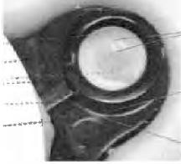

Plastic asserts that Donghee is incorrect in arguing that "the concave relief must be immediately adjacent to the orifice." (D.I. 236 at 23) Essentially, it appears that Donghee is arguing that the concave relief must be within walls, whereas Plastic is arguing that the concave relief may be outside of the walls (or rivet, in Donghee's product).

The Court agrees with Donghee. The patent defines "concave" as having a base that "is formed by the part of the accessory surrounding the orifice." ('490 patent at 3:64-65) Hence, moving outward from the center of the orifice, there must be orifice, then base material of the accessory's fastening tab, then some sort of raised wall, ridge, or lip — rather than orifice, then wall or ridge, and then base material. The record does not permit a reasonable juror to find that Donghee's accused product meets these requirements. Accordingly, the Court will grant summary judgment of non-infringement of the '490 patent.'

**5. "Orifice" Limitation in '326 Patent**

Claim 1, from which claim 13 depends, requires that "the accessory has a wall portion which is equipped with at least one orifice which passes through the wall portion of the accessory." ('326 patent, cl. 1) The specification defines an "accessory" as "any object or

'Given the Court's conclusion, it is unnecessary for the Court to address the two other bases for summary judgment of non-infringement that have been pressed by Donghee.

20

**Appx26**

Case 1:16-cv-00187-LPS Document 310 Filed 05/22/18 Page 22 of 26 PageID #: 9627

functional device generally associated with the fuel tank in its conventional mode of use or of operation and which collaborates therewith in order to perform certain useful functions; *or a support for one or several of such devices." (Id.* at 3:5-10) (emphasis added)

Donghee argues that it cannot be found to infringe claims **1** and 13 of the '326 patent because Plastic cannot show that in its accused product its orifice exists in the accessory itself rather than in the support for the accessory. *(See* D.I. 224 at 23) Plastic acknowledges that Donghee's orifices are in the support for the accessory rather than in the accessories themselves. But it contends that the patentee was its own lexicographer, clearly setting forth a definition of "accessory". that includes "support." (D.I. 236 at 26) (citing *Jack Guttman, Inc. v. Kopykake Enters.,* 302 F.3d 1352, 1360-61 (Fed. Cir. 2002))

The Court agrees with Plastic. Even Donghee concedes that the patentee was its own lexicographer in defining "accessory." *(See* Tr. at 46) This lexicography governs,

notwithstanding Donghee's suggestion that the claims can use a term in a different manner than the express definition it was given in the specification by the patentee. Even if some redundancy results, a patentee is permitted to be its own lexicographer, and when it does the Court must construe claim terms consistent with the patentee's express definition. Based on that

lexicography, a reasonable factfinder, taking the evidence in the light most favorable to Plastic, could find infringement. Accordingly, summary judgment is not warranted.

**6. Outer Layer Protruding Through Orifice in '326 Patent**

Claims 25, 27, and 33 of the '326 patent require that "the wall of the fuel tank comprises an outer layer of thermoplastic polymer and a barrier layer of thermoplastic resin impermeable to fuel" and that "some of the thermoplastic polymer of the outer layer and some of the barrier layer

21

**Appx27**

Case 1:16-cv-00187-LPS Document 310 Filed 05/22/18 Page 23 of 26 PageID #: 9628

of the fuel tank wall [are] forced in the molten state into and through the at least one orifice." ('326 patent, cl. 25) The parties do not dispute that Donghee's fuel tank wall consists of six layers, as shown below:

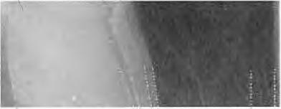

It is undisputed that the HDPE and HDPE Regrind layers are thermoplastic polymer layers and that the EVOH layer is a fuel-impermeable barrier layer. *(See* D.I. 236 at 27) It is further undisputed that at least some of the barrier layer and at least some of the HDPE Regrind layer enter the orifice. *(See* D.I. 224 at 24; D.I. 236 at 27) The central dispute is whether the "outer layer" is the HDPE Regrind layer, the HDPE layer, or both.

Plastic argues that "Donghee's tank is made from a tripartite HDPE-EVOH-HDPE layered structure," so that the "outer layer of thermoplastic polymer" is either a single layer "made from ***both*** HDPE regrind and pure HDPE" or ***"any layer on the outside*** of the EVOH." **(D.I.** 236 at 27) (emphasis added) Donghee counters that the "outer layer of thermoplastic polymer" must be the "outside" or outermost layer only and that the pure HDPE layer is "compositionally distinct" from the HDPE Regrind layer, so there is no infringement. (D.I. 224 at 24; D.I. 258 at 12)

The Court agrees with Plastic that "there is a genuine issue of material fact as to whether one of ordinary skill in the art would consider the HDPE regrind and final HDPE la[y]er to be a

22

**Appx28**

Case 1:16-cv-00187-LPS Document 310 Filed 05/22/18 Page 24 of 26 PageID #: 9629

single outer layer or multiple, discrete outer layers of plastic." (D.I. 236 at 27-28) Accordingly, the Court will deny summary judgment of non-infringement on claims 25, 27, and 33 of the '326 patent.

7. **Willful Infringement**

Plastic has alleged that Donghee's infringement is willful. As the Court will be entering summary judgment of non-infringement on all patents other than the '326 patent, the Court will consider willfulness only with respect to the '326 patent. Donghee moves for summary judgment of no willful infringement.

Willfulness may be found when a party shows, by a preponderance of the evidence, that an infringer has engaged in conduct that is "willful. wanton, malicious, bad-faith, deliberate, consciously wrongful, flagrant, or . . . characteristic of a pirate." *Halo Elecs., Inc. v. Pulse Ekes., Inc.,* 136 S. Ct. 1923, 1932 (2016). A patentee need only prove -subjective willfulness alone — i.e., proof that the defendant acted despite a risk of infringement that was 'either known or so obvious that it should have been known to the accused infringer.— *WesternGeco L.L.C. v. ION Geophysical Corp.,* 837 F.3d 1358, 1362 (Fed. Cir. 2016) (quoting *Halo,* 136 S. Ct. at 1930). "[C]ulpability is generally measured against the knowledge of the actor at the time of the challenged conduct." *Halo,* 136 S. Ct. at 1933.

Drawing all reasonable inferences in favor of Plastic, the Court concludes that a reasonable factfinder could not find that Donghee engaged in the type of egregious conduct to permit a finding of willful infringement, even taking the evidence in the light most favorable to Plastic.

On May 18, 2016, Plastic informed Donghee that the '326 patent was pending before the

23

**Appx29**

Case 1:16-cv-00187-LPS Document 310 Filed 05/22/18 Page 25 of 26 PageID #: 9630

PTO; on July 27, 2016, Donghee learned that the patent had issued the day before. *(See* D.I. 225 Ex. P at 10) It is undisputed that Donghee had knowledge of the patent as of July 27, 2016.

About one month later, on August 24, 2016, Plastic first asserted infringement of the '326 patent, when it filed its Amended Complaint. *(See* D.I. 14) Less than a month of pre-suit conduct had occurred. Plastic alleges that, during that month. Donghee willfully infringed the '326 patent by failing to engage in a process to design around the patent, knowing that Kautex had already taken a license to the '326 patent's parent patent. *(See* Tr. at 54; D.I. 236 at 29) This is not sufficient to constitute willful infringement. *See, e.g., Ansell Healthcare Prods. LLC v. Reckitt Benckiser LLC,* 2018 WL 620968, at *6 (D. Del. Jan. 30, 2018) ("[P]re-suit knowledge of the patent is not by itself sufficient to find 'willful misconduct.' . . . Rather, the patentee must identify evidence beyond pre-suit knowledge of the patent to show that the accused infringer's infringement is 'egregious,' deliberate,' or 'wanton.'"); *Finjan. Inc. v. Cisco Sys. Inc.,* 2017 WL 2462423, at *5 (N.D. Cal. June 7, 2017) (dismissing claim for willful infringement where behavior was not egregious); *Continental Circuits LLC v. Intel Corp.,* 2017 WL 679116, at *11 (D. Ariz. Feb. 21, 2017) ("After *Halo,* egregiousness is the touchstone of the willfulness

Plastic's allegations relating to post-suit conduct — Donghee's 2016 and 2017 sales of the Lfa fuel tank and preparations for future fuel tank sales (D.I. 236 at 32) — are also insufficient. Plastic did not seek a preliminary injunction and Donghee has asserted reasonable defenses. *See, e.g., Radware, Ltd. v. F5 Networks, Inc.,* 2016 WL 4427490, at *6 (N.D. Cal. Aug. 22, 2016) (concluding -since [patentee] did not seek a preliminary injunction, it is not entitled to a finding of willfulness based solely on [the defendant's] post-complaint infringement"). There is no

24

**Appx30**

Case 1:16-cv-00187-LPS Document 310 Filed 05/22/18 Page 26 of 26 PageID #: 9631

evidence of record from which a reasonable jury could find egregious conduct.

Accordingly, the Court will grant Donghee's motion for summary judgment of no willful

infringement.

IV. CONCLUSION

For the reasons stated, Donghee's *Daubert* motion and summary judgment motion will be

granted in part and denied in part. An appropriate Order follows.

25

**Appx31**

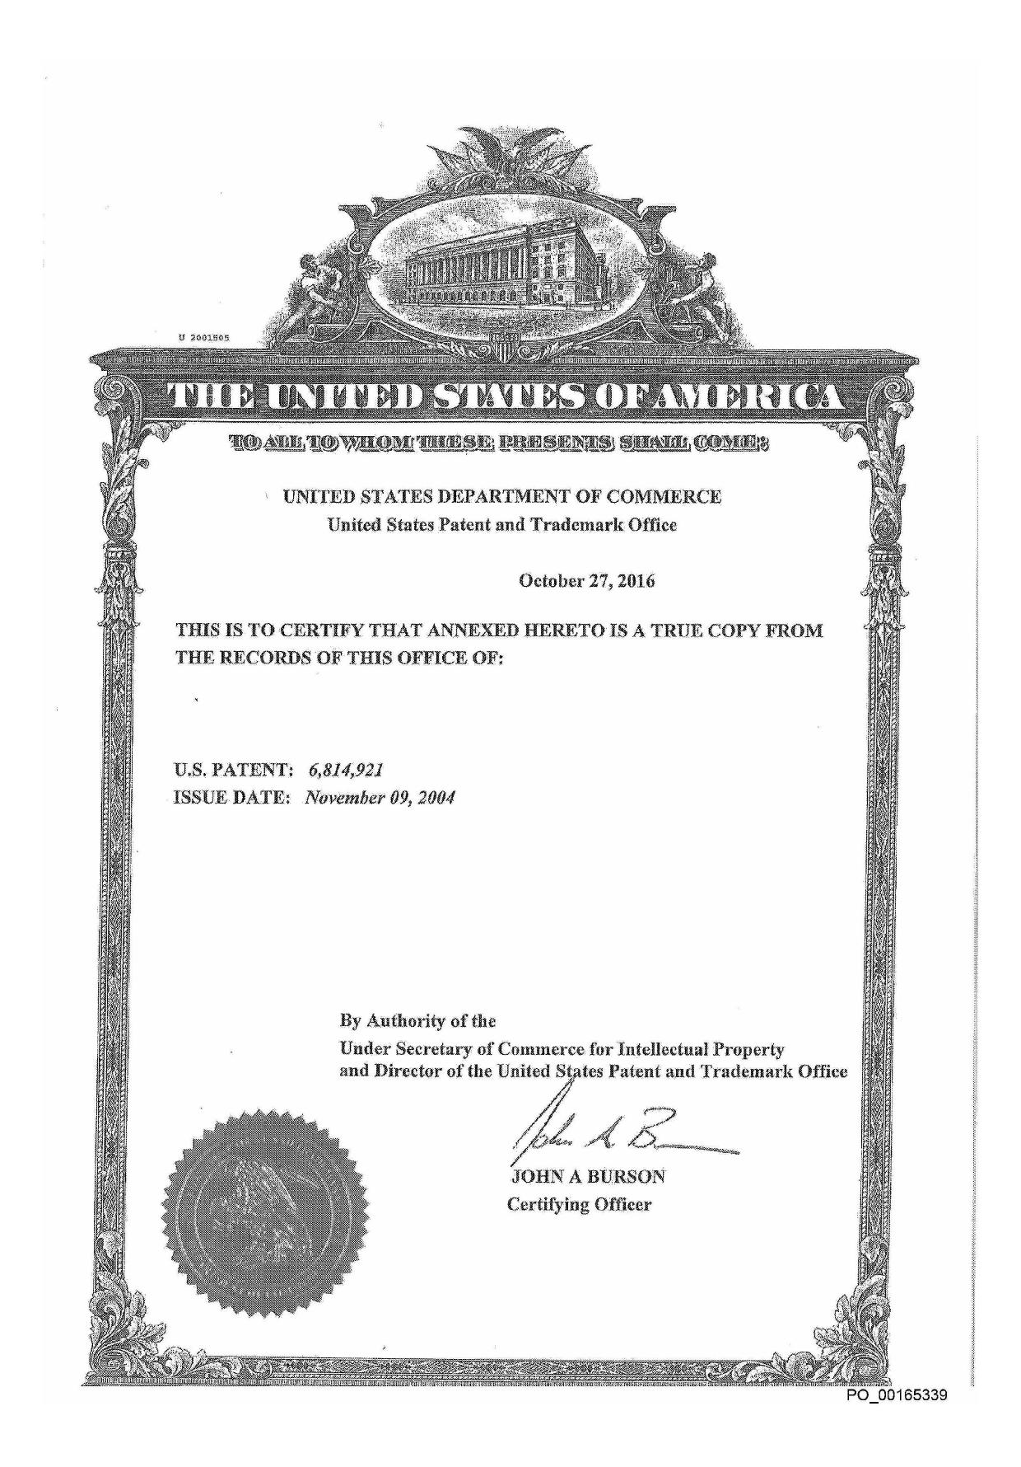

Appx68

1111111111111111111111111111)11j11J!IIRII1111111111111111111111

(12) **United States Patent (10) Patent No.: US 6,814,921 B1**

**Van Schaftingen et al.** (45) **Date of Patent: Nov. 9, 2004**

(54) METHOD FOR MAKING A FUEL TANK IN PLASTIC MATERIAL

(75) Inventors: Jules-Joseph Van Schaftingen, Wavre (BE); Yannick Gerard, Kraainem (BE); Serge Dupont, Vilvoorde (BE); Stephane Leonard, Brussels (BE)

(73) Assignee: Solvay (Societe Anonyme), Brussels (BE)

(* ) Notice: Subject to any disclaimer, the term of this

patent is extended or adjusted under 35 U.S.C. 154(0 by 175 days.

1. Appl. No.: 10/203,962
2. PCT Filed: Feb. 16, 2001
3. PCT No.: PCT/EP01/01804

§ 371 (c)(1),

(2), (4) Date: Nov. 14, 2002

1. PCT Pub, No.: W001/60592
     
   PCT Pub. Date: Aug. 23, 2001

(30) Foreign Application Priority Data

Feb. 18, 2000 (BE) 2000/0130

1. Mt. C1.7  B29C 49/20
2. U.S. Cl. 264/513; 264/516; 264/152;
     
   264/161
3. Field of Search 264/513, 516,
     
   264/152, 161
4. References Cited U,S. PATENT DOCUMENTS

3,767,740 A 10/1973 Jones-Hinton et al.

5,106,569 A 4' 4/1992 Rathman et al. 264/529

5,129,544 A 7/1992 Jacobson et al.

2001/0015513 Al 8/2001 Schaftingen et al.

FOREIGN PATENT DOCUMENTS

DE 1 801 966 6/1970

EP 1 110 697 A2 6/2001

FR 1541652 10/1968

JP 05229015 9/1993

JP 11254511 9/1999

* cited by examiner

*Primary Examiner—Suzanne* E. McDowell

(74) *Attorney, Agent, or* Firm—Stites & Harbison PLLC;

Ross F. Hunt, Jr.

1. ABSTRACT

Process for manufacturing a plastic fuel tank from two shells formed by molding, which are joined together, at least one shell being produced by compression-molding a portion of a plastic sheet between a mold and a punch and by the remaining portion of the sheet being blow-molded in the region not compression-molded.

10 Claims, 1 Drawing Sheet

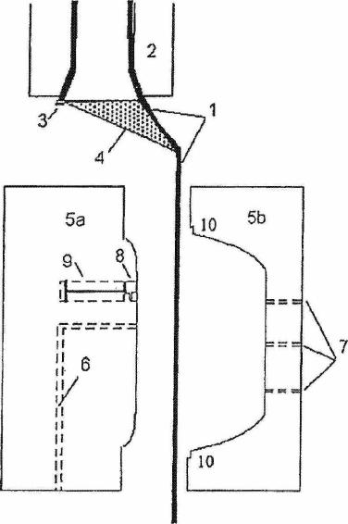

P0_00165340

**Appx69**

**U.S. Patent** Nov. 9, 2004 US 6,814,92.1 B1

P0_00165341

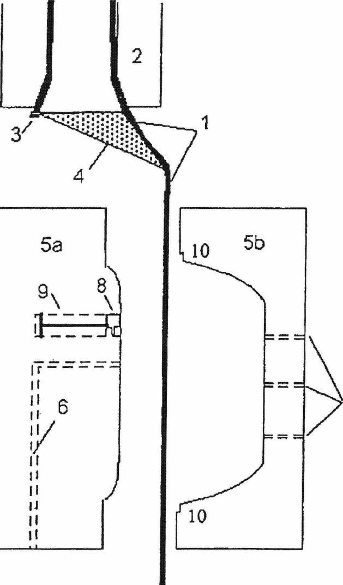

Appx70

US 6,814,921 B1

1

10

15

METHOD FOR MAKING A FUEL TANK IN
  
PLASTIC MATERIAL

The present invention relates to a process for manufac­turing a plastic fuel tank.

Plastic fuel tanks on board vehicles of various kinds must generally meet sealing and permeability standards in relation to the type of usage for which they are designed and the environmental requirements that they must respect. At the present time, both in Europe and in the world, there is a substantial tightening of the requirements relating to the limitation of pollutant emissions into the atmosphere and the environment in general. As a consequence, the design of fuel tanks is moving rapidly toward techniques capable of pro­viding a better guarantee of sealing and of safety under various operating conditions. Moreover, manufacturers are also striving to reduce as far as possible the losses caused by various pipes and accessories connected to the tanks. One means sometimes used has been to incorporate certain accessories and pipes inside the tanks, thus eliminating their

interface with the external environment. 20

Patent application GB-1 136 613 discloses a process for molding articles from a sheet of thermoplastic resin, com­prising the extrusion of the sheet followed by its molding in a two-part mold, the peripheral outlines of which can press the peripheral parts of the sheet, producing a join capable of maintaining a pressure difference on either side of the sheet so as to form the central part.

25

This known process is, however, applied to the manu­facture of open articles having around their periphery a flat edge, which is optionally recessed by a groove. The articles, 30 of quite small size, are suitable as containers. They are manufactured with blowing pressures of at most 10 kg/cm2. In addition, no device or accessory is introduced before molding or found in the articles obtained.

35

Patent U.S. Pat. No. 5,129,544 is known, which discloses a plastic fuel tank comprising two hollow shells made of a multilayer material, said shells being joined together in an impervious manner over their entire perimeter by fastening together their flat peripheral rim. In this tank, the shells may be formed by stamping or by vacuum-forming.

German patent application DE-OS-1 801 966 discloses 40

the manufacture of hollow bodies made of thermoplastic from two shells which are formed by molding and joined

together by mirror welding. The molding of each of the shells is performed by compression-molding a portion of a thermoplastic sheet and by blow-molding the remaining 45

portion of the sheet in the region not compression molded. The aim of the invention is to provide a process for producing a plastic fuel tank with excellent control of the

reproducibility and accuracy of the dimensions, which may have a large volume of up to about 100 to 150 liters and 50 which is well suited to the incorporation of accessories before the molding phase.

For this purpose, the subject of the invention is a process for manufacturing a plastic fuel tank from two shells formed by molding, which are joined together, at least one shell 55 being produced by compression-molding a portion of a plastic sheet between a mold and a punch and by the remaining portion of the sheet being blow-molded in the region not compression-molded.

The term "fuel tank" is understood to denote a sealed 60 tank capable of storing fuel under diverse and varied oper­ating and environmental conditions. An example of this tank is that with which automobiles are equipped.

The fuel tank produced in the process according to the invention is made of plastic, that is to say of material 65 comprising at least one polymer in the form of a synthetic resin.

2

All types of plastic may be suitable. Plastics which are very suitable belong to the thermoplastics category.

The term "thermoplastic" denotes any thermoplastic polymer, including thermoplastic elastomers, and blends

thereof. The term "polymer" denotes both homopolymers and copolymers (especially binary or ternary copolymers). Examples of such copolymers are, in a non-limiting manner: random copolymers, alternating copolymers, block copoly­mers and graft copolymers.

Any type of thermoplastic polymer or copolymer whose melting point is below the decomposition temperature is

suitable. Synthetic thermoplastics which have a melting range spread over at least 10 degrees Celsius are particularly suitable, Examples of such materials include those which exhibit polydispersity in their molecular weight.

In particular, polyolefins, thermoplastic polyesters, polyketones, polyamides and copolymers thereof may be used. A blend of polymers or copolymers may also be used, as may a blend of polymeric materials with inorganic, organic and/or natural fillers such as, for example, but non-limitingly, carbon, salts and other inorganic derivatives, natural or polymeric fibers. It is also possible to use multi-layer structures consisting of stacked layers bonded together, comprising at least one of the polymers or copolymers described above.

A polymer often employed is polyethylene. Excellent results have been obtained with high-density polyethylene (HOPE).

According to the invention, the tank is manufactured from two shells. The term "shell" denotes a non-closed partial envelope in the form of an open hollow body, with a surface shape having at least one concave portion.

The two shells are joined together in order to obtain the tank. Any type of impervious joint is suitable. However, it is preferred to join the shells together by welding.

Each shell used has been formed by molding a plastic sheet. A sheet intended for molding may consist of a single plastic composition. It may also be in the form of a structure resulting from stacking several layers of different plastic compositions. A layer often used to advantage in such a structure is a layer comprising at least one material acting as a barrier to liquids and gases, in particular to hydrocarbons.

According to the invention, the molding of at least one shell comprises the compression-molding of a portion of the sheet and the blow-molding of the portion not compression-molded. These two operations are performed in the same mold.

The compression-molding is carried out by bringing together and clamping, on each side of the sheet, at least one region of a mold portion and of a punch which is fastened to the other mold portion.

The blow-molding is carried out by introducing, on one side of the sheet, into the region not compression-molded, a pressurized fluid. This fluid may be a gas, a liquid or a dispersion of at least one liquid in a gas. When the fluid comprises a liquid, it advantageously ensures better heat transfer between the sheet and the fluid. Preferably, the pressurized fluid is introduced on that side of the sheet where the punch is located. As pressurized fluid, compressed air has given good results. It is also possible to use a pressurized purging fluid containing a reactive gas. Such a reactive gas may be fluorine. It is also possible to use an inert gas, such as nitrogen. A mixture of various gases may also be used, in particular a mixture containing at least two of the above-mentioned gases. Among liquids, it may be advantageous to use water. A fluid that has led particularly to excellent results is a dispersion (a spray) of water in compressed air.

P0_00165342

**Appx71**

US 6,814 ,921 B1

3

In the process according to the invention, the molding is well suited to the treatment of a sheet placed vertically. One example is that of a sheet produced by extrusion, in an extruder placed vertically, the extrusion head which includes the die being located at the lowest point and the sheet 5 produced flowing rectilinearly owing to the effect of its own weight.

According to the invention, the sheet is obtained in the same manufacturing line as the shell which will be produced from this sheet, by cutting and opening an extruded parison 10 of closed cross section, One of the shells may have been independently manufactured beforehand in a manufacturing unit other than for the tank. For example, the shell may have been manufactured in a molding installation different from

that used to manufacture the tank. 15

However, at least one of the shells used is preferably molded in the same manufacturing unit as the tank. This shell may, for example, be molded in an operating phase immediately preceding the production of the tank. It may also be produced in an operating phase which is, at least 20 partly, simultaneous with producing the tank. Both shells may also be molded in the same manufacturing unit as the tank.

In accordance with the process according to the invention, the sheet is advantageously obtained by cutting 25 and opening a parison of closed cross section leaving the die mounted on the extrusion head. The cutting operation con­sists in piercing and cutting, through its entire thickness, the wall of the parison along a curve of predetermined shape and length. Preferably, the cutting curve is rectilinear. Also 30 preferably, the cutting is carried out continuously over the entire length of the parison. Most preferably, the cut is produced as a straight line over the entire length of the parison.

The cut parison may be opened by any suitable means. In *35* particular, the cut parison may be opened by means of guiding devices. Examples of such devices are, in a non-limiting manner, wheels and rollers.

According to one particularly preferred method of imple­menting the process according to the invention, that portion 40 of the sheet which undergoes compression-molding com­prises the regions for joining the shells together.

The "joining regions" are understood to mean those portions of the shell which are intended to co-operate with that portion of the other shell during joining so as to produce 45 a sealed tank.

When the two shells are joined together by welding, the joining regions comprise the weld edges.

One particular method of implementing the process according to the invention consists in compression-molding 50 and blow-molding the two shells at the same time, by using stacked double molds, also called sandwich molds or stack molds.

According to another particularly advantageous method of implementing the process according to the invention, *55* before joining, at least one accessory of the fuel tank is inserted into the shell and fixed onto it.

The term "accessory" is understood to denote any object or device generally associated with the fuel tank in its usual method of use or of operation and which co-operates with so the fuel tank to provide certain useful functions. Non-limiting examples of such accessories are liquid pumps, delivery tubes, reservoirs or baffles internal to the fuel tank, venting devices.

Any method of fixing the accessory to the shell which is *65* compatible with the use of the fuel tank *is* suitable. One fixing method which has given good results is welding.

**4**

Alternatively, the accessory may, while the shell is being molded, be molded at the same time as the latter, with the intervention of at least one particular device.

One useful technique for effecting this simultaneous molding of the accessory and of the shell is for the sheet serving for manufacturing the shell to undergo flow, at the very least in a localized region of this sheet.

Another method of fixing the accessory in the process according to the invention comprises the use of an additional

device for overmolding the shell, which allows at least one

accessory of the fuel tank to be molded and fixed directly by the addition of material on one side of the wall of the shell.

The preferred material is a plastic or a plastic-based com­posite. A plastic identical to that of the sheet has given good results.

The overmolding may, in this way, be carried out on the inside (concave side) of the shell. It may also be carried out on the outside (convex side). Preferably, this technique is used to mold and fix an accessory on the inside (concave side) of the shell, because of the incorporation, after the shells have been molded, of the accessory thus produced inside the tank.

According to this latter particular technique, the addition of material may be performed by injection-molding a plastic composition.

It is also possible to combine the fixing of at least one accessory by flow of the sheet, as described above, with that of at least one additional accessory by overmolding on the inside.

Another method for fixing an accessory to the inside of the shell comprises the use of at least one device placed on the punch side or on the die side of the mold, which is capable of fixing at least one fuel tank accessory by welding the latter to the sheet. An alternative fixing technique con­sists in at least partially covering the accessory with a portion of the sheet. Preferably, at least two devices are used.

The die side is that which corresponds in the mold to the outside of the shell and of the tank. Preferably, two devices placed on the punch side are used, so as to fix an accessory to the shell and to the tank on the inside.

This latter method of fixing an accessory may also be combined with one or more other methods described above.

In one particular beneficial method of implementing the process according to the invention, a pm-assembled struc­ture is inserted during molding, allowing the tank to be stiffened by simultaneously pressing on each of the two shells and/or fixing at least one accessory of the tank.

The preassembled structure is made of a material com­position or material compatible with the tank. Preferably, it comprises a plastic of the same nature as that of the internal wall of the tank. The preassembled structure may combine several identical or different accessories via any suitable fastening means. Examples of these means are snap-fastening, clamping by screwing, welding, etc. It is also advantageous for the preassembled structure to bear means which make it possible to combine further accessories which, optionally, would be fixed later. These means are also snap-fastening devices, tapped holes or threaded protuber­ances of circular shape allowing screwing, surface regions suitable for welding, etc.

The insertion of a preassembled structure may be com­bined with one or more methods of fixing accessories already described above.

It is particularly advantageous for the preassembled structure also itself to bear at least one fuel tank accessory.

After the operation of joining the two shells together, the tank may undergo any type of surface treatment. One

P0_00165343

**Appx72**

US 6,814,921 B1

5

**6**

the region not compression-molded, characterized in that it is applied to the manufacture of a fuel tank and in the sheet is obtained in the same manufacturing line as the shell which will be produced from this sheet, by the cutting and opening

5 an extruded parison of closed cross section.

1. The process is claimed in claim 1, characterized in that that portion of the sheet which undergoes compression-molding comprises the regions for joining the shells

together.

10

1. The process as claimed in claim 1, characterized in that

the two shells are compression-molded and blow-molded at the same time, by using stacked double molds (sandwich molds or stack molds).

15 4. The process as claimed in claim 1, characterized in that, before joining, at least one accessory of the fuel tank is inserted into the shell and fixed onto it.

1. The process as claimed in claim 4, characterized in that, during the operation of molding the shell, at least one 20 particular device allows the simultaneous molding onto the shell of at least one fuel tank accessory by flow of the sheet.
2. The process as claimed in claim 4, characterized in that at least one additional device for overmolding the shell allows at least one accessory of the fuel tank to he molded

25 and fixed directly by the addition of material on one side of the wall of the shell.

1. The process as claimed in claim 1, characterized in that the addition of material is performed by the injection-molding a plastic composition.

30 8. The process as claimed in claim 4, characterized in that at least one device placed on the punch side or on the die side of the mold makes it possible to fix, during molding, at least one fuel tank accessory by depositing and welding the accessory to the sheet or by partially covering the accessory

35 with a portion of the sheet.

1. The process as claimed in claim 1, characterized in that a preassmbled structure is inserted during molding, allowing the tank to be stiffened by simultaneously pressing on each of the two shells and/or fixing at least one accessory of the tank.
2. The process as claimed in claim 2, characterized in that, after shell has been molded, the weld beads are deflashed and then a shaping template is applied, which is left in contact with a least one portion of the regions of the

45 shells for the time need to cool the latter and to improve the

accuracy of the dimensions of the shells.

example of treatment is that which consists in fluorinating the tank. It is thus possible to treat the internal surface of the tank or its external surface, or else to treat both surfaces simultaneously. After the molding operation, the shell advantageously undergoes defiashing of material, for example of weld beads, in the regions which have been compression-molded. This operation is generally performed with a profiled knife matched to the external dimensions of the tank.

According to the invention, it is beneficial, so as to improve the accuracy of the dimensions of the shells, to then apply a shaping template around the shells and to leave it in contact with at least one portion of the regions of these shells for the time needed for the latter to cool. This technique is particularly beneficial when the template is in contact with the joining regions of the shells.

The figure below is given for the purpose of illustrating one specific method of implementing the invention, without wishing in any way to restrict its scope. It represents an extrusion-blow-molding installation with continuous extru­sion used to produce automobile gas tanks. The multilayer extrudate (1) comprises 5 layers, namely HDPE/adhesive/ barrier/adhesive/HDPE. The adhesive is maleic anhydride-grafted polyethylene. The tubular extrudate (1) leaving the circular die, which is mounted on the extrusion head (2), is cut along a generatrix using a steel blade (3) placed at the exit of the circular die.

After the extruale (1) has been cut, it is bent back to form a sheet (1) which is guided by means of a system of inclined surfaces (4). The mold (5) then comes into an open position beneath the extrusion head (2). The mold (5) is then closed around the sheet (1) causing it to be compression-molded in a region located between the punch *(5a)* and the die *(5b);* in line with the joint between the shells (10). The sheet (1) is then pressed against the surface of the die *(5b)* owing to it being impelled by the air on the die side being evacuated through venting lines (7) and pressurized air being inlet on the punch side via a blowing line (6).

A delivery tube (8) mounted on an actuator (9) has also been pressed against the inside of the sheet (1), while it was 40 still in the melt state, being directly welded to this internal wall.

What is claimed is:

1. A process for manufacturing plastic hollow bodies from two shells formed by molding, which are joined together, at least one shell being produced by compression-molding a portion of a plastic sheet between a mold and a punch and by the remaining portion of the sheet being blow-molded in

* * * * *

P0_00165344

**Appx73**

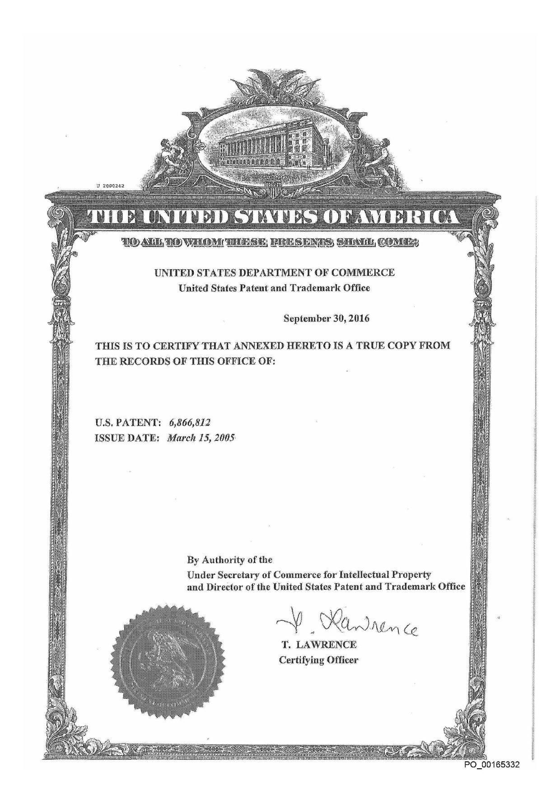

Appx74

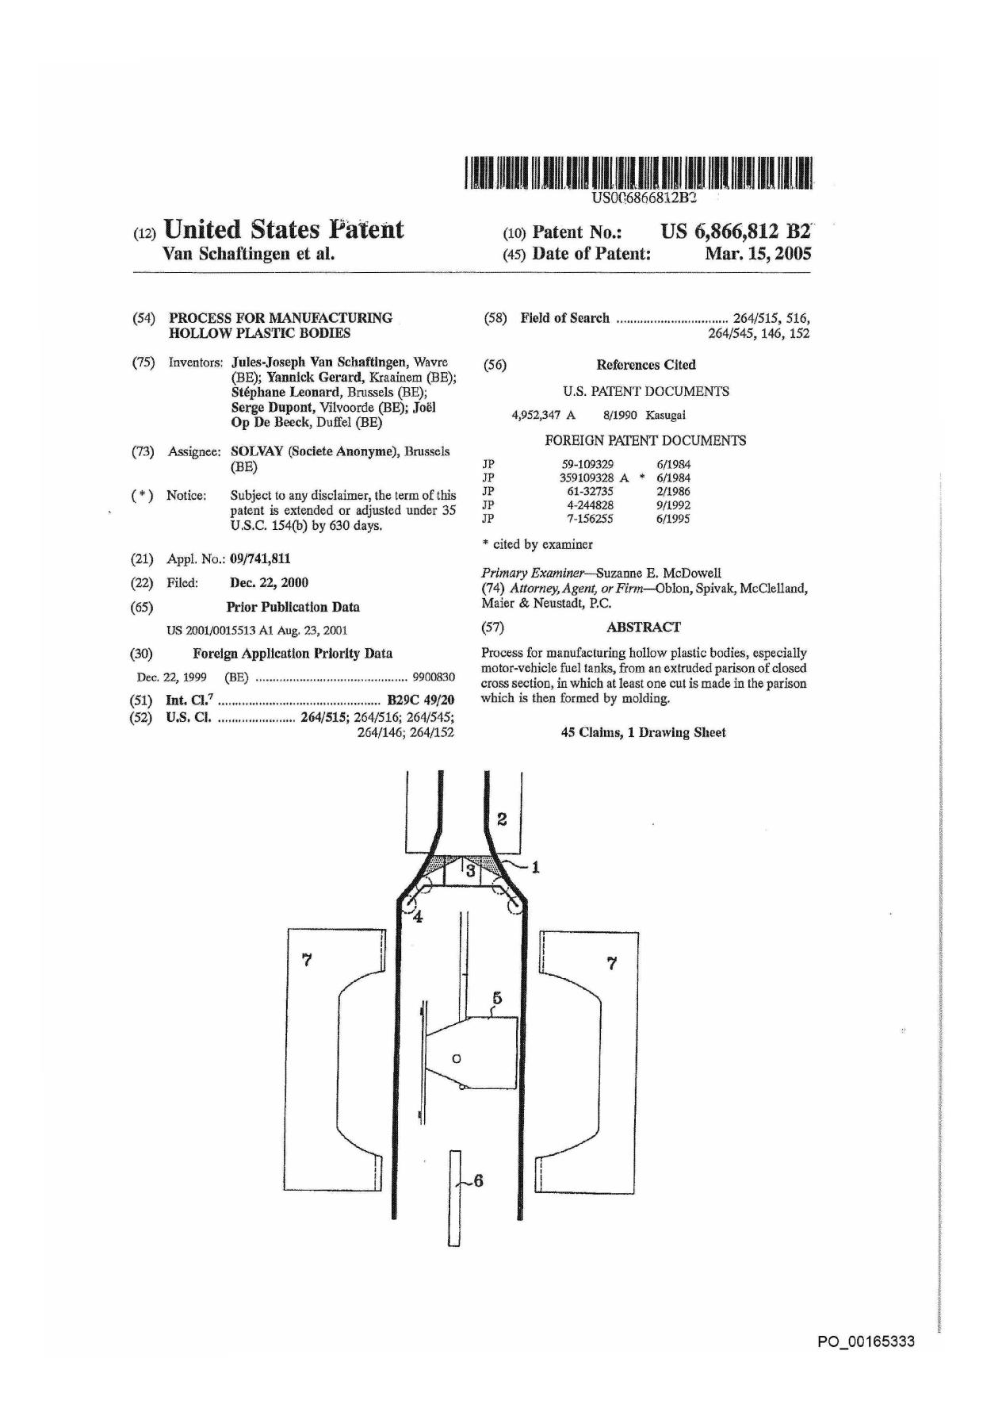

Appx75

|  |  |
| --- | --- |
| U-S. Patent | Mar.45,.2005, US 6,866;812 B2. |

P0_00165334

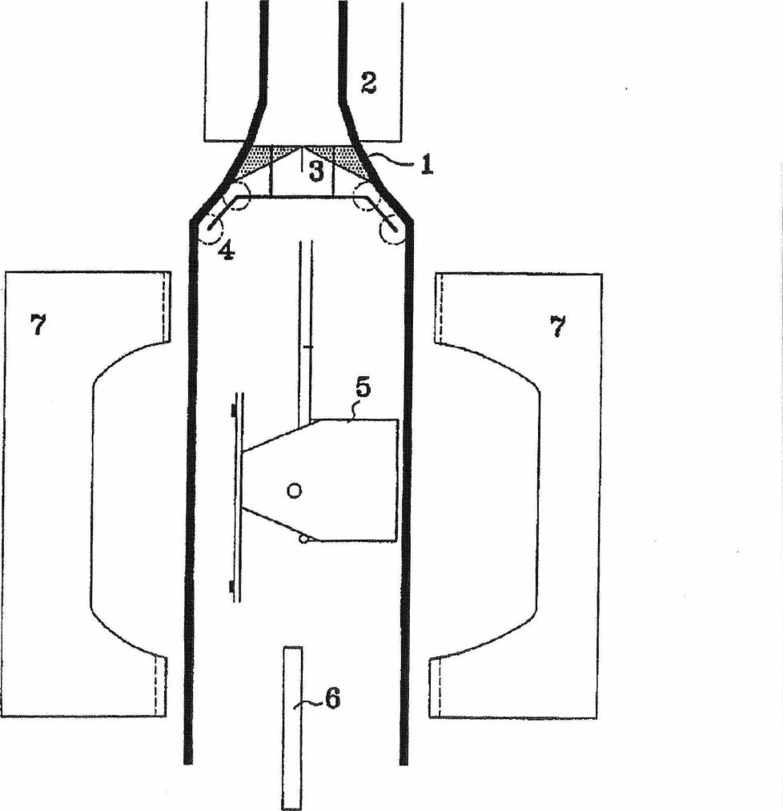

Appx76

US 6,-866,&12 B2

1

PROCESS FOR MANUFACTURING

HOLLOW PLASTIC BODIES

The present invention relates to a process for the manu­facture of hollow plastic bodies.

Hollow plastic bodies are used in a number of diverse and varied industries for many uses, especially as gas and

liquid tanks. For certain particular uses, these hollow bodies

often have to meet sealing standards in relation to the environmental requirements with which they must comply. At the present time, both in Europe and in the world, there is a considerable tightening of the requirements relating to limiting the leakage of pollutants into the atmosphere and

into the environment in general. The design of hollow bodies

intended to contain liquids and gases is consequently mov­ing rapidly towards techniques capable of providing a

greater guarantee of them being sealed and being safe under varied operating conditions. Moreover, endeavours have also been made to reduce as far as possible the losses arising from the various ducts and accessories associated with the hollow bodies. Sometimes one means used has been to incorporate certain accessories and ducts actually within the hollow bodies, thus eliminating any interface between them and the external atmosphere.

The insertion of accessories into a parison intended subsequently to be blown in order to produce a hollow body is itself well known and found in many industrial applica­tions in the manufacture of hollow bodies, particularly in that of liquid and gas tanks.

However, inserting accessories into a closed cylindrical parison proves to be tricky when they are bulky: this is because it is important for the parison to cover the acces­sories without interfering with them before the blowing operation is carried out.

U.S. Pat. No. 4,952,347 discloses a process for manu­facturing a plastic fuel tank which comprises the extrusion of two parallel flat sheets between which the accessories are inserted. The two sheets are then moulded by bringing together, and closing, two walls of a mould into which a blowing gas is injected and the ends of which produce the weld of the two sheets to each other so as to form the hollow body containing the accessories within it.

However, this process has the drawback of having to position two extrusion heads and/or extruders capable of simultaneously producing two flat sheets, the thickness uniformity and the production uniformity of which are constant from one sheet to another and at any point on each of the sheets.

The object of the invention is to provide a process which avoids the drawbacks of the known processes and allows bulky accessories to be easily and rapidly inserted into and positioned in a hollow body without any risk of producing undesirable irregularities in the walls of the hollow body obtained.

For this purpose, the invention relates to a process for manufacturing hollow plastic bodies from an extruded pad-son of closed cross section, in which at least one cut is made in the parison which is then formed by moulding.

The term "hollow body" is understood to mean any article whose surface has at least one empty or concave part. In particular, the process according to the invention is well suited to the manufacture of hollow articles which are in the form of closed bodies, such as tanks.

The hollow bodies produced by the process according to the invention are made of plastic, that is to say a material comprising at least one polymer made of synthetic resin.

All types of plastic may be suitable. Plastics that are very suitable belong to the category of thermoplastics.

2

The term "thermoplastic" is understood to mean any thermoplastic polymer, including thermoplastic elastomers, and blends thereof. The term "polymer" is understood to mean both homopolymers and copolymers (especially

5 binary or ternary copolymers). Examples of such copoly­mers are, without being restrictive: random copolymers, sequenced copolymers, block copolymers and graft copoly­mers.

Any type of thermoplastic polymer or copolymer whose

10

melting point is below the decomposition temperature is suitable. Synthetic thermoplastics which have a melting

range spread out over at least 10 degrees Celsius are particularly suitable. As examples of such materials, there are those which exhibit polydispersity in their molecular mass.

15 In particular, it is possible to use polyolefins, grafted

polyolefins, thermoplastic polymers, polyketones, polya-

mides and copolymers thereof. One copolymer often used is the copolymer ethylene-vinyl alcohol (EVOH). A blend of polymers or copolymers can also be used, as can a com-

ae pound of polymeric materials with inorganic, organic and/or natural fillers such as, for example, but not restrictively: carbon, salts and other inorganic derivatives, and natural or polymeric fibres. It is also possible to use multilayered structures consisting of stacked layers fastened to one

25 another, comprising at least one of the polymers or copoly­mers described above. Such multilayered structures may be obtained by means of a coextrusion head or by a technique of completely or partially covering a substrate layer with one or more other layers. An example of the covering technique

30 is the spraying of plastic onto the substrate layer using a spray gun.

One polymer often used is polyethylene. Excellent results have been obtained with high-density polyethylene (HOPE).

35 The term "extruded parison" is understood to mean the
  
product obtained by passing, through a die, a composition of at least one thermoplastic melt homogenized in an extruder whose head is terminated by the die. According to the invention, the parison has a closed cross section. Preferably,

40 this cross section is circular or elliptical.

The figure which follows is given for the purpose of illustrating a specific embodiment of the inventions without in any way wishing to restrict the scope theteof. It represents an extrusion blow-moulding machine with continuous extru-

45 sion used for producing motor-vehicle fuel tanks,

In accordance with the process according to the invention, at least one cut is made in the parison leaving the die mounted on the extrusion head. The cutting operation consists in cutting the wall of the parison, right through its

so thickness, in a curve of predetermined shape and length. Preferably, the curve of the cut is rectilinear. Also preferably, the cut is made continuously over the entire length of the parison. Most preferably, the cut is made as a straight line over the entire length of the parison.

55 Next, the cut parison undergoes a forming operation by
  
moulding, that is to say inserting it between at least two parts of a mould and then closing these parts and pressing at a predetermined temperature for a predetermined time. Preferably, the moulding operation comprises a blowing 60 operation and a welding operation. These two separate operations may be carried out independently in a sequence in any order. They may also, preferably, be carried out, at least in part, concomitantly.

The blowing operation inside the mould, the walls of 65 which may be maintained at a defined temperature by any suitable heating or cooling means, allows the cut parison to undergo a forming operation.

P0_0016533 5

Appx77

US 6;866,8'12; 82

3

The welding operation in the mould consists in pinching the periphery of the parison, at least partially, and in welding together, by hot fusion welding, the surfaces of the parison which have been pinched.

Optionally, the hollow body obtained may also undergo a surface treatment. Examples of such surface treatments are, non-restrictively: fluorination, sulphonation and cover­ing with another composition or material,

Preferably, the process is carried out in an integrated manufacturing line comprising the extrusion of the parison

and its forming by moulding. In particular, identical parisons are produced by means of a knife blade which cuts, transversely, at regular intervals, the extrudate leaving the die.

Preferably, the parison is cut longitudinally, along a generatrix of the latter. In this case, it is particularly advan­tageous that this cut be made in the direction of flow of the parison.

One particularly preferred technique is that in which the parison is cut twice over its entire length, that is to say along two separate lines, so as to produce two separate sheets. Cutting along two parallel generatrices is very particularly preferred.

The two sheets obtained may be held apart at a constant distance until the step of closing the mould. As a variant, it is also possible to modify, over time, the spacing of the two sheets until the mould is closed. According to this variant, it is also possible to bring the sheets together at the moment when the mould closes. This makes it possible, advantageously, to reduce the manufacturing scrap.

Another preferred technique is that in which the two parts of the cut parison are held apart at a sufficient distance from each other so that it is possible to insert between them, before moulding, an object intended to be incorporated inside the hollow body. Thus, it is possible in particular to insert a bulky object. It is also possible to combine the double cutting which produces two separate sheets with the technique of keeping the parts of the cut parison apart by a sufficient distance. In the latter case, it is then the separate sheets which are kept apart.

This bulky object may be conventionally introduced via the lower side of the sheets, in the opposite direction to the flow.

More advantageously, this object may be introduced laterally, or even via the top of the sheet. In this way, it is possible to choose the region or the side of the sheet where the available space is least cluttered. This way of proceeding is particularly advantageous in the case of large objects.

In one particular embodiment of the process according to the invention, the sheets obtained by cutting the parison are guided by means of a guiding device. This guiding device may be chosen from among any device for guiding a flattened plastic object, which is itself well known. For example, wheels and/or rollers may be used. The guiding device may also include a device for transversely and/or longitudinally stretching the sheet.

The process according to the invention is beneficial when it is desired to insert into the cut parison at least one accessory intended to be incorporated into the hollow body. The process according to the invention is particularly advan­tageous when it is desired to insert between the sheets at least one accessory intended to be incorporated into the hollow body.

The term "accessory" is understood to mean any object or device which is generally associated with the hollow body in its usual method of use or operation and which interacts with it in order to fulfil certain useful functions. Non-

**4**

limiting examples of such accessories are: liquid pumps, pipettes, reservoirs or baffles internal to the hollow body, and ventilation devices.

Preferably, the inserted accessory, especially when it is 5 inserted as several examples, which may or may not be identical, is supported by a preassembled structure. This has

the advantage of being able to produce the preassembled

structure, supporting all or at the very least several acces­sories to be introduced into the hollow body, in a separate to process prior to their introduction into the hollow body. As a result, the subsequent mounting, by insertion, into the

hollow body is greatly facilitated and this allows the pro­duction of preassembled structures of relatively complex accessories to be more easily subcontracted.

It is also possible, independently of the above insertion

15 of accessories, to insert, between the sheets, a preassembled structure which comprises at least one device for anchoring this structure to the internal wall of the hollow body. Such a device is, for example, an arm provided with a tab for fastening to the wall of the hollow body. These tabs may, for

20 example, be fastened by welding to the wall of the hollow body, upon closing the mould. Alternatively, they may be judiciously placed so as to be pressed, by jamming, between opposed walls of the hollow body.

The preassembled structure may also be designed so that

25 it also supports an anchoring device which will be used only later for fastening an accessory. One example is the fasten­ing of an accessory which comes from a manufacturer different from that of the preassembled structure and which it would be desirable to insert at the same time as those

30 already present in this structure, Another example could also be the possibility of fastening an accessory after the manu­facture of the hollow body, in a step independent of this manufacture, via an opening that would be made in its wall.

Alternatively, it may be advantageous to combine the

35 insertion of at least one accessory on a preassembled struc­ture with the structure having the anchoring device. Here, the benefit resides in reducing the number of objects to be inserted, each of them possibly fulfilling both functions, that of a support for the accessories and that of anchoring them

40 in the wall, or for an accessory to be introduced later.

It is also possible to reheat or cool at least one part of the sheets by any suitable means, such as, for example, but non-restrictively: the radiation from infrared lamps, the convection of hot or cold gases, etc. When the sheets are

45 completely separate over their entire perimeter before they are moulded, it is much easier to bring up and position the heating and/or cooling means.

The process according to the invention is well suited to the use of means for positioning bulky objects and press-50 sembled structures which can be mounted very precisely in the hollow body.

An example of these means is the use of supports in the form of films, sheets or plates made of polyolefin, which are attached to the object or the structure at points such that it

55 is possible to support and move the object or the structure while holding it, by pulling, between grippers. The films, sheets or plates are, for example, attached to the structure at points located at 180° to each other. Advantageously, the films, sheets or plates are extended to the outside of the

60 perimeter of the sheets and thus make it possible to hold and continuously position the object or the structure while the mould is closing. The films, sheets or plates are in this way held between the pinching regions of the parison which are intended to be fastened together. A preferred method of

*65* fastening is welding. In this way, the films, sheets or plates melt, at least on the surface, during the operation of welding them to the internal surface of the parison.

P0_00 1 65336

**Appx78**

US 6;866;812.32

S

30

The films, sheets or plates generally have thicknesses of at least 5 *pm.* This thickness generally does not exceed 20 mm. Preferably, films at least 50 pm in thickness are used. These preferred films generally do not exceed 1 mm in thickness. The advantage of using films with such a small thickness is that it limits the losses of gas and/or liquid contained in the hollow body right at the regions where the sheets are joined.

An additional way of precisely positioning the bulky objects or the preassembled structures inside the hollow body is to provide the films, sheets or plates serving as support with plastic cones intended to be inserted precisely in the corresponding relief parts located on the edges of the mould, in the parison welding regions.

The invention also allows the use of moveable moulds and the lateral insertion of a blowing nozzle a few moments before the closing of the mould, this having the advantage of being able to shorten the cycle time and increase the production rates.

The process according to the invention is well suited to the manufacture of hollow bodies which are fuel tanks. In particular, it is suitable for the manufacture of fuel tanks intended to be fitted to motor vehicles.

The tubular multilayer extrudate (1) of circular cross section, which has external layers made of high-density polyethylene and a central barrier layer made of ethylene-vinyl alcohol copolymer (EVOH) surrounded by two layers of adhesive made of maleic-anhydride-grafted polyethylene, leaves the extrusion head (2) and is separated into two sheets (1), using two steel blades (3) placed at 180° to each other, at the exit of the circular die mounted on the extrusion head (2).

The two sheets (1) are guided and kept apart using wheels (not shown) and rollers (4). At the start of a cycle, the two parts (7) of an open mould lie beneath the extrusion head (2). A robot (not shown) then positions the structure (5) supporting the accessories to be incorporated into the tank. A blowing nozzle (6) is also positioned between the two parts of the mould. The latter is then closed around the combination of sheets and accessories, causing the two sheets to be welded together, while blowing air is injected under pressure via the nozzle (6) so as to carry out the forming operation on the sheets.

What is claimed is:

1. Aprocess of manufacturing a hollow body for receiving a liquid, comprising the steps of:

extruding a parison;

cutting through said parison so as to form two portions separated by a cut; and

molding said two portions so as to form said hollow body for receiving said liquids,

wherein said step of cutting said parison comprises mak­ing at least two cuts in said parison so as to form two separate sheets.

1. The process of claim 1, wherein said hollow body is a tank and said liquid is a fuel.
2. The process of claim 1, wherein said step of molding

comprises:

pinching surfaces of said parison, and

hot fusion welding said surfaces.

1. The process of claim 1, wherein said step of cutting is Performed along a longitudinal direction.
2. The process of claim 1, wherein said step of extruding said parison comprises passing a composition of at least one thermoplastic melt through a die.
3. The process of claim 1, further comprising a step of cutting said parison in a transverse direction thereby obtain­ing a plurality of parisons.

6

1. The process of claim 1, wherein said step of molding comprises a step of holding apart said two portions of said parison and a subsequent step of bring said two portions together.

5 8. The process of claim 7, further comprising a step of
  
inserting an object in said parison during said step of holding apart said two portions.

9. The process of claim 8, wherein said object is a preassembled structure.

10 10. The process of claim 9, wherein said preassembled
  
structure is configured to anchor to an internal wall of said hollow body.

1. The process of claim 8, further comprising a step of controlling a position of said object with members, said members being coupled to said object and extending outside 15 said parison while said object is inside said parison.
2. The process of claim 11, wherein said members melt during said molding step.
3. The process of claim 1, wherein said step of molding comprises a step of blowing gas within said parison, and a 20 step of welding said two portions together.
4. The process of claim 1, wherein said step of molding comprises a step of bringing said two portions together and a step of welding said two portions together so as to form a joint leak-tight to said liquid.

25 15. The process of claim 1, further comprising a step of
  
guiding said sheets with a guiding device.

1. A process of manufacturing a hollow body, compris­ing the steps of:

extruding a multilayered parison comprising stacked lay­ers fastened to each other;

cutting through said multilayered parison so as to form two portions separated by a cut; and

molding said two portions so as to form said hollow body, 35 wherein said step of cutting said multilayered parison

comprises making at least two cuts in said multilayered

parison so as to form two separate sheets.

1. The process of claim 16, wherein said hollow body is a fuel.

40 18. The process of claim 16, wherein said multilayered
  
parison comprises at least one layer of a thermoplastic.

1. The process of claim 16, wherein said multilayered parison comprises at least one layer of polyethylene.
2. The process of claim 16, wherein said step of molding

45 comprises:

pinching surfaces of said parison, and

hot fusion welding said surfaces.

1. The process of claim 16, wherein said step of cutting is performed along a longitudinal direction.

50 22. The process of claim 16, wherein said step of extrud-
  
ing said multilayered parison comprises passing a compo­sition of at least one thermoplastic melt through a die.

1. The process of claim 16, further comprising a step of cutting said parison in a transverse direction thereby obtain-55 ing a plurality of parisons.
2. The process of claim 16, wherein said step of molding comprises a step of holding apart said two portions of said parison and a subsequent step of bringing said two portions together.

60 25. The process of claim 24, further comprising a step of
  
inserting an object in said parison during said step of holding apart said two portions.

26. The process of claim 25, wherein said object is a preassembled structure.

65 27. The process of claim 26, wherein said preassembled
  
structure is configured to anchor to an internal wall of said low body.

P0_00165337

**Appx79**

US 6;866,812 B2-

**7**

**8**

36, The process of claim 32, wherein said step of extrud­ing said parison comprises passing a composition of at least one thermoplastic melt through a die.

1. The process of claim 32, further comprising a step of 5 cutting said parison in a transverse direction thereby obtain­ing a plurality of parisons.
2. The process of claim 32, wherein said step of molding comprises a step of holding apart said two portions of said parison and a subsequent step said two portions together.

10 39. The process of claim 38, further comprising a step of

inserting an object in said parison during said step of holding a part said two portions.

40. The process of claim 39, wherein said object is a preassembled structure.

5 41. The process of claim 40, wherein said preassembled structure is configured to anchor to an internal wall of said fuel tank.

1. The process of claim 39, further comprising a step of controlling a position of said object with members, said 0 members being coupled to said object and extending outside said parison while said object is inside said parison.
2. The process of claim 42, wherein said members melt during said molding step.
3. The process of claim 32, wherein said step of molding

5 comprises a step of blowing gas within said parison, and a step of welding said two portions together.

1. The process of claim 32, wherein said step of molding comprises a step of bringing said two portions together and a step of welding said two portions together so as to form a

0 leak-tight joint.

1. The process of claim 25, further comprising a step of controlling a position of said object with members, said members being coupled to said object and extending outside said parison while said object is inside said parison.
2. The process of claim 28, wherein said members melt during molding step.
3. The process of claim 16, wherein said step of molding comprises a step of blowing gas within said parison, and a step of welding said two portions together.
4. The process of claim 16, wherein said step of molding comprises a step of bringing said two portions together and a step of welding said two portions together so as to form a leak-tight joint.
5. A process of manufacturing a fuel tank, comprising

the steps of: a
  
extruding a parison;

cutting through said parison so as to form two portions separated by a cut; and

molding said two portions so as to form said fuel tank, 2 wherein said step of cutting said parison comprises mak-

ing at least two cuts in said parison so as to form two

separate sheets.

1. The process of claim 32, further comprising a step of positioning fuel tank accessories between said two portions 2 prior to a step of bringing said two portions together.
2. The process of claim 32, wherein said step of molding

comprises:

pinching surfaces of said parison, and

hot fusion welding said surfaces. 3

1. The process of claim 32, wherein said step of cutting is performed along a longitudinal direction.

**\* * \***

P0_00165338

**Appx80**

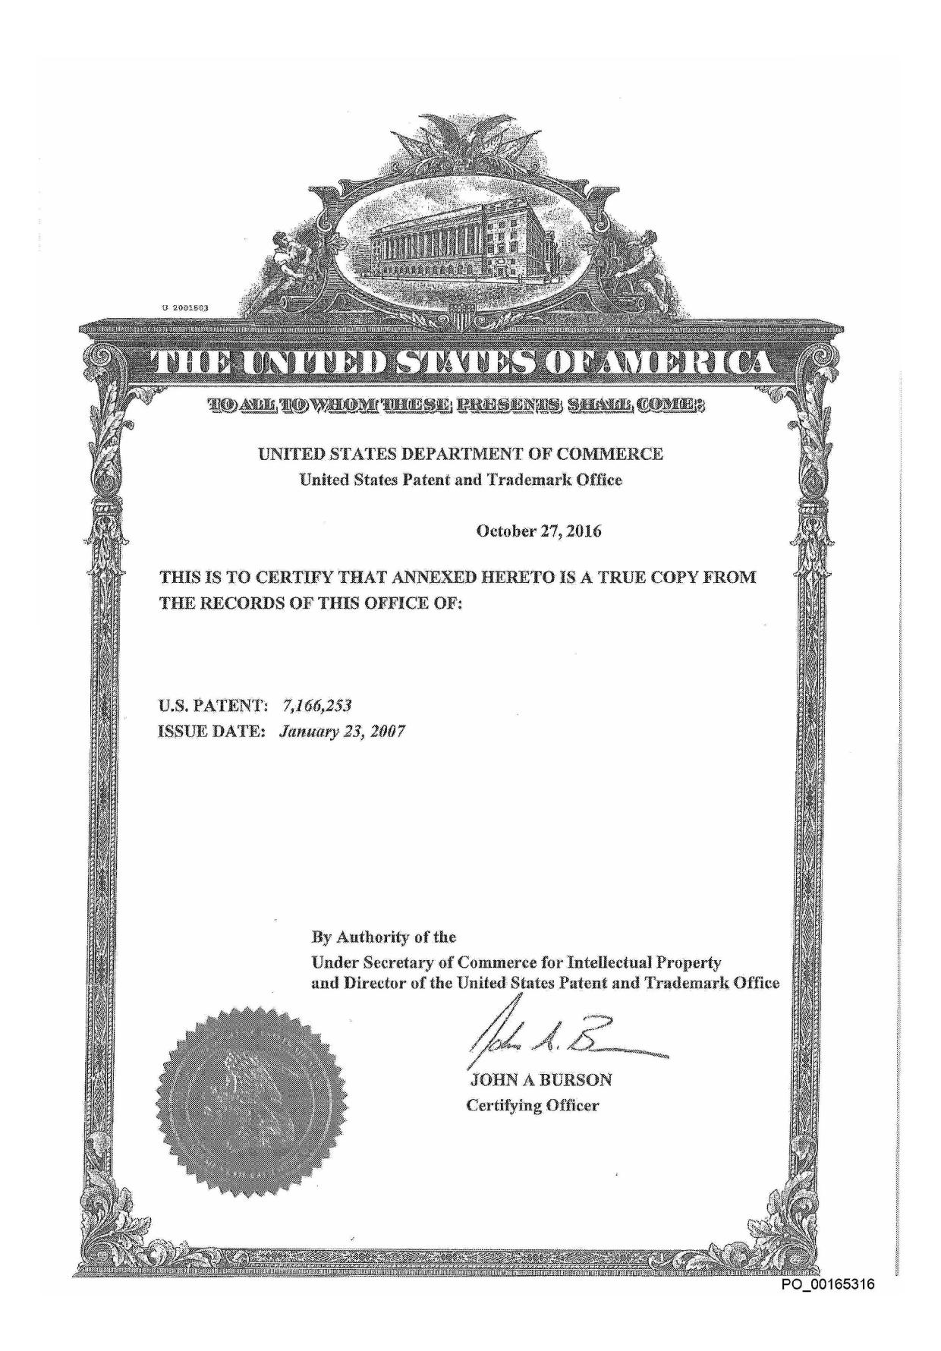

Appx81

111111111111111111111111111111jI111,611111!1111111111111111111111111

(12) **United States Patent (10) Patent No.: US 7,166,253 B2**

**Van Schaftingen et al.** (45) **Date of Patent: Jan. 23, 2007**

(54) PROCESS FOR MANUFACTURING HOLLOW PLASTIC BODIES

(75) Inventors: Jules-Joseph Van Schaftingen, Wavre (BE); Yannick Gerard, Kraainem (BE); Stephan Leonard, Brussels (BE); Serge Dupont, Vilvoorde (BE); Joel Op De Beeck, Duffel (BE)

(73) Assignee: Solvay (Societe Anonyme), Brussels (BE)

(5) Notice: Subject to any disclaimer, the term of this

patent is extended or adjusted under 35 U.S.C. 154(b) by 35 days.

1. Appl. No.: 11/016,745
2. Filed: Dec. 21, 2004

(65) Prior Publication Data

US 2005/0104260 Al May 19, 2005

Related U.S. Application Data

(63) Continuation of application No. 09/741,811, filed on Dec. 22, 2000, now Pat. No. 6,866,812.

(30) Foreign Application Priority Data

Dec. 22, 1999 (BE) 9900830

(51) Int. Cl.

*B29C 49/20* (2006.01)

*B29C 49/22* (2006.01)

(52) U.S. Cl. 264/515; 264/516

1. Field of Classification Search 264/515,
     
   264/516 See application *file* for complete search history.
2. References Cited U.S. PATENT DOCUMENTS

4,952,347 A 8/1990 Kasugai

5,514,323 A * 5/1996 Ramioulle 264/516

6,712,234 B2 3/2004 Boecker

FOREIGN PATENT DOCUMENTS

JP 59-109329 6/1984

JP 359109328 A 6/1984

JP 61.32735 2/1986

JP 4-244828 9/1992

JP 7-156255 6/1995

* cited by examiner

*Primary* Examiner—Suzanne E. McDowell

(74) *Attorney Agent, or Firm—Oblon,* Spivak, McClelland,

Maier & Neustadt, P.C.

1. ABSTRACT

Process for manufacturing hollow plastic bodies, especially motor-vehicle fuel tanks, from an extruded parison of closed cross section, in which at least one cut is made in the parison which is then formed by moulding.

14 Claims, 1 Drawing Sheet

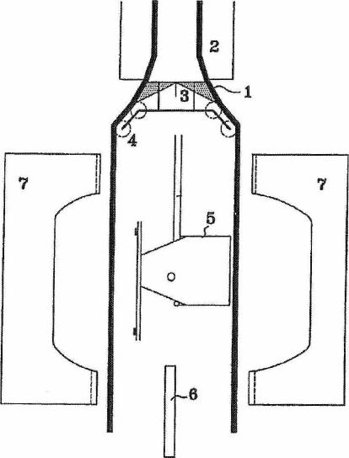

P0_00165317

**Appx82**

**U.S. Patent** Jan. 23, 2007 **US 7,166,253 B2**

P0_00165318

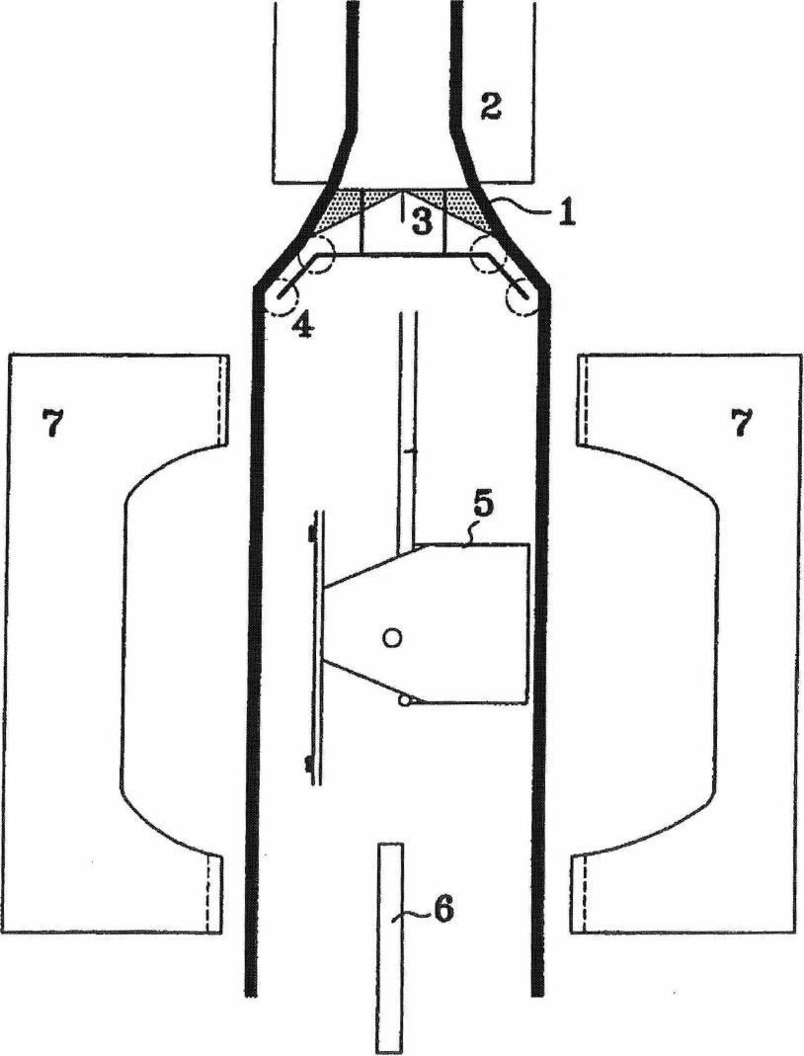

**Appx83**

US 7,166,253 B2

2

1

PROCESS FOR MANUFACTURING

HOLLOW PLASTIC BODIES

CROSS-REFERENCE TO RELATED
  
APPLICATIONS

particular, the process according to the invention is well suited to the manufacture of hollow articles which are in the form of closed bodies, such as tanks.

The hollow bodies produced by the process according to

5 the invention are made of plastic, that is to say a material comprising at least one polymer made of synthetic resin.

All types of plastic may be suitable. Plastics that are very suitable belong to the category of thermoplastics.

This application is a continuation application of, and claims priority to, Ser No. 09/741,811 filed Dec. 22, 2000, now U.S. Pat. No. 6,866,812, and claims priority to Belgium Patent Application No. 09900830 filed Dec. 22, 1999.

The present invention relates to a process for the manu­facture of hollow plastic bodies.

Hollow plastic bodies are used in a number of diverse and varied industries for many uses, especially as gas and liquid tanks. For certain particular uses, these hollow bodies often have to meet sealing standards in relation to the environ­mental requirements with which they must comply. At the

present time, both in Europe and in the world, there is a considerable tightening of the requirements relating to lim­iting the leakage of pollutants into the atmosphere and into the environment in general. The design of hollow bodies intended to contain liquids and gases is consequently mov­ing rapidly towards techniques capable of providing a greater guarantee of them being sealed and being safe under varied operating conditions. Moreover, endeavours have also been made to reduce as far as possible the losses arising from the various ducts an d accessories ass elated with the

The term "thermoplastic" is understood to mean any

10 thermoplastic polymer, including thermoplastic elastomers, and blends thereof. The term "polymer" is understood to mean both homopolymers and copolymers (especially binary or ternary copolymers). Examples of such copoly­mers are, without being restrictive: random copolymers,

15 sequenced copolymers, block copolymers and graft copoly­mers.

Any type of thermoplastic polymer or copolymer whose melting point is below the decomposition temperature is suitable. Synthetic thermoplastics which have a melting

20 range spread out over at least 10 degrees Celsius are particularly suitable. As examples of such materials, there are those which exhibit polydispersity in their molecular mass.

25 In particular, it is possible to use polyolefins, grafted
  
polyolefins, thermoplastic polymers, polyketones, polya-mides and copolymers thereof. One copolymer often used is

hollow bodies. Sometimes one means used has been to the copolymer ethylene-vinyl alcohol (EVOH). A blend of

with inorganic, organic and/or

incorporate certain accessories and ducts actually within the

polymers or copolymers can also be used, as can a corn-

hollow bodies, thus eliminating any interface between them 30 pound of polymeric materials

and the external atmosphere, natural fillers such as, for example, but not restrictively:
  
The insertion of accessories into a parison intended sub-

carbon, fibres. It is also possible to use multilayered

salts and other inorganic derivatives, and natural or

.ng of stacked layers fastened to one

sequently to be blown in order to produce a hollow body is

polymeric.issm.tig at least one of the polymers or copoly-

liquid and gas tanks. itself well known and found in many industrial applications

structures cons

in the manufacture of hollow bodies, particularly in that of 35 another, comprising

mers described above. Such multilayered structures may be

However, inserting accessories into a closed cylindrical obtained by means of a coextrusion head or by a technique

parison proves to be tricky when they are bulky: this is of completely or partially covering a substrate layer with one

o r more other layers. An example of the covering technique because it is important for the parison to cover the acces-

s the spraying of plastic onto the substrate layer using a sories without interfering with them before the blowing ao i

operation is carried out. spray gun.

U.S. Pat. No. 4,952,347 discloses a process for manufac- One polymer often used is polyethylene. Excellent results

have been obtained with high-density polyethylene (HDPE).

Wring a plastic fuel tank which comprises the extrusion of

two parallel flat sheets between which the accessories are The term "extruded parison" is understood to mean the
  
inserted. The two sheets are then moulded by bringing 45 product obtained by passing, through a die, a composition of

together, and closing, two walls of a mould into which a at least one thermoplastic melt homogenized in an extruder

blowing gas is injected and the ends of which produce the whose head is terminated by the die. According to the

weld of the two sheets to each other so as to form the hollow invention, the parison has a closed cross section. Preferably,

body containing the accessories within it, this cross section is circular or elliptical.

However, this process has the drawback of having to 50 The FIGURE which follows is given for the purpose of

position two extrusion heads and/or extruders capable of illustrating a specific embodiment of the inventions without

simultaneously producing two flat sheets, the thickness in any way wishing to restrict the scope thereof. It represents

uniformity and the production uniformity of which are an extrusion blow-moulding machine with continuous extru-

constant from one sheet to another and at any point on each sion used for producing motor-vehicle fuel tanks.

of the sheets. 55 In accordance with the process according to the invention,

The object of the invention is to provide a process which at least one cut is made in the parison leaving the die

avoids the drawbacks of the known processes and allows mounted on the extrusion head. The cutting operation con-

bulky accessories to be easily and rapidly inserted into and sists in cutting the wall of the parison, right through its

positioned in a hollow body without any risk of producing thickness, in a curve of predetermined shape and length.

undesirable irregularities in the walls of the hollow body so Preferably, the curve of the cut is rectilinear. Also preferably,

obtained, the cut is made continuously over the entire length of the

For this purpose, the invention relates to a process for parison. Most preferably, the cut is made as a straight line

manufacturing hollow plastic bodies from an extruded pari- over the entire length of the parison.

son of closed cross section, in which at least one cut is made Next, the cut parison undergoes a forming operation by

in the parison which is then formed by moulding. 65 moulding, that is to say inserting it between at least two parts

The term "hollow body" is understood to mean any article of a mould and then closing these parts and pressing at a

whose surface has at least one empty or concave part. In predetermined temperature for a predetermined time.

P0_00165319

**Appx84**

US 7,166,253 B2

**4**

**3**

Preferably, the moulding operation comprises a blowing operation and a welding operation. These two separate operations may be carried out independently in a sequence in any order. They may also, preferably, be carried out, at least in part, concomitantly.

The blowing operation inside the mould, the walls of

which may be maintained at a defined temperature by any suitable heating or cooling means, allows the cut parison to undergo a forming operation.

The welding operation in the mould consists in pinching the periphery of the parison, at least partially, and in welding together, by hot fusion welding, the surfaces of the parison which have been pinched.

Optionally, the hollow body obtained may also undergo a surface treatment. Examples of such surface treatments are, non-restrictively: fluorination, sulphonation and covering with another composition or material.

Preferably, the process is carried out in an integrated manufacturing line comprising the extrusion of the parison and its forming by moulding. In particular, identical parisons are produced by means of a knife blade which cuts, trans­versely, at regular intervals, the extrudate leaving the die.

Preferably, the parison is cut longitudinally, along a generatrix of the latter. In this case, it is particularly advan­tageous that this cut be made in the direction of flow of the parison.

One particularly preferred technique is that in which the parison is cut twice over its entire length, that is to say along two separate lines, so as to produce two separate sheets. Cutting along two parallel generatrices is very particularly preferred.

The two sheets obtained may be held apart at a constant distance until the step of closing the mould. As a variant, it is also possible to modify, over time, the spacing of the two sheets until the mould is closed. According to this variant, it is also possible to bring the sheets together at the moment when the mould closes. This makes it possible, advanta­geously, to reduce the manufacturing scrap.

Another preferred technique is that in which the two parts of the cut parison are held apart at a sufficient distance from each other so that it is possible to insert between them, before moulding, an object intended to be incorporated inside the hollow body. Thus, it is possible in particular to insert a bulky object. It is also possible to combine the double cutting which produces two separate sheets with the technique of keeping the parts of the cut parison apart by a sufficient distance. In the latter case, it is then the separate sheets which are kept apart.

This bulky object may be conventionally introduced via the lower side of the sheets, in the opposite direction to the flow.

More advantageously, this object may be introduced lat­erally, or even via the top of the sheet. In this way, it is possible to choose the region or the side of the sheet where the available space is least cluttered. This way of proceeding is particularly advantageous in the case of large objects. hi one particular embodiment of the process according to the invention, the sheets obtained by cutting the parison are guided by means of a guiding device. This guiding device may be chosen from among any device for guiding a flattened plastic object, which is itself well known. For example, wheels and/or rollers may be used. The guiding device may also include a device for transversely and/or longitudinally stretching the sheet.

The process according to the invention is beneficial when it is desired to insert into the cut parison at least one accessory intended to be incorporated into the hollow body.

The process according to the invention is particularly advan­tageous when it is desired to insert between the sheets at least one accessory intended to be incorporated into the hollow body.

s The term "accessory" is understood to mean any object or

device which is generally associated with the hollow body in

its usual method of use or operation and which interacts with it in order to fulfil certain useful functions. Non-limiting examples of such accessories are: liquid pumps, pipettes,

to reservoirs or baffles internal to the hollow body, and venti-
  
lation devices.

Preferably, the inserted accessory, especially when it is inserted as several examples, which may or may not be identical, is supported by a preassembled structure. This has

is the advantage of being able to produce the preassembled structure, supporting all or at the very least several acces­sories to be introduced into the hollow body, in a separate process prior to their introduction into the hollow body. As a result, the subsequent mounting, by insertion, into the

20 hollow body is greatly facilitated and this allows the pro­duction of preassembled structures of relatively complex accessories to be more easily subcontracted.

It is also possible, independently of the above insertion of accessories, to insert, between the sheets, a preassembled

25 structure which comprises at least one device for anchoring this structure to the internal wall of the hollow body. Such a device is, for example, an arm provided with a tab for fastening to the wall of the hollow body. These tabs may, for example, be fastened by welding to the wall of the hollow

30 body, upon closing the mould. Alternatively, they may be judiciously placed so as to be pressed, by jamming, between opposed walls of the hollow body.

The preassembled structure may also be designed so that it also supports an anchoring device which will be used only

35 later for fastening an accessory. One example is the fasten­ing of an accessory which comes from a manufacturer different from that of the preassembled structure and which it would be desirable to insert at the same time as those already present in this structure. Another example could also

ao be the possibility of fastening an accessory after the manu­facture of the hollow body, in a step independent of this manufacture, via an opening that would be made in its wall.

Alternatively, it may be advantageous to combine the insertion of at least one accessory on a preassembled struc-

45 tore with the structure having the anchoring device. Here, the benefit resides in reducing the number of objects to be inserted, each of them possibly fulfilling both functions, that of a support for the accessories and that of anchoring them in the wall, or for an accessory to be introduced later.

so It is also possible to reheat or cool at least one part of the
  
sheets by any suitable means, such as, for example, but non-restrictively: the radiation from infrared lamps, the convection of hot or cold gases, etc. When the sheets are completely separate over their entire perimeter before they

55 are moulded, it is much easier to bring up and position the heating and/or cooling means.

The process according to the invention is well suited to the use of means for positioning bulky objects and preas-sembled structures which can be mounted very precisely in 60 the hollow body,

An example of these means is the use of supports in the form of films, sheets or plates made of polyolefin, which are attached to the object or the structure at points such that it is possible to support and move the object or the structure

65 while holding it, by pulling, between grippers. The films, sheets or plates are, for example, attached to the structure at points located at 180° to each other. Advantageously, the

P 0_0 0 1 65320

**Appx85**

US 7,166 953 B2

5

films, sheets or plates are extended to the outside of the perimeter of the sheets and thus make'it possible to hold and continuously position the object or the structure while the mould is closing. The films, sheets or plates are in this way held between the pinching regions of the parison which are intended to be fastened together. A preferred method of fastening is welding. In this Ivey, the films, sheets or plates melt, at least on the surface, during the operation of welding them to the internal surface of the parison,

The films, sheets or plates generally have thicknesses of at least 5 pm. This thickness generally does not exceed 20 mm. Preferably, films at least 50 gm in thickness are used. These preferred films generally do not exceed I nun in thickness. The advantage of using films with such a small thickness is that it limits the losses of gas and/or liquid contained in the hollow body right at the regions where the sheets are joined.

An additional way of precisely positioning the bulky objects or the preassembled structures inside the hollow body is to provide the films, sheets or plates serving as support with plastic cones intended to be inserted precisely in the corresponding relief parts located on the edges of the mould, in the parison welding regions,

The invention also allows the use of moveable moulds and the lateral insertion of a blowing nozzle a few moments before the closing of the mould, this having the advantage of being able to shorten the cycle tune and increase the production rates.

The FIGURE which follows is given for the purpose of illustrating a specific embodiment of the invention, without in any way wishing to restrict the scope thereof. It represents an extrusion blow-moulding machine with continuous extru­sion used for producing motor-vehicle fuel tanks.

The tubular multilayer extnidate (1) of circular cross section, which has external layers made of high-density polyethylene and a central barrier layer made of ethylene-vinyl alcohol. copolymer (EVOH) surrounded by two layers of adhesive made of melees-anhydride-grafted polyethylene, leaves the extrusion head (2) and is separated into two sheets (1), using two steel blades (3) placed at 180' to each other-, at the exit of the circular die mounted on the extrusion head (2).

The two sheets (1) are guided and kept apart using wheels (not shown) and rollers (4). At the start of a cycle, the two parts (7) of an open mould lie beneath the extrusion head (2), A robot (not shown) then positione the structure (5) sup­porting the accessories to be ineorpolated into the tank. A blowing nozzle (6) is also positioned between the two parts of the mould. The latter is then closed around the combi­nation of sheets and accessories, causing the two sheets to be welded together, while blowing air is injected under pressure via the nozzle (6) so as to carry out the forming operation on

6

The invention claimed is:

I. A process for manufacturing a hollow body using a

mould, comprising the steps of;

incorporating at least one of an accessory or a duct within

*5* the hollow body;

after said step of incorporating, closing said mould in a way which eliminates any interface between said at least one of said accessory or said duct and an external atmosphere outside of the hollow body;

10 wherein said at least one of said accessory or said duet is
  
supported by a preassembled structure which com­prises at least one device configured to anchor said reassembled structure to an internal wall of the hollow body.

15 2. A process for manufacturing a hollow body according
  
to claim 1, wherein said device includes tabs and said process further comprises a step of welding said tabs to said internal wall.

1. A process for manufacturing a hollow body according so to claim 2, wherein said tabs are supported by an arm.
2. A process for manufacturing a hollow body according to claim 1, further comprising positionieg a fastener on the preassembled stracture, said fastener being configured to fasten an accessory at a later time,

25 5. A process for manufacturing a hollow body according
  
to claim 1, further comprising positioning the preassembled structure precisely in the hollow body with means for positioning.

1. A process for manufacturing a hollow body according 30 to claim 1, wherein the hollow body is made of plastic,
2. A process for manufacturing a hollow body according to claim 1, wherein the hollow body is a multilayered structure made of stacked layers.
3. A process for manufacturing a hollow body according 35 to claim 7, wherein said stacked layers include a central layer of EVOH surrounded by two layers of adhesive.
4. A recess for manufacturing a hollow body according to claim 8, wherein said adhesive is made of maleic-aeydride-grafted PE.

40 10, A process for manufacturing a hollow bode, according
  
to claim 9, wherein said stacked layers further include external layers of HDPE.

11. A process for manufacturing a hollow body according to claim 7, wherein said multilayered structure was obtained 45 by cotretnision.

12.A process for manufacturing a hollow body according to claim 1, wherein the hollow body is a fuel tail.

1. A process for manufacturing a hollow body according to claim 1, comprising a step ofineorporating said accessory so Within said hollow body and wherein said accessory is supported by said preassembled structure..
2. A process for manufacturing a hollow body according to claim 1, comprising a step of incorporating said duct within said hollow body, and wherein said duct is supported 55 by said preassembled structure.

|  |  |  |  |
| --- | --- | --- | --- |
| the sheets. |  |  |  |
|  |  |  | P0_00165321 |
|  | **Appx86** |

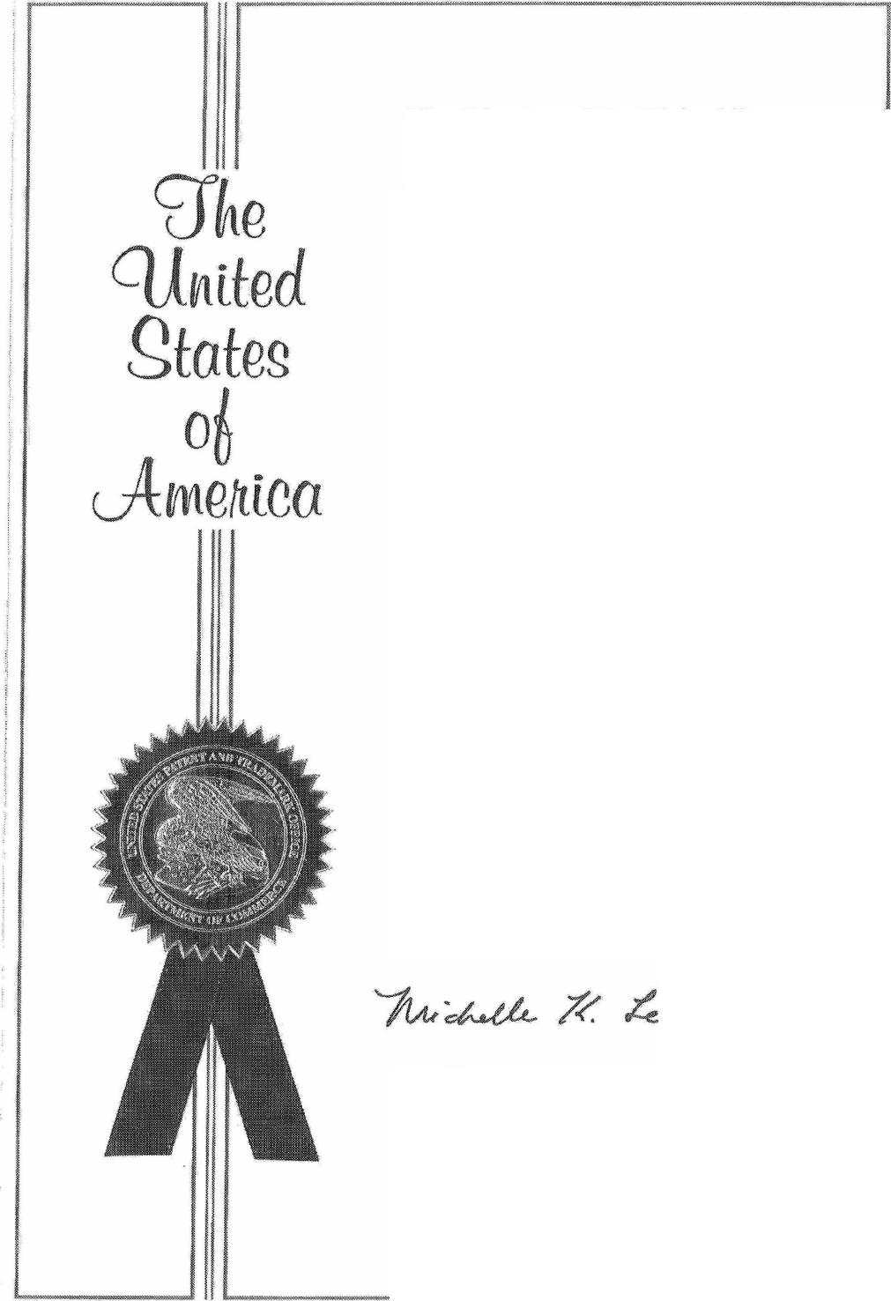Appx98

The Director of the United States
  
Patent and Trademark Office

*Has received an application for a patent for a new and useful invention. The title and description of the invention are enclosed The requirements of law have been com­plied with, and it has been determined that a patent on the invention shall be granted under the law.*

*Therefore, this*

United States Patent

*Grants to the person(s) having title to this patent the right to exclude others from mak­ing, using, offering for sale, or selling the invention throughout the United States of America or importing the invention into the United States of America, and ifthe inven­tion is a process, of the right to exclude oth­ers from using, offering for sale or selling throughout the United States of America, or importing into the United States of America, products made by that process, for the term set forth in 35 US.0 154(x)(2) or (c)(1), subject to the payment of mainte­nance fees as provided by 35 U.S.C. 41(b). See the Maintenance Fee Notice on the inside of the cover*

*Director o Under/ States nava ekd Traelemork Office*

P0_00165358

**MAINTENANCE FEE NOTICE**

*If the application for this patent was filed on or after December 12, 1980, maintenance fees are due three years and six months, seven years and six months, and eleven years and six months after the date of this grant, or within a grace period of six months thereafter upon payment of a surcharge as provided by law. The amount, number and timing of the maintenance fees required may be changed by law or regulation. Unless payment of the applicable maintenance fee is received in the United States Patent and Trademark Office on or before the date the fee is due or within a grace period of six months thereafter, the patent will expire as of the end of such grace period.*

**PATENT TERM NOTICE**

*If the application for this patent was filed on or after June 8, 1995, the term of this patent begins on the date on which this patent issues and ends twenty years from the filing date of the application or if the application contains a specific reference to an earlier filed application or applications tinder 35 U.S.C. 120, 121, 365(c), or 386(c), twenty years from the filing date of the earliest such application ("the twenty-year term'), subject to the payment of maintenance fees as provided by 35 U.S.C. 41(b), and any extension as provided by 35 U.S.C. 154(b) or 156 or any disclaimer under 35 U.S.C. 253.*

*If this application was filed prior to June 8, 1995, the term of this patent begins on the date on which this patent issues and ends on the later of seventeen years from the date of the grant of this patent or the twenty-year term set forth above for patents resulting from applications filed on or after June 8, 1995, subject to the payment of maintenance fees as provided by 35 U.S.C. 41(b) and any extension as provided by 35 U.S.C. 156 or any disclaimer under 35 U.S.C, 253.*

P0_00165359

**Appx99**

11111111111111111111111111111131111111111111111111111

11111

|  |  |  |  |
| --- | --- | --- | --- |
| (12) **United States Patent**  **Criel et al.** | |  | **(10)**  (45)  **Patent No.: US 9,399,327 B2**  **Date of Patent: *Jul. 26, 2016** |
| (54) | METHOD FOR FASTENING AN ACCESSORY IN A PLASTIC FUEL TANK |  | USPC 220/562, 4.14, 4.13, 678; 264/512, 511,  2641516, 550, 571, 545, 523, 531, 249,  264/259; 425/528 |
|  | Applicant: PLASTIC OMNIUM ADVANCED |  | See application file for complete search history. |
|  | INNOVATION AND RESEARCH, Brussels (BE) |  |  |
|  |  | (56) | References Cited |
|  | Inventors: Bjorn Criel, Merelbeke (BE); Jules-Joseph Van Schaftingen, Wavre |  | U.S. PATENT DOCUMENTS |
|  | (BE); Pascal De Henan,  Maleves-Ste-Marie (BE)  Assignee: PLASTIC OMNIUM ADVANCED |  | 3,308,225 A 3/1967 Wells  3,785,217 A 1/1974 Peura  (Continued) |
|  | INNOVATION AND RESEARCH, Brussels (BE) |  | FOREIGN PATENT DOCUMENTS |
| ) | Notice: Subject to any disclaimer, the term of this  patent is extended or adjusted under 35 | EP  EP | 0 103 832 3/1984  0 368 809 5/1990 |
|  | U.S.C. 154(b) by 0 days. |  | (Continued) |
|  | This patent is subject to a terminal dis­claimer. |  | OTHER PUBLICATIONS |

1. Appl. No.: 14/070,767
2. Filed: Nov. 4, 2013

(65) Prior Publication Data

US 2014/0131918 Al May 15, 2014

Related U.S. Application Data

(63) Continuation of application No. 11/658,085, filed as application No. PCT/EP2005/053519 on Jul. 20, 2005, now Pat. No. 8,591,798.

(30) Foreign Application Priority Data

Jul. 23, 2004 (FR) 04 08196

1. Int. Cl.

*B29C 49/20* (2006.01)

*B29D 22/00* (2006.01)

(Continued)

1. U.S. Cl.

CPC *B29D 22/003* (2013.01); *829C 49/20*

(2013.01); *B29C 65/606* (2013.01); (Continued)

(58) Field of Classification Search

CPC B29C 49/20; B29C 2049/2008; B29C 2049/2034; B29C 65/606; B29C 66/532; B29C 66/8322; B29C 51/12; B29C 51/267; B29D 22/003

U.S. Appl. No. 14/043,983, filed Oct. 2, 2013, Criel, et al.

*Primary Examiner —* Alison L Hindenlang

*Assistant Examiner —* Lawrence D Hohenbrink, Jr.

(74) *Attorney, Agent, or Firm —* Oblon, McClelland,

Maier & Neustadt, L.L.P.

(57) ABSTRACT

Method for stake-fastening an accessory (4) into a plastic fuel tank, whereby:

the accessory (4) is equipped with at least one orifice (5)

which passes right through the accessory (4); at least some of the plastic of which the wall of the tank (1)

is made is melted; and

some of the molten plastic is forced through the orifice *(5)* of the accessory without becoming detached from the remainder of the molten plastic;

the protruding molten plastic is given an appropriate shape (8) to obtain a self-formed plastic rivet, and is left to solidify;

the size and shape of the orifice (5) and/or of the solidified plastic (8) being such that the accessory (4) is mechanically fastened to the tank by at least some of the solidified plastic (8), the stake-fastening of the accessory (4) occurring at the time of manufacture of the tank (1) through the molding of a split or at least two-part parison.

16 Claims, 4 Drawing Sheets

1

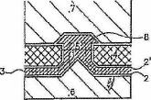

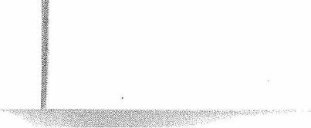

P0_00165360

**Appx100**

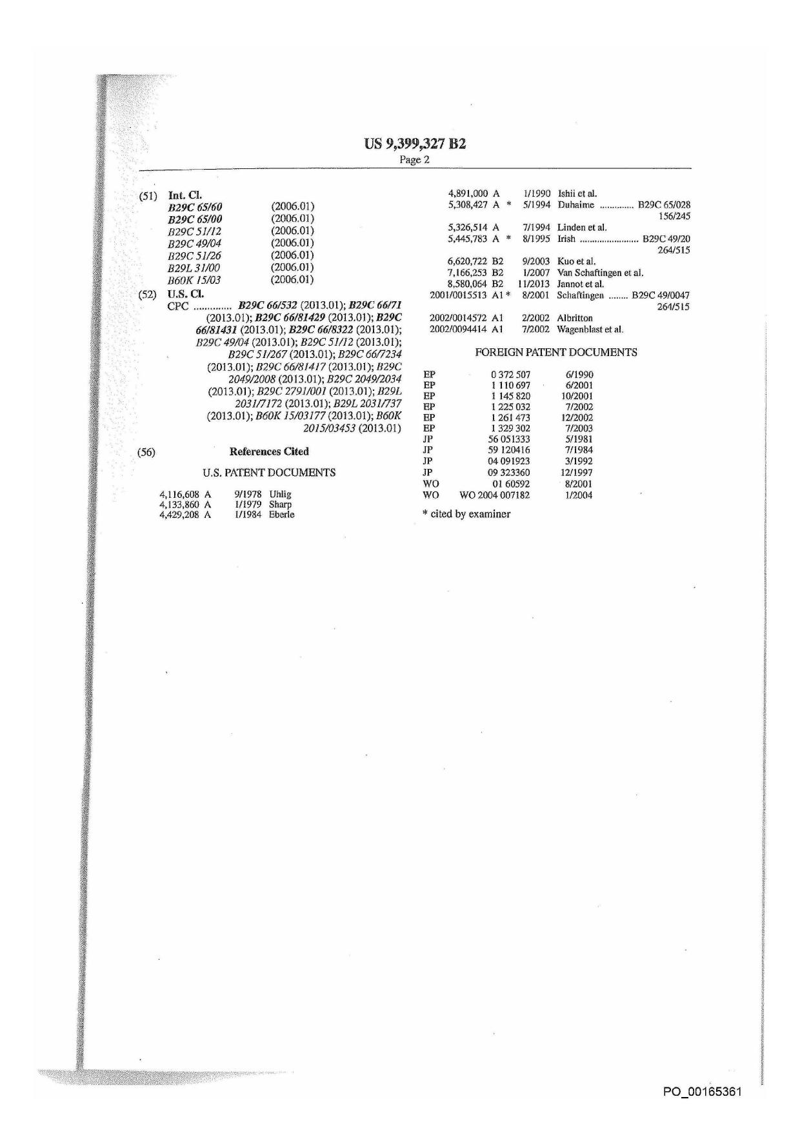

Appx101

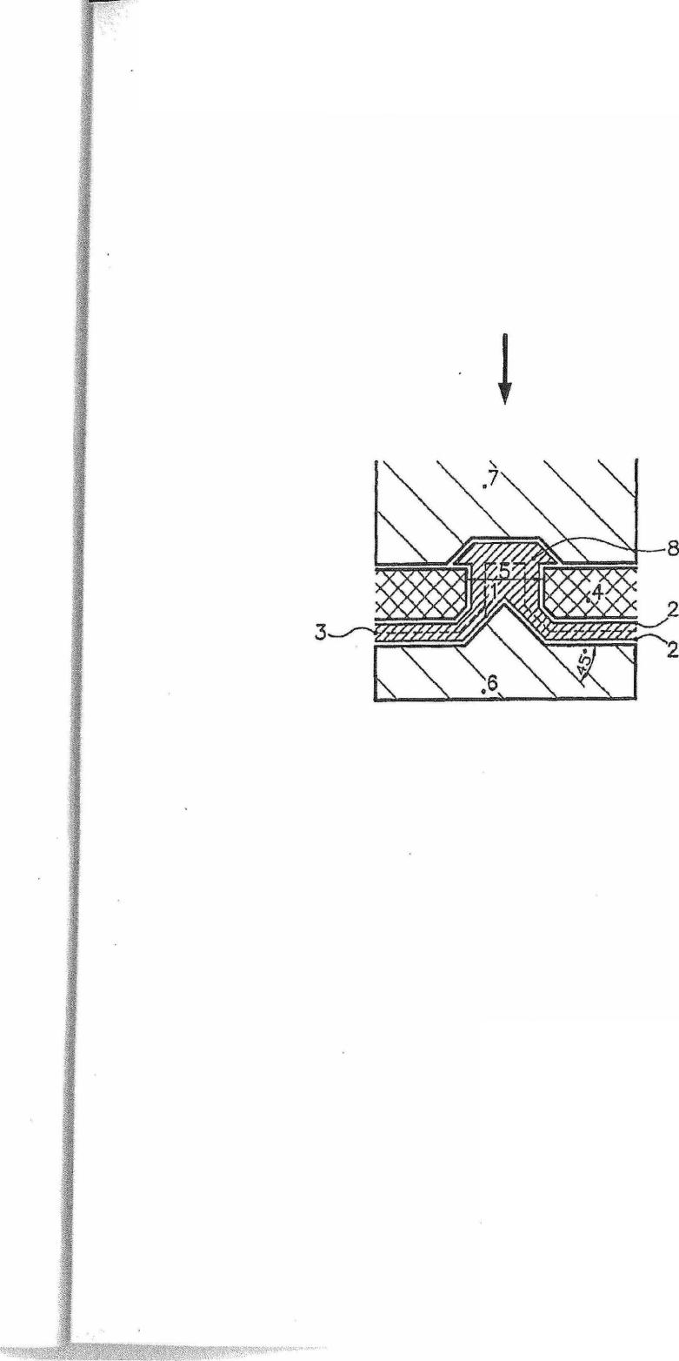P0_00165362

**U.S. Patent Jul. 26, 2016 Sheet 1 of 4 US 9,399,327 B2**

**Fig. 1**

**Appx102**

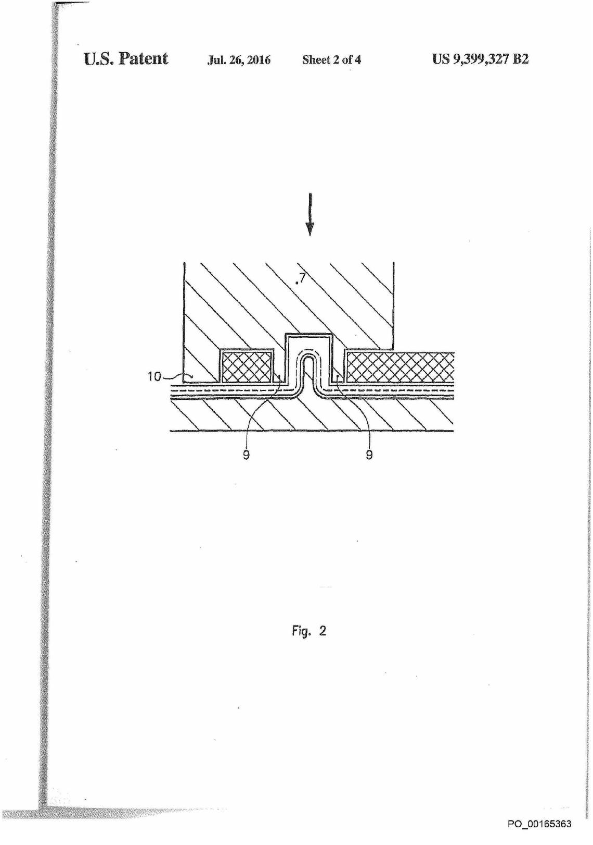

Appx103

U.S. Patent Jul. 26, 2016 Sheet 3 of 4 US 9,399,327 B2

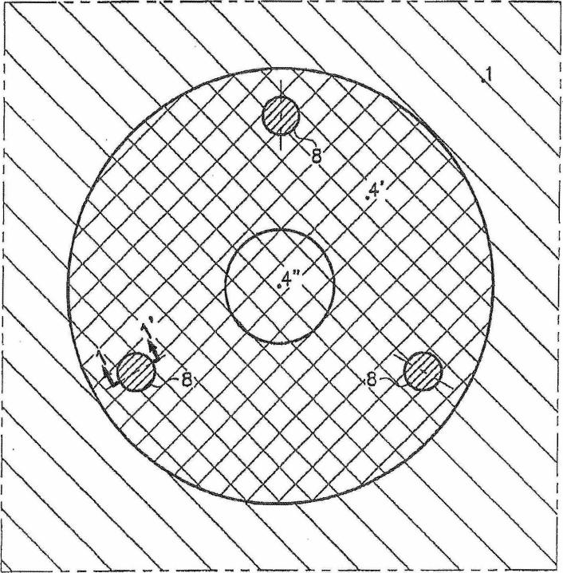

Fig. 3

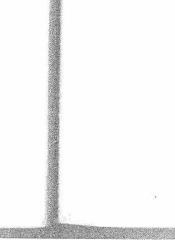

P0_00165364

Appx104

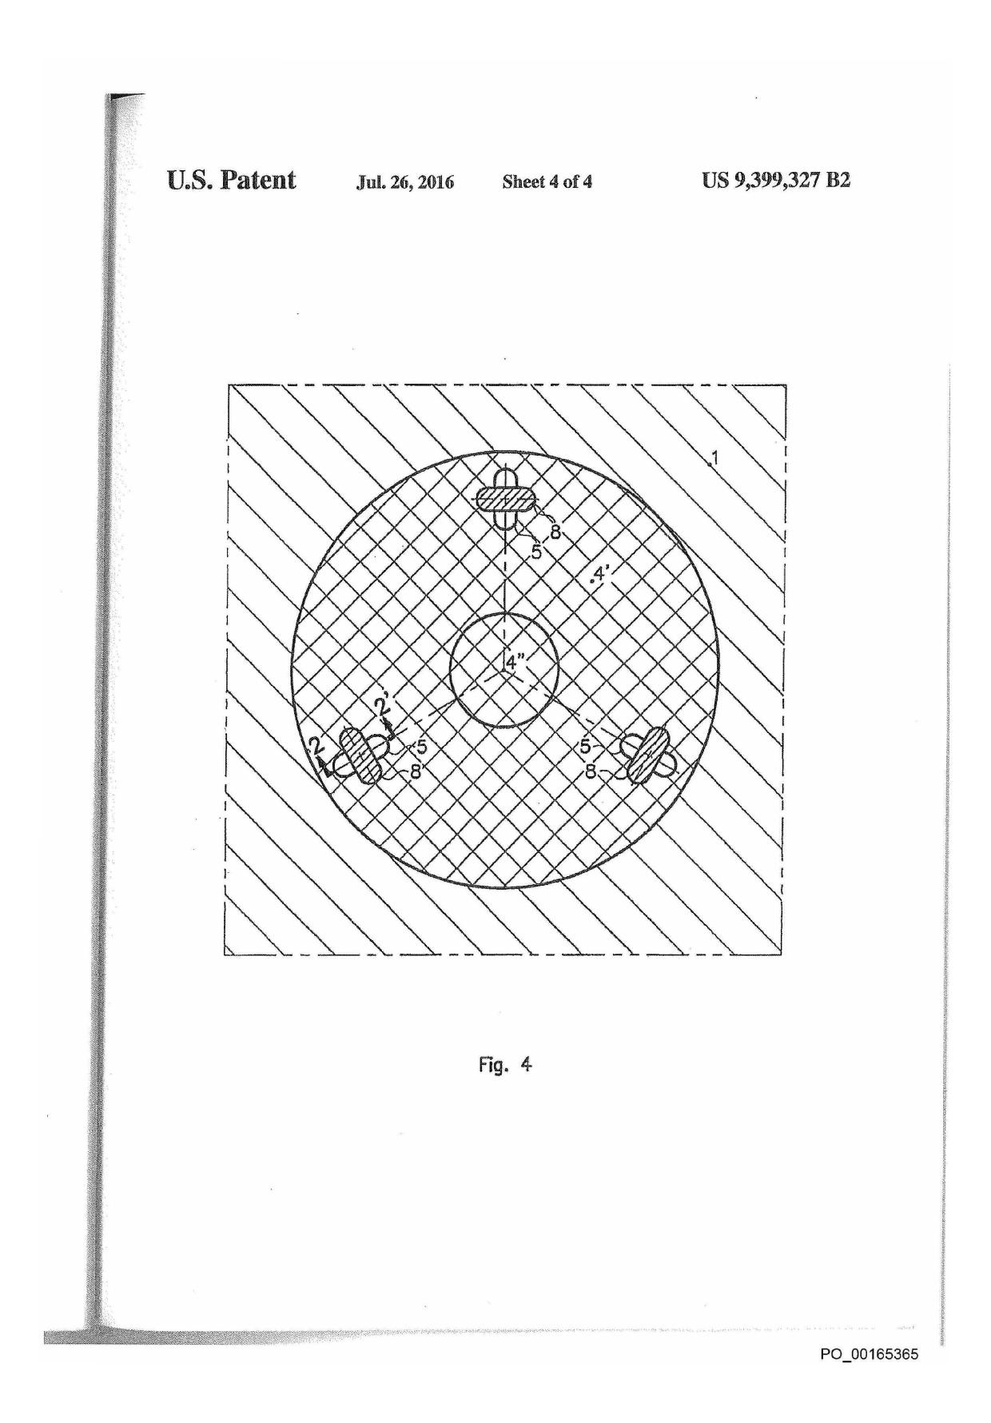

Appx105

US 9,399,327 B2



**2**

**1**

**METHOD FOR FASTENING AN ACCESSORY**

**IN A PLASTIC FUEL TANK**

REFERENCE TO PRIOR APPLICATIONS

can be stake-fastened in it. This fastening technique is used in application U.S. Pat. No. 5,308,427, but in order to fasten an accessory in an existing (already manufactured) fuel tank that has to be locally heated (using hot gas or the injection of

5 molten material). As the fastening occurs after production, it is not possible to benefit from a local flux of material. In consequence, that technique requires an external addition of material, with the inherent risks of non-homogeneity. Fur­thermore, in the case of a multilayer tank (typically, made of

This application is a continuation of U.S. application Ser. No. 11/658,085, filed Oct. 4, 2007, now allowed; which'is a 371 of PCT/EP2005/053519, filed Jul. 20, 2005.

The present invention relates to a method for fastening an accessory in a plastic fuel tank.

Fuel tanks on board vehicles of various kinds generally have to meet imperviousness and permeability standards in relation to the type of use for which they are designed and the environmental requirements that they have to satisfy. Both in Europe and throughout the world we are currently experienc­ing a considerable tightening of the requirements concerned with limiting the emissions of pollutants into the atmosphere and into the environment in general. The design of fuel tanks is therefore evolving quickly towards techniques capable of

better guaranteeing the imperviousness and safety under varying conditions of use. Furthermore, attempts are also being made to minimize the losses originating from the pipes and various accessories associated with the tanks. One means sometimes used is to incorporate certain accessories and pipe work within the tanks, thus eliminating their interface with the external surroundings. As a preference, these elements are fixed to the internal wall of the tank and do not pass through it, so as to avoid damaging the barrier layer often present in these tanks and so as to eliminate the risk of leakage associ­ated with recourse to sealing devices.

Thus, Patent Application WO 01/60592 in the name of the applicant company discloses a method of manufacturing a plastic fuel tank from two shells formed by moulding, that are assembled, the moulding of at least one shell being performed by compressing part of a sheet of plastic between a mould and a punch and by blowing the remaining part of the sheet in the region not compressed. The advantage of this method is that it allows one or more accessories easily to be included inside the tank, preferably by welding onto the internal face of the tank, for the permeability reasons mentioned hereinbelow. This fastening technique is simple but, unfortunately, limited to accessories having at least part of their basic surface made of the same plastic as the tank (generally HDPE) or, at least, of a plastic compatible therewith. Now, numerous accessories are based either on a metal or on a plastic different from that of the tank, having improved rigidity, improved dimensional stability and improved impermeability to hydrocarbons, such as polyacetal (and, in particular, polyoxymethylene or POM), polyamide, possibly glass-fibre-reinforced polyamide, poly-butylene terephthalate (PBT) etc. An alternative fastening technique proposed in this patent application consists in at least partially coating the accessory with part of the sheet at the time of its moulding. However, such a practice uses up a great deal of material and sometimes requires significant modifications to be made to the accessory. Furthermore, this technique may generate deformations and internal tensions as the skin of the tank cools.

It is therefore an object of the invention to provide a method that allows an accessory based on a material different from

that of the tank to be fastened inside a plastic fuel tank, and fastened quickly, easily, without consuming excessive amounts of material and without the risk of damaging the barrier layer or of creating excessive internal tensions.

The invention is based on the idea of benefiting from the fact that a parison is melted during its moulding, and that it

can be opened up (i.e. split or made up of two independent parts that can be parted from one another) so that an accessory

to high density polyethylene (HDPE)) with a layer of EVOH (a copolymer of ethylene and partially hydrolysed vinyl acetate), it is necessary to be careful not to damage the con­tinuity of the barrier layer. It is therefore necessary to melt through the entire thickness locally. This heating step is

15 lengthy and consumes power and furthermore gives rise to deformation and local tensions.

The invention therefore relates to a method for stake-fas­tening an accessory in a plastic fuel tank, whereby:

the accessory is equipped with at least one orifice which

20 passes right through the accessory;

at least some of the plastic of which the wall of the tank is

made is melted; and

some of the molten plastic is forced through the orifice of

the accessory without becoming detached from the

25 remainder of the molten plastic;

the protruding molten plastic is given an appropriate shape to obtain a self-formed plastic rivet, and is left to solidify;

the size and shape of the orifice and/or of the solidified plastic

30 being such that the accessory is mechanically fastened to the tank by at least some of the solidified plastic, the stake-fastening of the accessory occurring at the time of manufac­ture of the tank through the moulding of a split or at least two-part parison.

35 The term "fuel tank" is intended to denote a sealed tank able to store fuel under diverse and varying environmental and usage conditions. An example of this tank is a tank fitted to motor vehicles.

The fuel tank produced according to the method according cio to the invention is made **of plastic, that is** to say of a material comprising at least one synthetic resin polymer.

All types of plastic may be suitable. Particularly suitable plastics come from the thermoplastics category.

The term "thermoplastic" denotes any thermoplastic poly-

45 mer, including thermoplastic elastomers, as well as blends thereof. The term "polymer" denotes both homopolymers and copolyrners (especially binary or ternary copolymers). Examples of such copolymers are, non-limitingly, random copolymers, linear block copolymers, other block copoly-

50 mess and graft copolymers.

Any type of thermoplastic polymer or copolymer whose melting point is below the decomposition temperature is suit­able. Synthetic thermoplastics that have a melting range spread over at least **10°** Celsius are particularly suitable.

55 Examples of such materials include those that exhibit poly-dispersion in their molecular weight.

In particular, polyolefins, thermoplastic polyesters, polyketones, polyamides and copolymers thereof may be used. A blend of polymers or copolymers may also be used, as 60 may a blend of polymer materials with inorganic, organic and/or natural fillers such as, for example, but non-limitingly, carbon, salts and other inorganic derivatives, natural fibres or polymeric fibres. It is also possible to use multilayer struc­tures consisting of stacked layers bonded together comprising 65 at least one of the polymers or copolymers described above. One polymer which is often used is polyethylene. Excel­lent results have been obtained with high density polyethyl-

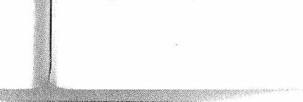

P0_00165366

**Appx106**

ene (HDPE).As a preference, the tank also comprises a layer of a resin impermeable to the fuel, such as EVOH for example (a copolymer of ethylene and partially hydrolysed vinyl acetate). Alternatively, it may be subjected to a surface treat­ment (fluoration or sulphonation) the purpose of which is to render it impermeable to the fuel.

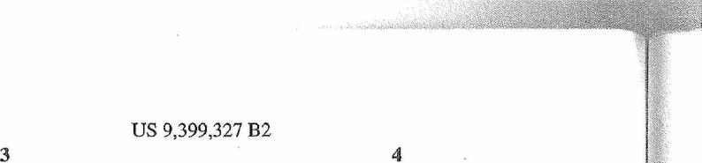

US 9,399,327 B2

3 4

tally greater than the swelling in the presence of petrol), the orifice then preferably also having a more or less oblong shape. The tools mentioned hereinabove (insert, counterform in the mould) are preferably cooled so as to accelerate the

*s* actual fastening of the accessory and allow the rates of manu-
  
facture of integrated tanks (comprising at least one fixed accessory) to be increased.

In general, in the method according to the invention, recourse is had to several staking orifices. These are in fact

* somewhat pinpoint-like, i.e. small in size by comparison with the size of the accessory. Typically, their size is of the order of a few mm (10 mm or less).

An advantageous embodiment positions the staking ori­fices, for the oblong or semi-oblong versions, in the direction

5 of the dimensional changes. These changes generally occur along lines which meet at a point located at the centre of the various orifices. In the case of (more or less) oblong orifices, one way of achieving this is to arrange the said orifices in such a way that the planes normal to the surface of the accessory at

20

the orifices and containing the longitudinal axes thereof inter­sect along the same axis (i.e. along one and the same straight line which kind of constitutes an axis of symmetry of the accessory). When the longitudinal axes of the various orifices are in one and the same plane, this amounts to saying that 25 these axes meet at a point more or less at their centre. This

approach allows the accessory not to be deformed or shifted excessively with respect to the centre of the various orifices. In the method according to the invention, the plastic of which the wall of the tank is made at the site intended for

* fastening the accessory is melted (which means to say in fact that it is truly subjected to fusion in the case of a sernicrys-talline polymer such as HDPE, but in fact means to say plasticized/softened in the case of amorphous polymers). The pasty material is then forced through the orifice of the acces-

s sory without detaching from the wall of the tank, and to solidify there. As already mentioned earlier, the size and shape of the orifice and/or of the solidified plastic are such that the accessory is mechanically fastened to the tank by at least some of the solidified plastic.

* The accessory is fastened by the method according to the invention at the time of manufacture of the tank by moulding. This approach can be achieved in practice by virtue of the fact that moulding takes place starting from a split or at least two-part parison. In particular, advantageously, the stake-

as

fastening occurs at the time of moulding of the tank by:

thermoforming sheets;

compressing/blow-moulding sheets (as described in the aforementioned application WO 01/60592, the content of which for this purpose is also incorporated into this application);

blow-moulding a parison comprising at least one cut-out (as described in Patent Application EP 1110697, the content of which for this purpose is incorporated by reference into this application).

When the tank is produced by thermoforming sheets (a technique that essentially employs a mould consisting of two moulding cavities), the stake-fastening may be performed by a robot which introduces the accessory between the two parts of the mould in which the sheets are inserted and pushes it against these sheets in order to perform the stake-fastening. In this case, the tooling mentioned hereinabove (insert, counter-form in the mould) can be incorporated into the robot arm.

When the tank is produced by blow-moulding or by com-pression/blow-moulding (techniques both of which simulta­neously use a core and an actual mould proper consisting of moulding cavities), the stake-fastening is preferably per­formed with the aid of an insert on the mould side (so as to

An "accessory" is intended to denote:

any object or functional device generally associated with the fuel tank in its conventional mode of use or of opera­tion and which collaborates therewith in order to per­form certain useful functions; or

a support for one or several of such devices.

Non-limiting examples of such devices are: liquid pumps, level gauges, pipettes, tanks or baffles internal to the fuel tank, ventilation devices, electronic units and stiffening bars.

According to one advantageous embodiment of the method according to the invention, the accessory is in actual fact a preassembled structure comprising a support and one or sev­eral identical or different devices which are fixed by any suitable fastening means. Examples of these means are clip­ping, screw-fastening, welding, etc. It is also advantageous for the preassembled structure to bear means that allow addi­tional devices that may be added on later to be attached. These means are also clipping devices, tapped holes or threaded protrusions of circular shape to allow screwing, surface regions suited to welding, etc. In the same vein, the accessory may consist of a simple support comprising suitable means for the later attachment of one or more devices. In other words, as a preference, the accessory comprises a support which is either equipped with fastening means for one or 3 several functional devices of the fuel tank (and which may be the lid of the accessory), or bears one or several such devices directly. In this case, the orifice used for stake-fastening the

accessory is preferably situated on the support. According to the invention, the accessory comprises an 3

orifice (hole) which passes right through its wall and allows the "staking" technique to be applied. This technique consists in forcing molten plastic through the orifice and causing it to protrude on the opposite side to the entry of said material into the orifice, while at the same time giving the protruding 4 plastic an appropriate shape such that it somewhat "self-forms" a plastic rivet (i.e. it forms the rivet in-situ from molten plastic from the wall of the tank). This shape is gen­erally that of a plateau.

The orifice may have any shape. However, its cross section (in section parallel to the wall of the accessory) will generally not be constant but will vary in such a way as to create a volume (intended to be occupied by the molten plastic) of a suitable shape so as to create a non-removable mechanical connection once the said material has solidified. Furthermore, so the shape of the cross section (and its variation along a plane perpendicular to the wall of the accessory) will preferably be tailored in such a way as to make it easier to force the material through the orifice, and for this to be done using an appropri-

ate tool (insert). 55

It is also often advantageous from a technical standpoint to contrive for the molten plastic not to entirely fill the orifice, and for this to be achieved by means of an appropriate tool (counterform). This approach allows variations in volume of the plastic (shrinkage upon cooling, swelling upon contact Go with the fuel) to be accommodated without generating stresses. In this case, the plateau will preferably have a more or less oblong shape (whereas it is generally more or less circular in shape, as, incidentally, is the upper part of the orifice) or semi-oblong shape (if the flow of material through 65 the orifice has been impeded on just one side, something which may be advantageous because the shrinkage is typi-

P0_00165367

**Appx107**

US 9,399,327 B2



**5 6**

force the material through the orifice) and a counterform tank. For example, an accessory made of a material other than

actuated by a ram on the core side (so as to defOrm the HDPE (for example made of POM) can be overmoulded with

material which has protruded through the orifice) HDPE.
  
A method of manufacturing the tank and of fastening the

accessory by blow-moulding (in a mould comprising a core 5 BRIEF DESCRIPTION OF THE SEVERAL

and a moulding cavity) which uses such accessories generally VIEWS OF THE DRAWINGS runs as follows:

positioning the accessory on the core; FIG. 1 depicts a section (on a plane perpendicular to the

initial closing of the mould (moulding cavities brought surface of the tank at this point) through a tank to which an

around the core); to accessory is in one process of being stake-fastened, the sec-

pressing a split or at least two-part parison (or wall of a fuel don being confined to the vicinity of a staking point of given

tank made of plastic in the molten state) onto the maul- geometry.

ding cavities of the mould (by blowing through the core FIG. 2 depicts a section (on a plane perpendicular to the

and applying suction behind the moulding cavities); surface of the tank at this point) through a tank to which an advancing a hydraulic ram which is fastened to the core in 15 accessory is in another process of being stake-fastened, the

order to perform the staking; section being confined to the vicinity of a staking point of

pricking the parison using a needle; given geometry.

degassing, opening the mould, removing the core, closing FIG. 3 depicts a view of the internal surface of the finished

the mould again and blowing in a conventional manner. tank (bearing the accessory) seen in section (on plane 1-1) of
  
During this method, there is of course a retraction of the 20 FIG. 1.

hydraulic ram which may occur before, during and/or after FIG. 4 depicts a view of the internal surface of the finished

degassing. There is also a device preventing the slot or the tank (bearing the accessory) seen in section (on plane 2-2) of

edges of the parts of the parison from welding together during FIG. 2.

the initial closing of the mould (in order to perform the stake- The purpose of FIGS. 1 to 4 is to illustrate certain concrete
  
fastening). To achieve this, the moulding cavities of the 25 aspects of the invention without in any way wishing to limit

mould are advantageously provided with a heat regulating its scope.

device that allows this region to be heated during the steps FIGS. 1 and 2 each depict a section (on a plane perpen-

involved with the initial closing of the mould. Such a device dicular to the surface of the tank at this point) through a tank

is described for example in application FR 04.13407 in the to which an accessory is in the process of being stake-fas-name of the applicant company, the content of which for this 30 tened, the said tank being in the process of being manufac-

purpose is incorporated by reference into this application. Lured by moulding but the section confining itself to the

In this method, the insert preferably bears a protrusion in vicinity of a staking point of given geometry. FIGS. 3 and 4

the shape of a spike making an angle preferably of between 30 depict a view of the internal surface of the finished tank

and 60°, or even 40 and 50°, and ideally of about 45°, thus (bearing the accessory) seen in section (on planes 1-1' and encouraging the material of which the wall is made to flow 35 2-2' respectively) of FIGS. 1 and 2.

through the orifice. Any abrupt transition in angle may be FIGS. 1 and 2 depict a fraction of the wall of a fuel tank (1)

provided with a rounded radius so as to optimize the flow comprising two layers of HDPE (2,2') one on each side of a

during the staking phase while at the same time preventing the layer of EVOH (3), the said tank being in the process of being

barrier layer of the tank, if there is one, from rupturing. manufactured by moulding a two-part parison. An accessory With a view to strengthening the mechanical connection 40 (4) equipped with at least one orifice (5) is in the process of

between the accessory and the wall of the tank, the counter- being stake-fastened to this wall (1). Constituent material of

form preferably applies pressure via the hydraulic ram not the wall of the tank (1) has been forced through this orifice (5)

only to the accessory itself but also at least partially to the by means of an insert (6) fixed in the mould and has been

molten plastic of the wall of the tank surrounding the acres- deformed on the inside of the tank by a counterform (7)

sory to encourage its compaction. 45 operated by a ram (not depicted but acting in the direction of

The present invention also relates to a plastic fuel tank the arrow) so as to form a kind of plateau (8) which overhangs

equipped with at least one (support for) accessory in direct the orifice (5) and prevents the accessory (4) from being

contact with part of the wall of the tank and being equipped removed without tearing/destroying the plateau (8). To these

with several orifices of more or less oblong shape in which ends, the plateau (8) has dimensions tailored to the desired and over which plastic identical to that of the wall of the tank 50 mechanical strength for the fastening of the accessory before

is present, these orifices being arranged in such a way that the and after contact with a fuel.

planes normal to the surface of the accessory at the orifices The insert (6) and the counterform (7) are cooled in order to

and comprising the longitudinal axes of the latter intersect on accelerate the setting of the molten plastic around the orifice

one and the same axis. (5). The insert (6) bears a protrusion in the shape of a spike In the context of the invention, the accessory may be based 55 making an angle of about 45° (see FIG. 1), encouraging the

on a material different from the wall of the tank. Advanta- constituent material of the wall (1) to flow through the orifice

geously, the accessory is based on at least one material corn- (5). In FIG. 2, the abrupt transitions in angle have been given

patible or compatibilized with that of the wall of the tank (for a rounded radius to optimize the flow during the stake-fasten-

example PA compatibilized with HDPE in particular by a ing phase while at the same time avoiding rupturing the layer suitable surface treatment or alternatively by overmoulding 60 of EVOH.

with an adhesive), which allows a strengthened mechanical In the case illustrated in FIG. 1, the plateau (8) is circular

fastening and imperviousness through chemical bonding and plastic occupies the entire orifice (5).

between the two materials when the accessory comes into In the case illustrated in FIG. 2, the circular plateau (8) has

contact with the molten material of the tank lobe fastened to been deformed (rendered oblong) by an appropriate relief (9) the latter. Alternatively, the accessory may be made of two 65 on the counterform (7), this being so as to absorb the dimen-

materials, one offering dimensional stability and the other sional changes introduced by shrinkage during cooling of the

permitting adhesion between the accessory and the wall of the tank and expansion by swelling upon contact with the fuel. In

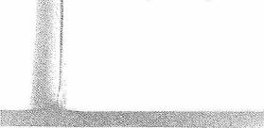

P0_00 1 65368

**Appx108**

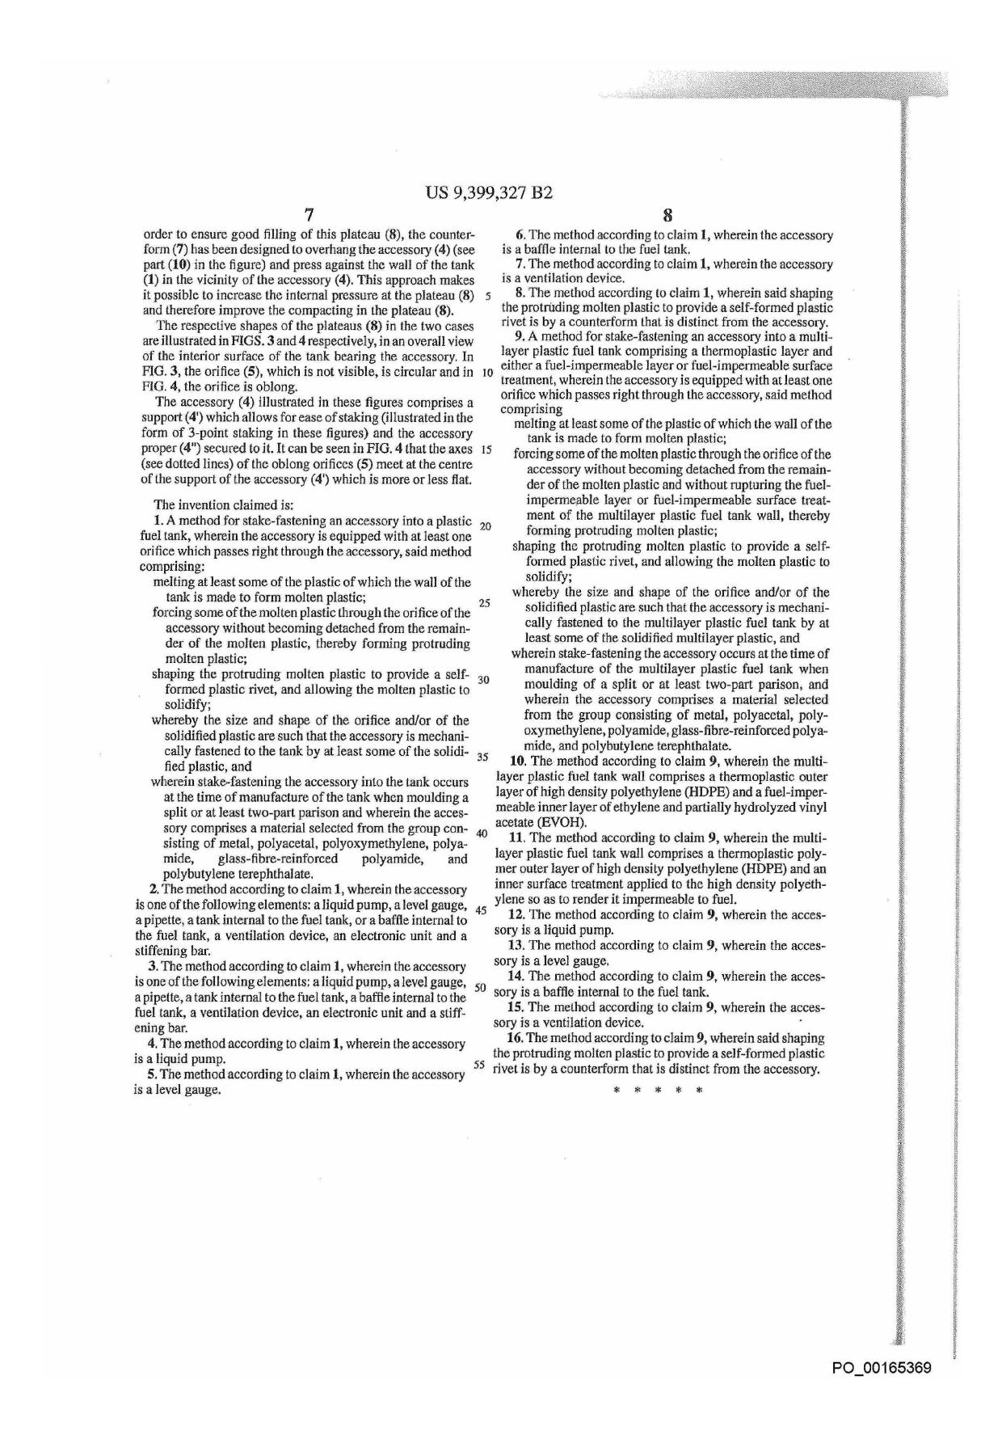

Appx109

**Case 1:16-cv-00187-LPS Document 199 Filed 11/06/17 Page 1 of 18 PageID #: 3635**

**IN THE UNITED STATES DISTRICT COURT
  
FOR THE DISTRICT OF DELAWARE**

PLASTIC OMNIUM ADVANCED
  
INNOVATION AND RESEARCH,

Plaintiff,

v. C.A. No. 16-187-LPS

DONGHEE AMERICA, INC. and
  
DONGHEE ALABAMA, LLC,

Defendants..

Chad S.C. Stover and Regina S.E. Murphy, BARNES & THORNBURG LLP, Wilmington, DE

Robert C. Mattson, Eric W. Schweibenz, Frank J. West, Vincent K. Shier, Christopher Ricciuti, and Katherine D. Cappaert, OBLON, McCLELLAND, MAIER & NEUSTADT, L.L.P., Alexandria, VA

Attorneys for Plaintiff.

Philip A. Rovner and Jonathan A. Choa, POTTER ANDERSON & CORROON LLP, Wilmington, DE

Alyssa Caridis, ORRICK, HERRINGTON & SUTCLIFFE LLP, Los Angeles, CA Nicholas H. Lam, ORRICK, HERRINGTON & SUTCLIFFE LLP, New York, NY Attorneys for Defendants.

**MEMORANDUM OPINION**

November 6, 2017
  
Wilmington, Delaware

**Appx941**

**Case 1:16-cv-00187-LPS Document 199 Filed 11/06/17 Page 2 of 18 PageID #: 3636**

**aC,j1**

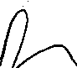

**ST U.S. Diste t Judge:**

Plaintiff Plastic Omnium Advanced Innovation and Research ("Plastic Omnium" or "Plastic") brought this patent infringement suit against Defendants Donghee America, Inc. and Donghee Alabama, LLC (together, "Donghee"), alleging that Donghee's manufacture and sale of certain automotive fuel tanks infringes Plastic's U.S. Patent Nos. 6,814,921 (the "'921 patent"); 6,866,812 (the "'812 patent"); 7,166,253 (the "'253 patent"); 8,122,604 (the "'604 patent")1; 8,163,228 (the '228 patent"); 9,079,490 (the "'490 patent"); 9,399,326 (the '326 patent"); and 9,399,327 (the '327 patent"). *(See generally* D.I. 1, 14) The asserted patents generally relate to methods for manufacturing automotive fuel tanks; they describe and claim processes "known in the industry as `twin-sheet blow molding' or `TSBM.'" (D.I. 14 at 3)

Presently before the Court is the issue of claim construction. The parties submitted technology tutorials *(see* D.I. 81, 86), arid claim construction briefs *(see* D.I. 84, 85, 102, 105). The Court held a claim construction hearing on September 6, 2017, at which both sides presented oral argument. *(See* D.I. 184 ("Tr."))

I. **LEGAL STANDARDS**

The ultimate question of the proper construction of a patent is a question of law. *See Teva Pharm. USA, Inc. v. Sandoz, Inc.,* 135 S. Ct. 831, 837 (2015) (citing *Markman v. Westview Instruments, Inc.,* 517 U.S. 370, 388-91 (1996)). "It is a bedrock principle of patent law that the claims of a patent define the invention to which the patentee is entitled the right to exclude." *Phillips v. AWH Corp.,* 415 F.3d 1303, 1312 (Fed. Cir. 2005) (internal quotation marks omitted).

'Per the parties' recent stipulation *(see* **D.I.** 195), the '604 patent has been dismissed from this case.

1

**Appx942**

**Case 1:16-cv-00187-LPS Document 199 Filed 11/06/17 Page 3 of 18 PageID #: 3637**

"[T]here is no magic formula or catechism for conducting claim construction." *Id.* at 1324. Instead, the court is free to attach the appropriate weight to appropriate sources "in light of the statutes and policies that inform patent law." *Id.*

"[T]he words of a claim are generally given their ordinary and customary meaning . . . [which is] the meaning that the term would have to a person of ordinary skill in the art in question at the time of the invention, i.e., as of the effective filing date of the patent application." *Id.* at 1312-13 (internal citations and quotation marks omitted). "[T]he ordinary meaning of a claim term is its meaning to the ordinary artisan after reading the entire patent." *Id.* at 1321 (internal quotation marks omitted). The patent specification "is always highly relevant to the claim construction analysis. Usually, it is dispositive; it is the single best guide to the meaning of a disputed term." *Vitronics Corp. v. Conceptronic, Inc.,* 90 F.3d 1576, 1582 (Fed. Cir. 1996).

While "the claims themselves provide substantial guidance as to the meaning of particular claim terms," the context of the surrounding words of the claim also must be considered. *Phillips,* 415 F.3d at 1314. Furthermore, "[o]ther claims of the patent in question, both asserted and unasserted, can also be valuable sources of enlightenment . . . [b]ecause claim terms are normally used consistently throughout the patent . . . ." *Id.* (internal citation omitted).

It is likewise true that "[d]ifferences among claims can also be a useful guide . . . . For example, the presence of a dependent claim that adds a particular limitation gives rise to a presumption that the limitation in question is not present in the independent claim." *Id.* at 1314­15 (internal citation omitted). This "presumption is especially strong when the limitation in dispute is the only meaningful difference between an independent and dependent claim, and one party is urging that the limitation in the dependent claim should be read into the independent

2

**Appx943**

**Case 1:16-cv-00187-LPS Document 199 Filed 11/06/17 Page 4 of 18 PageID #: 3638**

claim." *SunRace Roots Enter. Co., Ltd. v. SRAM Corp.,* 336 F.3d 1298, 1303 (Fed. Cir. 2003).

It is also possible that "the specification may reveal a special definition given to a claim term by the patentee that differs from the meaning it would otherwise possess. In such cases, the inventor's lexicography governs." *Phillips,* 415 F.3d at 1316. It bears emphasis that "[e]ven when the specification describes only a single embodiment, the claims of the patent will not be read restrictively unless the patentee has demonstrated a clear intention to limit the claim scope using words or expressions of manifest exclusion or restriction." *Hill-Rom Servs., Inc. v. Stryker Corp.,* 755 F.3d 1367, 1372 (Fed. Cir. 2014) (quoting *Liebel-Flarsheim Co. v. Medrad, Inc.,* 358 F.3d 898, 906 (Fed. Cir. 2004)) (internal quotation marks omitted).

In addition to the specification, a court "should also consider the patent's prosecution history, if it is in evidence." *Markman v. Westview Instruments, Inc.,* 52 F.3d 967, 980 (Fed. Cir. 1995), *aff'd, 517* U.S. 370 (1996). The prosecution history, which is "intrinsic evidence," "consists of the complete record of the proceedings before the PTO [Patent and Trademark Office] and includes the prior art cited during the examination of the patent." *Phillips,* 415 F.3d at 1317. "[T]he prosecution history can often inform the meaning of the claim language by demonstrating how the inventor understood the invention and whether the inventor limited the invention in the course of prosecution, making the claim scope narrower than it would otherwise be." *Id.*

In some cases, "the district court will need to look beyond the patent's intrinsic evidence and to consult extrinsic evidence in order to understand, for example, the background science or the meaning of a term in the relevant art during the relevant time period." *Teva,* 135 S. Ct. at 841. Extrinsic evidence "consists of all evidence external to the patent and prosecution history,

3

**Appx944**

**Case 1:16-cv-00187-LPS Document 199 Filed 11/06/17 Page 5 of 18 PageID #: 3639**

including expert and inventor testimony, dictionaries, and learned treatises." *Markman,* 52 F.3d at 980. For instance, technical dictionaries can assist the court in determining the meaning of a term to those of skill in the relevant art because such dictionaries "endeavor to collect the accepted meanings of terms used in various fields of science and technology." *Phillips,* 415 F.3d at 1318. In addition, expert testimony can be useful "to ensure that the court's understanding of the technical aspects of the patent is consistent with that of a person of skill in the art, or to establish that a particular term in the patent or the prior art has a particular meaning in the pertinent field." *Id.* Nonetheless, courts must not lose sight of the fact that "expert reports and testimony [are] generated at the time of and for the purpose of litigation and thus can suffer from bias that is not present in intrinsic evidence." *Id.* Overall, while extrinsic evidence "may be useful" to the court, it is "less reliable" than intrinsic evidence, and its consideration "is unlikely to result in a reliable interpretation of patent claim scope unless considered in the context of the intrinsic evidence." *Id.* at 1318-19. Where the intrinsic record unambiguously describes the scope of the patented invention, reliance on any extrinsic evidence is improper. *See Pitney Bowes, Inc. v. Hewlett-Packard Co.,* 182 F.3d 1298, 1308 (Fed. Cir. 1999) (citing *Vitronics,* 90 F.3d at 1583).

Finally, "[t]he construction that stays true to the claim language and most naturally aligns with the patent's description of the invention will be, in the end, the correct construction." *Renishaw PLC v. Marposs Societa' per Azioni,* 158 F.3d 1243, 1250 (Fed. Cir. 1998). It follows that "a claim interpretation that would exclude the inventor's device is rarely the correct interpretation." *Osram GmbH v. Int? Trade Comm 'n,* 505 F.3d 1351, 1358 (Fed. Cir. 2007) (quoting *Modine Mfg. Co. v. U.S. Int'l Trade Comm 'n,* 75 F.3d 1545, 1550 (Fed. Cir. 1996)).

4

**Appx945**

**Case 1:16-cv-00187-LPS Document 199 Filed 11/06/17 Page 6 of 18 PageID #: 3640**

**II. CONSTRUCTION OF DISPUTED TERMS**

**A. Parison Terms**

1. **"extruded parison of closed cross section"2**
2. **"extruding a [multilayered] parison"3**

|  |
| --- |
| **Plastic Omnium**   1. "an extruded plastic body having a closed cross section" 2. "extruding a [multilayered] plastic body having a closed cross section"   **Donghee**   1. "a plastic tube with a closed cross section formed by forcing plastic through a die" 2. "forcing plastic through a die head to form a plastic tube [of multiple layers] with a closed cross section"   **Court**   1. "a tubular preform with a closed cross-section that has been forced through a die, and is cut or split as it exits the die or at some time thereafter" 2. "a [multilayered] tubular preform with a closed cross-section that has been forced through a die, and is cut or split as it exits the die or at some time thereafter" |

There is no disagreement between the parties as to the "ordinary and customary" meaning of the term "parison." *(See, e.g.,* D.I. 85 at 5-6, D.I. 105 at 2) As Plastic states, the term refers to a "hollow plastic tube exiting the die of an extrusion head." (D.I. 105 at 2) Donghee, citing the two patents' disclosures, as well as technical encyclopedias and dictionaries, contends that this definition should play a prominent role here. *(See* D.I. 85 at 4-6) In Plastic's view, however, Donghee "conflat[es] the use of the term `parison' in conventional blow molding with the use of the term `parison' in Plastic Omnium's improved and novel . . . process." (D.I. 84 at 3) Plastic

'This term appears in claims 1, 2-5, 8, and 9 of the '921 patent.

3This term appears in claims 16, 25, 27, 30-32, 39, 41, 44, and 45 of the '812 patent.

5

**Appx946**

**Case 1:16-cv-00187-LPS Document 199 Filed 11/06/17 Page 7 of 18 PageID #: 3641**

urges the Court to find that the "conventional definition of `parison' does not apply to the asserted patents." (D.I. 105 at 2)

More specifically, Plastic argues that here the term "parison" should not be construed to require that "a traditional, plastic test-tube like structure . . . be formed outside of the extrusion head/die." (D.I. 84 at 3) Instead, according to Plastic, the relevant technology "uses a traditional extrusion head to form a parison that is split or cut into two sheets of plastic *as it is being extruded." (Id.)* (emphasis added) Thus, the "extruded parison" here "refers to the preform shape that is intended to be *split or cut* into two sheets." (D.I. 105 at 5)

"To act as its own lexicographer, a patentee must clearly set forth a definition of the disputed claim term other than its plain and ordinary meaning." *Aventis Pharma S.A. v. Hospira, Inc.,* 675 F.3d 1324, 1330 (Fed. Cir. 2012) (internal quotation marks omitted). This "clear expression" may be "inferred from clear limiting descriptions of the invention in the specification or prosecution history." *Id.; see also Phillips,* 415 F.3d at 1313 ("Importantly, the person of ordinary skill in the art is deemed to read the claim term not only in the context of the particular claim in which the disputed term appears, but in the context of the entire patent, including the specification.").

The Court agrees with Plastic that the '921 and '812 patents do not use the term "parison" is its conventional, plain and ordinary meaning. Instead, among other things, the patents specify that the "parison" is cut in two as it leaves the die at the end of the extrusion head. *(See, e.g.,* '921 patent at 3:24-27; '812 patent at 2:46-47) In this context, this "parison" cannot be strictly limited to a fully-formed tubular structure existing in its entirety outside the extrusion head/die.

Having concluded that the term "parison" as used in the asserted claims is not to be given

6

**Appx947**

**Case 1:16-cv-00187-LPS Document 199 Filed 11/06/17 Page 8 of 18 PageID #: 3642**

its plain and ordinary meaning, the principal disagreements between the parties seem to be identifying the point at which the molten plastic within the extrusion head becomes a "parison," and identifying the location of the die.

While the Court agrees with Plastic that "the claimed `parison' may be split . . . at the exit of the extrusion head/die, . . . or . . . even after a plastic tube has exited the extrusion head/die" (D.I. 84 at 4; *see also* '921 patent at 3:24-27 (describing splitting of tubular structure right as it leaves extrusion head)), the Court finds no support for Plastic's additional contention that its claimed process includes the splitting of molten plastic ***"within*** the extrusion head/die" (D.I. 84 at 4) (emphasis added). There is no disclosure in the patents' specifications that contemplates the splitting of the tubular preform at any stage earlier than right as the previously tubular structure leaves the die/extrusion head. Thus, the Court agrees with Donghee that the construction of the "extruded parison" terms should not include molten plastic (or a tubular preform) present inside the die/extrusion head. *(See generally* D.I. 85 at 5) ("Nowhere in the patents is an extruded parison described as the molten plastic inside of the machine.") The Court further agrees with Donghee that Plastic is incorrect in its contention that the die can be located anywhere. *(See generally* Tr. at 24; D.I. 105 at 3)4

Accordingly, the Court will construe the term "parison" as referring to a plastic tube with a closed cross section that is shaped by — and has reached the end of — a die, and is split either immediately upon exiting the die or at some point thereafter.

4Both patents specify that the "die" is located at the "extrusion head[' s]" "lowest point." ('921 patent at 3:4-5; *see also '812* patent at 2:37-38 (referring to "extruder whose head is terminated by the die"); *see also* Tr. at 24-25 (identifying location of extrusion head or die as important dispute))

7

**Appx948**

**Case 1:16-cv-00187-LPS Document 199 Filed 11/06/17 Page 9 of 18 PageID #: 3643**

1. **"split or at least two part parison"5**

|  |
| --- |
| **Plastic Omnium**  Plain and ordinary meaning.  If an express construction is deemed necessary: "a plastic body for blow-molding that is split or made into two parts"  **Donghee**  "a plastic tube with a closed cross section formed by forcing plastic through a die, which is  then cut"  **Court**  "a tubular preform with a closed cross-section that has been forced through a die, and is cut or  split as it exits the die or at some time thereafter" |

The parties appear to agree that the Court's construction of this term follows from its construction of the first two "parison" terms. *(See, e.g.,* D.I. 84 at 6) ("The disputed term 'split or at least two part parison' raises similar issues as the `parison' terms recited in the '921 and '812 patents.") As Donghee notes, "the '327 patent expressly incorporates, by reference, the European counterpart of the '812 patent . . . and the PCT parent of the '921 patent . . . in

explaining how to make a split or at least two-part parison." 85 at 6-7) The Court fmds no basis on which to construe the term "split or at least two part parison" in a manner distinct from its preceding constructions above.

1. **"extruded tubular parison"6**

**Plastic Omnium**

"extruded tubular preform intended to form the wall of the fuel tank after molding"

'This term appears in claims 1, 7, 9, and 15 of the '327 patent.

6This term appears in claim 2 of the '228 patent.

8

**Appx949**

**Case 1:16-cv-00187-LPS Document 199 Filed 11/06/17 Page 10 of 18 PageID #: 3644**

**Donghee**

"tubular preform intended to form the wall of the fuel tank after molding, formed by forcing

plastic through a die"

**Court**

"a tubular preform with a closed cross-section that has been forced through a die, and is cut or

split as it exits the die or at some time thereafter"

Similarly here, there is no basis for the Court's construction of this term to differ from its construction of the "parison" terms construed above, and the parties' arguments with respect to this term refer back to their contentions regarding the earlier terms. *(See, e.g.,* D.I. 84 at 8) ("As before, the dispute between the parties is whether the term 'extruded tubular parison' should be . . . narrowed to require a plastic tube to exit an extrusion/die head before it is cut into two sheets.")

**B. Molding Terms**

1. **"during the operation of molding the shell" and "during molding"'**
2. **"at the same time as said tank is manufactured by moulding with a mould"'**
3. **"at the time of manufacture of the tank when moulding"9**

**Plastic Omnium**

Plain and ordinary meaning. If an express construction is deemed necessary:

1. "during the processing of forming the tank shell and before joining the shells"
2. & (3) "during the blow molding process"

'These terms appear in claims 5 and 9 of the '921 patent.

'This term appears in claims 1, 2, 7, 8, and 12-14 of the '490 patent.

9This term appears in claims 1 and 7 of the '327 patent.

9

**Appx950**

**Case 1:16-cv-00187-LPS Document 199 Filed 11/06/17 Page 11 of 18 PageID #: 3645**

**Donghee**

1. "while the sheet is being compression and/or blow molded to form the shell"
2. & (3) "while the plastic is being thermoformed or blow molded to form the tank"

**Court**

1. "during the process of forming the tank shell and before joining the shells, until the plastic is no longer molten and pliable"
2. **&** (3) "during the blow molding process, until the plastic is no longer molten and pliable"

Donghee characterizes the parties' dispute as "one of timing and ambiguity." (D.I. 85 at 9) Donghee contends that these terms are limited to the attachment of components during the period of time when the tank plastic "is actually being shaped" — that is, at some point before the plastic "has taken the shape of the mold." *(Id.* at 11-12) In support of its position, Donghee argues that "Mlle verb 'molding' (or 'moulding') has a well understood meaning — it refers to the act of shaping material." *(Id.* at 9)

Plastic responds that Donghee's proposals are "nonsensical" because they would require "accessory attachment to occur . . . simultaneously with the molten plastic being forced against the mold cavity to give the fuel-tank walls their shape." (D.I. 105 at 9) Plastic says this would be a "technical nightmare, if not an outright impossibility." *(Id.)* Plastic also refers to certain intrinsic evidence that it argues supports its view that the relevant period extends beyond the literal shaping process *(see id.* at 10-12); it contends that these "molding" terms contemplate the installation of accessories in a manner that utilizes the "flow" or "pliable" nature of molten plastic *(id.* at 10).

The Court is not persuaded that Donghee's narrow view is consistent with the ordinary and customary meaning of these terms as a skilled artisan would perceive them. The Court

10

**Appx951**

**Case 1:16-cv-00187-LPS Document 199 Filed 11/06/17 Page 12 of 18 PageID #: 3646**

agrees with Plastic that the relevant "process" lasts as long as "the plastic is still molten and pliable." *(Id.* at 14)

**C. "preassembled structure"10**

**Plastic Omnium**

Plain and ordinary meaning.

If an express construction is deemed necessary: "a premade structure"

**Donghee**

"a set of multiple parts previously joined into a single arrangement that attaches to at least

several accessories"

**Court**

"a set of multiple parts previously joined into a single arrangement that is capable of

attachment to at least one accessory"

Emphasizing claim language specifying that the relevant "accessor[ies]" are "supported by a preassembled structure" ('253 patent at claim 1), and noting that the word "preassembled" implies "a structure previously assembled from multiple parts" (D.I. 85 at 15), Donghee argues that "preassembled structures" are distinct structures that attach to accessories (and are not themselves accessories), and are not merely "premade" but, rather, comprise multiple parts that are joined at some earlier point in time. Plastic counters that "the specification requires only that the `preassembled structure' be produced in a separate process from the blow-molded fuel tank *— i.e.,* it is a `premade structure.' (D.I. 105 at 15)

The Court agrees with Donghee that the term "preassembled structure" here refers to a structural feature comprising at least two parts, which is initially distinct from the accessory or accessories that it "supports" and can then be joined with the relevant accessor(ies). This is

wThis term appears in claims 40 and 41 of the '812 patent as well as claims 1, 2, 3, 11, 12, and 14 of the '253 patent.

*11*

**Appx952**

**Case 1:16-cv-00187-LPS Document 199 Filed 11/06/17 Page 13 of 18 PageID #: 3647**

consistent with the patents' disclosure that the structure: is "preassembled" (which the Court does not understand to merely mean "premade," as Plastic suggests); it "support[s]" the "inserted accessory" or accessories ('253 patent at 4:12-16); it "comprises at least one device configured to anchor said preassembled structure to an internal wall" ('253 patent at claim 1); and that the "preassembled structure" can be inserted "independently of the . . . insertion of accessories . . . to the internal wall of the hollow body" ('253 patent at 4:23-26).

The Court finds insufficient support, however, for Donghee's assertion that any given "preassembled structure must attach to 'at least several accessories' for the invention to make sense" (D.I. 85 at 16), or that it must at least be capable of attaching to several accessories. Donghee's proposal would result, improperly, in importing a limitation from the specification. The claims may be satisfied so long as the "preassembled structure" is capable of attaching to at least one accessory.

**D. "orifice""**

**Plastic Omnium**

Plain and ordinary meaning.

If an express construction is deemed necessary: "hole"

**Donghee**

"a hole that passes through the accessory [or support for an accessory]"

**Court**"hole"

The parties' disagreement here is whether the term requires the claimed "orifice" to extend fully through the relevant accessory or only some portion of the accessory. Donghee,

'This term appears in claims 1, 13, 25-27, 33, 34, and 44 of the '326 patent.

12

**Appx953**

**Case 1:16-cv-00187-LPS Document 199 Filed 11/06/17 Page 14 of 18 PageID #: 3648**

pointing to the '326 patent's disclosure, argues that the invention is limited to —a method for stake-fastening an accessory in a plastic fuel tank whereby the accessory is equipped with at least one ***orifice which passes right through the accessory:"*** (D.I. 85 at 17) (quoting '326 patent at 2:15-18) Donghee also points out that the claims explicitly require that the relevant accessory have a "wall portion," and an "orifice" which "passes through the wall portion of the accessory." *(E.g.,* '326 patent at claim 1)

Plastic responds that the plain and ordinary meaning of the term "orifice" is simply "hole," and further cites to the patent's disclosure, which indicates that the two words are synonymous. *(See '326* patent at 3:34) Plastic also argues that Donghee's construction would be redundant, as the "claims themselves define the precise structural relationship of the 'orifice' or `hole' with respect to the claimed wall portion of the accessory." (D.I. 84 at 20)

The Court agrees with Plastic. Although the patent refers to an "orifice" or "hole" that "passes right ***through*** [the accessory's] wall" ('326 patent at 3:34 (emphasis added); *see also, e.g., id.* at claim 1) — rather than ***into*** the accessory wall — this disclosure is not sufficient to make Donghee's proposed construction correct. *See generally Thorner v. Sony Computer Entm'tAm LLC,* 669 F.3d 1362, 1366 (Fed. Cir. 2012) (explaining that "standard for disavowal of claim scope is . . . exacting").

13

**Appx954**

**Case 1:16-cv-00187-LPS Document 199 Filed 11/06/17 Page 15 of 18 PageID #: 3649**

**E. Shaping terms**

1. **"shaping the protruding molten plastic"12**
2. **"the protrusion having been shaped"13**

|  |
| --- |
| **Plastic Omnium**  These claim terms are definite.  If an express construction is deemed necessary:   1. "shaping the top of the protruding molten plastic to provide a self-formed plastic rivet" 2. "the top of the protruding molten plastic having been shaped to overhang the at least one orifice"   **Donghee** Indefinite.  If not:   1. "applying a counterform to deform the protruding molten plastic" 2. "the protrusion having been deformed by the application of a counterform"   **Court**   1. "shaping the protruding molten plastic to provide a self-formed plastic rivet" 2. "the protruding molten plastic having been shaped to overhang the at least one orifice" |

As Donghee contends that these "shaping" terms are indefinite, it bears the burden of showing, by clear and convincing evidence, that this claim language, "viewed in light of the specification and prosecution history," fails to "inform those skilled in the art about the scope of the invention with reasonable certainty." *Biosig Instruments, Inc. v. Nautilus, Inc.,* 783 F.3d

12This term appears in claims 1 and 13 of the '326 patent and claims 1, 7, 9, and 15 of the '327 patent.

'This term appears in claims 25-27, 33-34, and 44 of the '326 patent.

14

**Appx955**

**Case 1:16-cv-00187-LPS Document 199 Filed 11/06/17 Page 16 of 18 PageID #: 3650**

1374, 1378 (Fed. Cir. 2015) (quoting *Nautilus, Inc. v. Biosig Instruments, Inc.,* 134 S. Ct. 2120, 2129 (2014)). In particular, Donghee asserts that the claims are "impermissibly ambiguous," and therefore invalid, because they are "internally inconsistent or nonsensical." (D.I. 85 at 18) Donghee points to the method claims' reference to a "self-formed plastic rivet." A rivet made by "deliberately shaping the plastic," Donghee says, "is, by definition, not self-formed." *(Id.* at 18 (emphasis omitted); *see also* '326 patent at claim 1) Similarly, Donghee suggests that the apparatus claims are ambiguous because they can be read to include both "active[]" shaping or "shap[ing] by the law of nature whereby molten plastic takes on some form." (D.I. 85 at 18; *see also, e.g.,* '326 patent at claim 25)

Donghee has failed to prove indefiniteness. Plastic explains that the method claims' reference to "self-formed" is to the rivet's formation from "some of the plastic of which the wall of the tank is made" (D.I. 105 at 18) (internal quotation marks omitted), rather than "a separate rivet inserted into or through the fuel-tank's wall" *(id.).*

Alternatively, Donghee seeks a construction that would limit the terms to active shaping through use of a counterform. Donghee argues this is necessary because (1) "passive shaping [is] not described in the patents," and (2) the relevant claims' "shaping" step is preceded by a "forcing" step, which results in the formation of "molten plastic protruding through the orifice of the accessory." (D.I. 102 at 9) (emphasis and internal quotation marks omitted) In Donghee's view, a "construction that encompasses passive shaping would render superfluous" the "shaping" step, because the "forcing" step already "requires plastic to flow through the orifice and form a protrusion on the opposite side." *(Id.)*

The Court is not persuaded. While it is clear that the "forcing" step would necessarily

15

**Appx956**

**Case 1:16-cv-00187-LPS Document 199 Filed 11/06/17 Page 17 of 18 PageID #: 3651**

produce "molten plastic protruding through the orifice" ('326 patent at claim 1), there is nothing to suggest that every type of "protru[sion]" will necessarily take on the shape of a rivet. The Court further agrees with Plastic that requiring the use of a counterform would, under the circumstances, improperly "limit[] the claims to a preferred embodiment." (D.I. 105 at 18)

Accordingly, the Court will adopt Plastic's proposed construction, except without including language requiring that the "shaping" occur at the "top" of the "protruding molten plastic," as such a restriction is not supported.

**F. "stretched"14**

**Plastic Omnium**

Plain and ordinary meaning.

If an express construction is deemed necessary, the term "bend which is stretched" means: "bend which is elongated relative to its relaxed state"

**Donghee**

"extended in length by pulling"

**Court**

"extended in length relative to a relaxed state"

The precise contours of the parties' disputes with respect to this term are not entirely clear. To the extent the parties disagree as to whether what is being "stretched" is only the "pipe," and not also the "bend" in the pipe, the Court agrees with Donghee that it is the pipe that is being stretched. *(See* '228 patent at 3:52-55) (explaining that claimed process uses "pipe" which features "bend," and that "bend" is "any deformation that allows ***the pipe*** to be lengthened when stretched") (emphasis added) To the extent the parties dispute whether the only manner by which stretching may be accomplished is by pulling, the Court agrees with Plastic that no such

14This term appears in claims 1-4 and 7-9 of the '228 patent.

16

**Appx957**

**Case 1:16-cv-00187-LPS Document 199 Filed 11/06/17 Page 18 of 18 PageID #: 3652**

limitation is warranted. To the extent the parties disagree as to what it means to be "extended," the Court again agrees with Plastic that "extended" requires a length greater than when the pipe is in its relaxed (unstreteched) state.

III. CONCLUSION

The Court construes the disputed terms as explained above. An appropriate Order follows.

17

**Appx958**

United States Court of Appeals for the Federal Circuit

*Plastic Omnium Advanced v. Donghee America, Inc.,* 2018-2087
  
**CERTIFICATE OF SERVICE**

I, Robyn Cocho, being duly sworn according to law and being over the age of 18, upon my oath depose and say that:

Counsel Press was retained by OBLON, MCCLELLAND, MAIER & NEUSTADT, LLP, counsel for Appellant to print this document. I am an employee of Counsel Press.

On **August 31, 2018** counsel has authorized me to electronically file the foregoing **OPENING BRIEF FOR APPELLANT (confidential and non-confidential versions)** with the Clerk of Court using the CM/ECF System, which will serve via e-mail notice of such filing to all counsel registered as CM/ECF users, including any of the following:

Alyssa Margaret Caridis

Orrick, Herrington & Sutcliffe LLP

777 South Figueroa Street, Suite 3200

Los Angeles, CA 90017

213-629-2020

[acaridis@orrick.com](mailto:acaridis@orrick.com)

*Principal Counsel for Appellees*

Additionally, confidential paper copies will also be mailed to the above principal counsel on this date and electronic copies will be emailed to the above counsel.

Upon acceptance by the Court of the e-filed document, six paper copies will be filed with the Court within the time provided in the Court’s rules.

August 31, 2018 /s/ Robyn Cocho

Counsel Press

**CERTIFICATE OF COMPLIANCE MOTIONS OR BRIEFS CONTAINING MATERIAL SUBJECT TO A PROTECTIVE ORDER**

**Briefs** Containing Material Subject to a Protective Order

[X] This brief complies with the limitations set forth in Fed. Cir. R. 28(d) and contains [**10**] words (including numbers and images) marked as confidential, or

[ ] This brief does not comply with the word count limitations set forth in Fed.

Cir. R. 27(m) and a motion is requesting permission to exceed the maximum word count

August 31, 2018 /s/ Robert C. Mattson

Robert C. Mattson *Counsel for Appellant*

**CERTIFICATE OF COMPLIANCE WITH TYPE-VOLUME LIMITATION** This brief was printed using a 14 point Times New Roman Font.

This brief complies with the type-volume limitation of Federal Rule of Appellate Procedure 32. According to MS Word 2013, the word processing system used to prepare this document, the brief contains **9,250** words.

August 31, 2018 /s/ Robert C. Mattson

Robert C. Mattson *Counsel for Appellant*